Growth of Ge_{1-x} Sn_{x} solid solution films by Liquid-phase epitaxy
and study of their photoelectric and structural properties

A. S. Saidov¹, Sh. N. Usmonov¹, U. P. Asatova², Sh. K. Ismailov²

¹Starodubtsev Physical-Technical Institute, Academy of Sciences of Uzbekistan
²Urgench State University, Uzbekistan

Abstract

Ge_{1-x}Sn_{x} solid solutions were grown with using liquid-phase epitaxy from a limited volume of Sn solution-melt by forced cooling in an atmosphere purified by palladium hydrogen. To grow the layers, we used a vertical quartz reactor with horizontally arranged substrates. Ge plates with a resistivity of 1 Ω⋅sm, crystallographic orientation (111), were used as substrates. The substrate diameter and thickkness were 50 mm and ~400 μm, respectively. The thickness of the film layyers varied within 3–35 μm, depending on and the thickness of the gap between the subb strates.
The surface relief of an epitaxial film of a Ge_{1-x}Sn_{x} solid solution (0 ≤ x ≤ 0.03) was studied using an atomic force microscope (AFM). A three-dimensional AFM image of an epitaxial film is shown in fig. 1. It can be seen that on the surface separate tubercles of various sizes are formed. The analysis showed that the diameter of the base of the hillocks varies in the range from 150 to 400 nm, and the height from 5 to 20 nm.
At heteroepitaxial growth the strain energy caused by the mismatch of the lattice parameters of the contacting semiconductors is the driving force for the formation of self-organizing three-dimensional islands. Since the mismatch of the lattice constants for Ge/α-Sn systems is ~ 12%, it is possible to form nanocrystals from the Ge1-xSnx solid solution on the surface of the epitaxial film. The dimensions of the hillocks on the surface of the film is shown in fig. 2. Therefore, apparently, the solid solution Ge1-xSnx with a high Sn content forms nanocrystals in the epitaxial film of the solid solution. These quantum-sized objects in an epitaxial film can be used in mono-optical properties of heterostructures made on the basis of the studied solid solution.
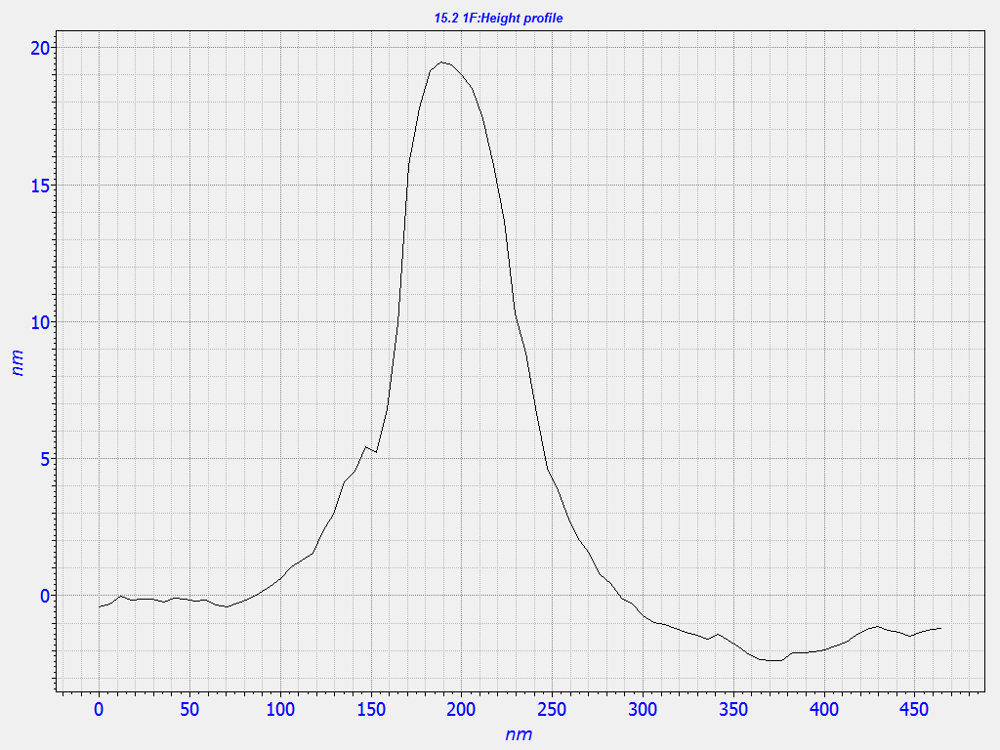
0
100
200
300
400
нм
0
5
10
15
20
нм
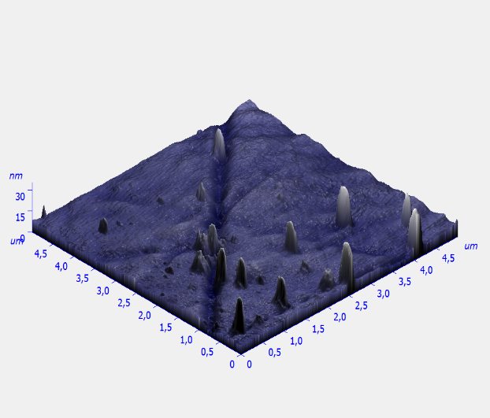
0
100
200
300
400
нм
0
5
10
15
20
нм
Fig. 1. Three-dimensional Fig. 2. The linear dimensions AFM image of the epitaxial layer of the average tubercle on the surface
of the Ge_{1-x}Sn_{x} solid solution (0≤x≤0.03). on the surface of the epitaxial film
of the Ge_{1-x}Sn_{x} solid solution
Keywords: solid solution, liquid phase epitaxy, heterostructures, epitaxial film, band gap, nanocrystals

Professional Biography

Asatova Umida graduated Tashkent State University, the Department of Semiconductor and dielectrical physics.The field of her specialization is semiconductor physics. She has been working for twenty five years in this sphere. Nowadays she is a PhD doctorant at the Department of Physics in the Urgench State University. Asatova U has more than 20 articles and theses. The aim of her research is to growth with using liquid-phase epitaxy a new solid solution films and study of their structural, electric and photoelectric properties.



Email Id:umida72@rambler.ru

