NEW FAST METHOD FOR READING CHARGE BIT STORED IN MNOSFET
A.E. Atamuratov¹, Z.A.Atamuratova², A. Yusupov³

¹ Docent, physics department (Urganch State University, Uzbekistan)
² Teaching assistant, physics department (Urganch State University, Uzbekistan)
³Professor, department of electronics and radio engineering (Tashkent University of Information Technologies, Uzbekistan)

The reading of data in nonvolatile memory elements can be achieved by using scanning microscopy. Though the scanning microscopy has high spatial resolution, they have sufficient lack for application, connected with the scan (or reading) speed. For them the scan rate is limited by the feedback response time. Besides almost all the scanning microscopes has expensive and complex electromechanical components to move tip or sample and optical systems (laser, photodetector) for registration. In this work with using simulation it is investigated possibility to detect (to read) localised charge (charge bit) trapped in metal-nitride-oxide-semiconductor field effect transistor (MNOSFET), without using the movable probe, by applying scanning voltage to source-base (or drain-base) transition. It allow to reach the enough reading rate. At applying saw-tooth sweep voltage the scan rate depend on the period of sawtooth voltage.
The trapped localized charge affect to capacitance of the lateral source-substrate (or drain-substrate) transition of MNOSFET. This effect is shown as a jump of the capacitance in the lateral C-V dependence (Fig.1,a). To experimental determination the jump voltage V_{jump} it is expedient to calculate the derivative of the change of the capacitance with respect to the bias voltage V_{bias}, d(𝛥C)/dV, at all voltages along voltage axis of the C-V dependence,. In this derivative the V_{jump} will be reflected as voltage corresponding to a extreme points of the derivative curves (Fig.1,b). The V_{jump} strongly depends on position and linear size of charge bit as well as on substrate doping concentration. At appropriate conditions the applying of the saw - tooth voltage may be used as scanning to read a bit information saved in the form of localized charge trapped in silicon nitride layer. In this case, for example, the channel of transistor can be considered as word line in random access read only nonvolatile memory element.
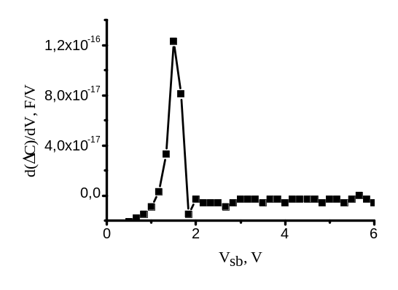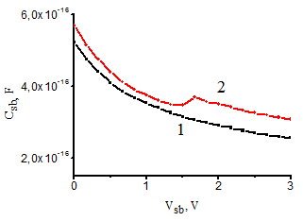 a) b)
Fig.1. C-V dependence of the source-base transition without(1) and with (2) localised charge embedded in silicon nitride layer of MNOSFET (a) and derivative d(𝛥C)/dV (b)

Keywords— C-V characteristics, charge bit , reading speed, trapped charge.

Professional Biography

Atabek Atamuratov has completed his specialist diploma in Physics in 1983 from Moscow State University and PhD from Uzbek National University in 1993. He is the docent of physics department of Urganch State University. He has published more than 15 papers in reputed journals. He is reviewer of International Journal of electronics. At Urganch state University he leads the group of electronics and modelling of semiconductor devices. The group has several national and international research projects. He is advisor for 2 PhD student and 5 MS student at the Physics department of Urganch State University.


Email Id: atabek.atamuratov@yahoo.com
atabek.atamuratov@urdu.uz

Any Comments: This research is conducted under supporting the grant OT-F2-67 of Ministry of Innovation Development of Republic of Uzbekistan
Full Name: Atamuratov Atabek Egamberdievich
Current Affiliation: docent, Urganch State University

Zuhra Atamuratova has completed his BS diploma in Physics in 2009 from Urganch State University and MS diploma in Nuclear Physics from Uzbek National University in 2011. She is the teaching assistant of physics department of Urganch State University. She has published 2 papers in reputed journals. At Urganch State University she is member of the group of electronics and modelling of semiconductor devices and participate in several national and international research projects. She is advisor for 3 BS student at the Physics department of Urganch State University.



Email Id: zuhra.atamuratova88@mail.ru

Full Name: Atamuratova Zuhra
Current Affiliation: Teaching assistant, Urganch State University

Professor Ahmed Yusupov has completed his PhD at the age of 30 years from Physics and Technics Institute of Academy of Sciences of the Republic of Uzbekistan and postdoctoral studies from Sankt-Petersburg Technical University at 1993. He occupied a post of vice-rector of Urganch State University between 1995 and 2005 years and post of vice rector of Tashkent University of Information Technologies (TUIT) between 2008 and 2012 years. He has published more than 50 papers in reputed journals, he is author of 5 invention and 3 books. He was a member of the editorial board, and then deputy editor-in-chief of the scientific journal Vestnik TUIT. Between 1999 and 2003 years was a member of the Scientific and Methodological Council of the Ministry of Higher Education of Uzbekistan in electronics . Now he is member of Council of Experts of Higher Attestation Commission under Cabinet of Ministry of Uzbekistan.
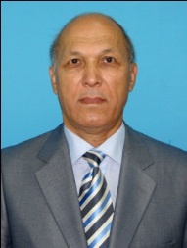
Email Id: ayus@mail.ru

Full Name: Yusupov Ahmed
Current Affiliation: professor, Tashkent University of Information Technologies

