CHAPTER 6
RESULTS AND DISCUSSIONS
Unsymmetrical Faults Analysis of Wind Farms
There are following types of Unsymmetrical or unbalanced faults analyzed for the DFIG based wind farms
- Line to Ground fault
- line to line fault
6.1. L-G fault (Phase a - G)
6.1.1. Fault at 620v bus (Generator terminal)
Boundary conditions for L-G fault are:
V_{a} = 0
I_{b} =I_{c} =0
Current and Voltage Values for the sequence and phase components has been discussed in table 10 and 11.(Chapter 4)
L-G (Phase 'a' to Ground) fault is introduced on the wind turbine generator-1 terminal at t=0.3s and cleared at 0.6s as per policy of the national grid code. Discovered voltages and currents in all the three phases at generator terminal are shown in fig.1 below.
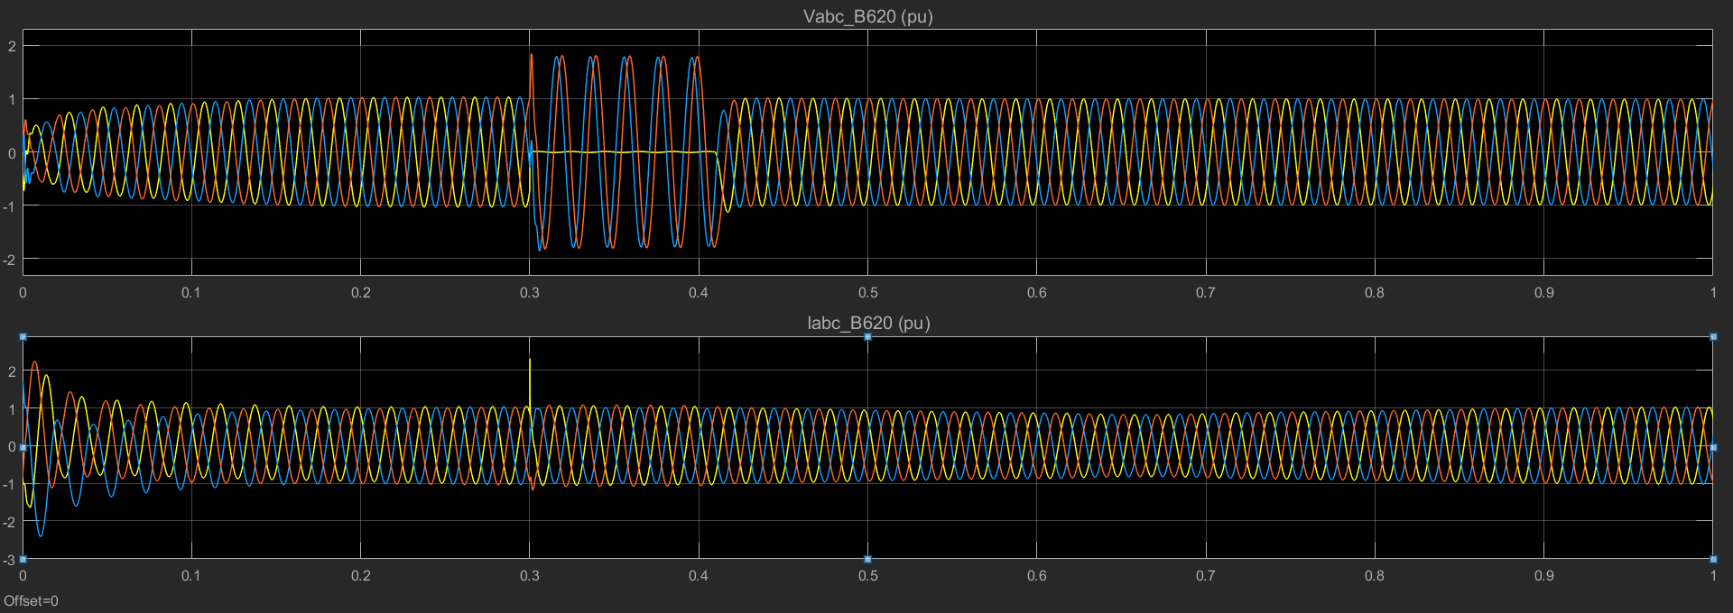
Fig 1.Voltage and current wave forms at gen terminal
Since the Phase 'A' (Yellow) is grounded so it can be seen clearly that the voltage in faulted phase has tone down to zero while during the period of fault the voltage in other two phases 'B & C' (Red and blue respectively) has increased considerably that is the ideal condition discussed in section 4.6.3 chapter 4. This overshooting of the voltage in phase B an C also depends upon the grounding of the Generator step up Transformer. If it is ungrounded or grounded through the resistor the voltage could be increased up to L-L values, but if it is solidly grounded than the voltages in the healthy phases will remain at L-G values. In This study LT (Low tension) side of the transformer is directly grounded. On the other hand, there will also be some leakage capacitance in addition to the resistance to the ground. These are the causes of over voltages in other two unfaulted phases.
For the current, it is clearly shown in the graph that during the initialization of fault current in the phase 'a' fault current has considerably increased which line up our result with boundary conditions of L-G fault as discussed in section 4.6.3 chapter 4.

6.1.2. L-G fault at 33kv bus.
L-G fault is introduced near the collector (33kV) bus. Obtained voltage and current wave forms are shown in fig. 2 below.
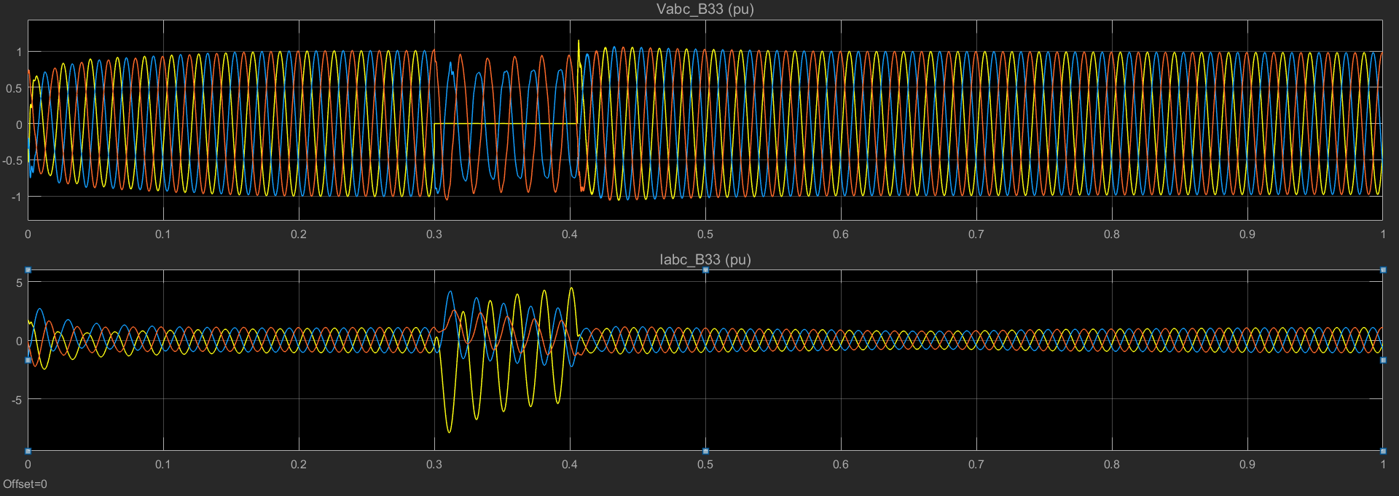
Fig 2. Fault at 33kV bus
Phase 'a' voltage drops to zero during the fault conditions. The obtained results are inline with the boundary conditions as discussed in section 4.6.3 chapter 4.
A small voltage drop has been observed in other two unfaulty phases. This is due to the fact that the collector bus zone of the wind farm is not grounded (fault location), and the fault current will travel towards the main transformer grounding. Since the distance between fault location and Main Transformer grounding is considerably large (3km in this study), therefore the loop impendence of the zone also increases which causes a small voltage drop in the healthy phases.
Current wave forms for the L-G fault is shown in fig.2. Current in Phase 'a' increases rapidly during the fault initialization and decays gradually.
since the collector bus (33kv)in the wind farms is not grounded. The effect of the L-G fault produced at 33kV bus, on the generator side is shown in the fig.3 below. during the fault, voltages in the yellow and blue phases are tone downed but do not fall to zero. The cause behind this situation may be presence of residual voltages caused by the line capacitance and additional fault loop impedance provided by the step up transformers connected between Generator and 33kV bus.
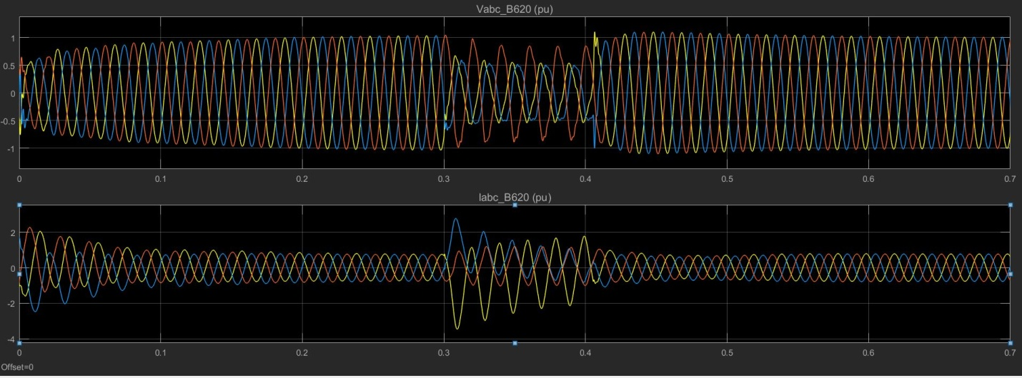Fig. 3 Voltage and current wave forms at generator terminal for L-G fault at 33kv Bus

6.1.3. L-G fault at 132 kV line.
For the L-G fault near high voltage transmission line (132kv), the obtained current and voltage wave forms are shown in fig.4
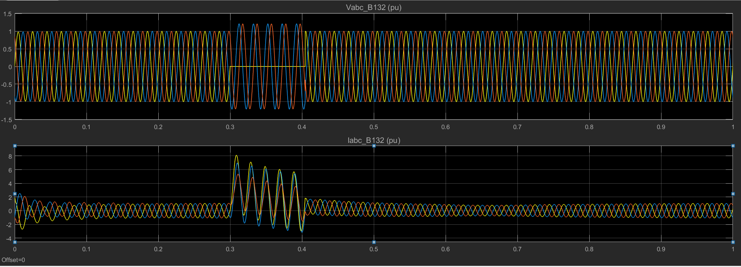
Fig 4. L-G at 132kv bus

L-G fault is introduced near high voltage bus. The voltage in the faulty phase 'a' exactly drop to zero. while other two phases experience a small voltage overshoot.
The phase 'a' current of the High voltage transmission line is much higher than that of the wind farm side during the fault time. Since wind farm is a weak power supply system as compared to the grid, the short circuit current provided by the wind farm is smaller than that of the grid side, hence the differences of the three-phase currents is not obvious as shown in fig.4 .

6.2 Unsymmetrical faults (L-L)
6.2.1.L-L fault (at Phase b - c ) at generator terminal
Line to Line fault (Phase B and Phase C) is created on the Wind turbine generator-1 terminal at for the time of 100ms. Voltage and current in all the phases obtained at 620v bus-1 Generator terminal are shown in fig below.
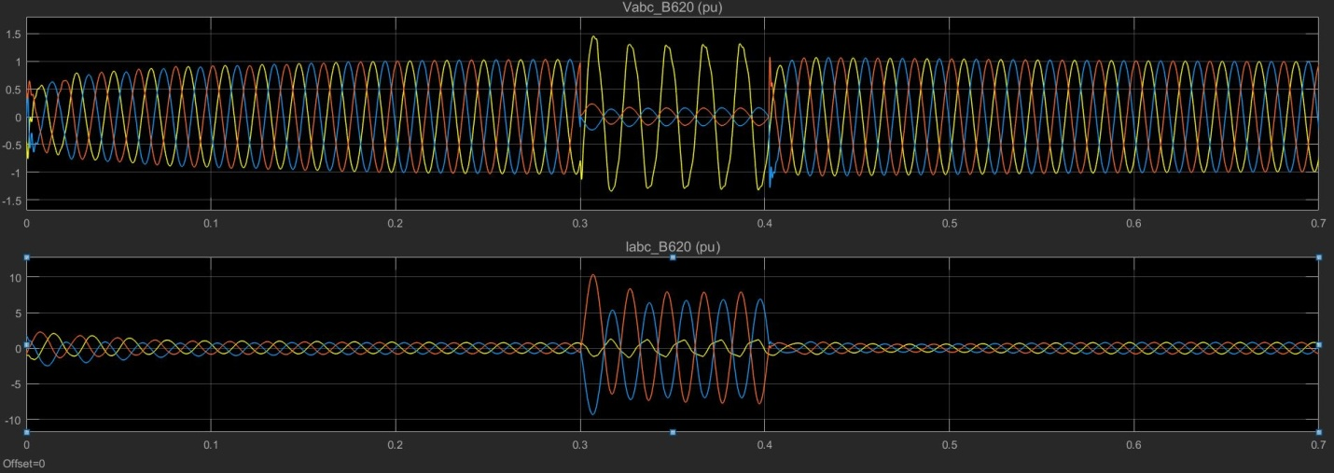
Fig 5: L-L-G fault(Phase b - c - G) at generator terminal
During the initialization of fault, the voltages in the phase b and c are considerably town down that is Vb = Vc and the Voltage overshoot in unfaulty phase is observed, which completely matches with the theoretical results that has been discussed in section 4.6.1 Chapter 4.
As per theoretical results current in the phase 'b' should go through the current in phase 'c' in the equal amount but opposite in direction. i.e I_{b} = -I_{c}. The analyzed results of the simulation are in phase with theoretical results and can be seen in the above fig 5, that clearly shows that current in phase b and phase c are equal but opposite in direction during the fault period. Ideally current in the phase 'a' should decay to zero, but in the case the presence of the current in the phase 'a' is due to the current fed from the other generators of the wind farm and power system.

6.2.2. L-L fault(Phase a - b ) at 33kV bus
At gen terminal
L-L fault is introduced at 33kv bus for the time of 100ms. the voltage and currents for the fault are shown in the fig below.
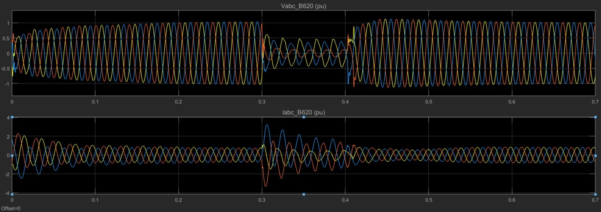
Fig 6. L-L fault(Phase a - b ) at 33kV bus observed voltage and currents at gen: ter
At the time of initialization the voltages in phase 'b' and 'c' are considerably decreased, the phenomenon is in line with the theoretical conditions discussed in section 4.6.1 chapter 4
The current in the faulty phases 'b' and 'c' are equal and opposite as can be shown in fig 6 above which is totally in phase with theoretical result. The current in phase 'a' should theoretically decay to zero, but here in phase 'a' there is transient current during the fault period it is because that fault current is also fed by the other generators of the wind farms.

6.2.3 L-L fault at 33kV bus itself
L-L fault is introduced near the collector bus (33kV). Observed voltages and currents are shown in fig below.
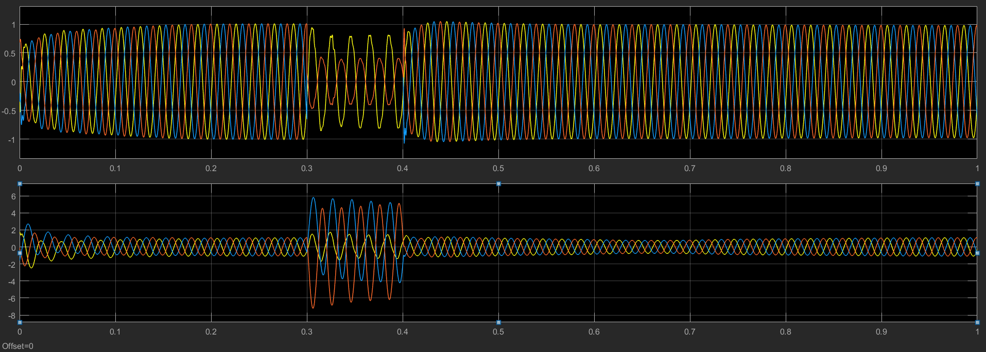
Fig: 7 L-L fault at 33kV bus
It is very much clear in the above graphs that voltage in phase 'b' and phase 'c' are exactly equal and opposite to each other which declares the ideal phenomenon of the L-L fault boundary conditions as discussed in section 4.6.1 chapter 4.
Current wave forms in the faulty phases 'b' and 'c' are equal and opposite to each other i.e I_{b}=-I_{c} which is also inline with boundary conditions.

Symmetrical Fault Analysis of Wind Farm
6.3 Symmetrical or Balanced Faults
Symmetrical or balanced faults are analyzed for the DFIG based wind farms. By balanced faults we mean that Three phases are short circuited. These faults are considered to be the severe types of faults in the power system. Also the symmetrical fault calculations helps to determine the short circuit current capacity of the circuit breakers and other protection equipments of the power system.

6.3.1 Balanced fault at generator terminal
A balanced fault is introduced at generator terminal of the wind turbine 1 shown in fig. Chapter 5. Fault is initialized for 100ms seconds i.e between t=0.3 to t=0.4 sec and the current and voltage graphs are observed. Graphical results for balanced fault at generator terminal are shown in fig 9. below
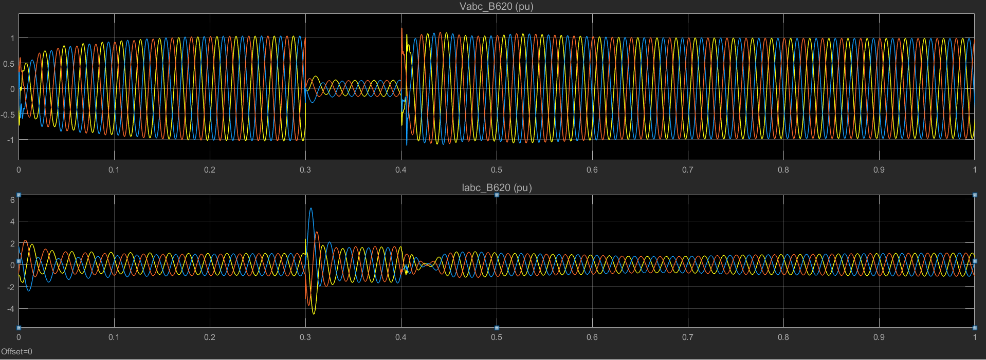
Fig 9. Balanced fault at Generator terminal.
When the fault is initialized the voltages in all the three phases attain very small magnitude. Ideally these voltages should attain the zero value as discussed in the boundary conditions of three phase short circuited fault in section 4.5 Chapter 5.
But in real conditions, there is always some fault resistance which causes the presence of the small magnitude of voltages in all three phases. Fault resistance is kept constant at 0.001 ohms for this study.
Generator terminal fault increases abruptly when the fault is initialized as shown in fig 9. above. Then a fast decay fault current can be seen in the graph, this is due to transient time constant of the generator.
Fast decay in the fault current is due to the fact that the DFIGs in the wind farm are not equipped with external capacitor compensation devices. Hence when the three phases of the rotor circuit are short circuited the DFIG start behaving like an ordinary induction generator with crowbar resistance (Crowbar is a over voltage protection circuit provided in DFIG to protect the Power Electronic Converters from the over voltages). Hence there will be no reactive power source to the generator to feed the fault current continuously thereby a fast decay be observed in the fault current.

6.3.2 Balanced fault at 33kV bus.
Three phase balanced fault is created near the collector bus. Voltage and current wave forms obtained are shown in fig 10 below.

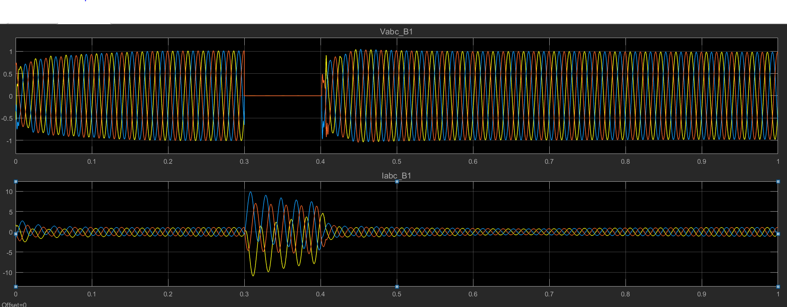
Fig: 33kv bus voltage and currents
According to ideal boundary conditions of the Symmetrical faults voltages in all the phase should drop to zero during the fault condition as discussed in section 4.5 chapter 4.
V_{a} = V_{b} = V_{c} = 0 (equation 23 Chapter 4)
In the obtained graphs it can be seen that when fault is initialized all voltages in three phases becomes zero, that result is inline with ideal condition.
During the fault time, current at collector bus abruptly increases in all phases and do not decay rapidly during the whole period of fault. This phenomenon is due the expected feed current from the power system and other generators operating in parallel. The fault is also seen by the other generators until and unless the fault is cleared. The fault current at generator terminal 5 is shown in fig 11 which reveals that during the balanced fault at collector bus the fault current is feed from other generators. The fault current contributed by the other generators is comparatively lower because of the greater loop impedance between collector Bus and generator transformer. Current characteristics of generator terminal - 5 is shown on fig 11 below.
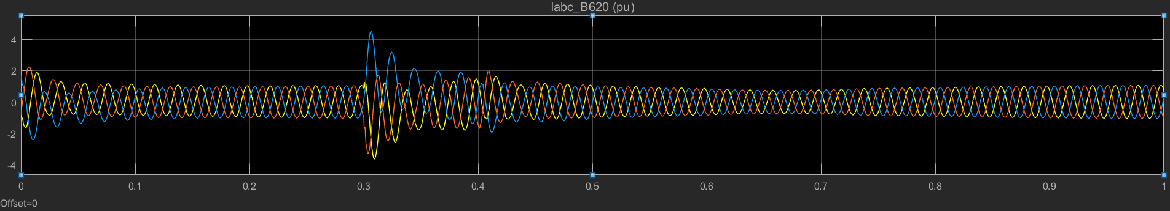
Fig 11. Current behavior at generator terminal - 5

6.3.3 Balanced fault at 132kv line:
Balanced fault is introduced near 132kV bus. Voltage and current wave forms are obtained at 132kV bus are shown in fig 12.

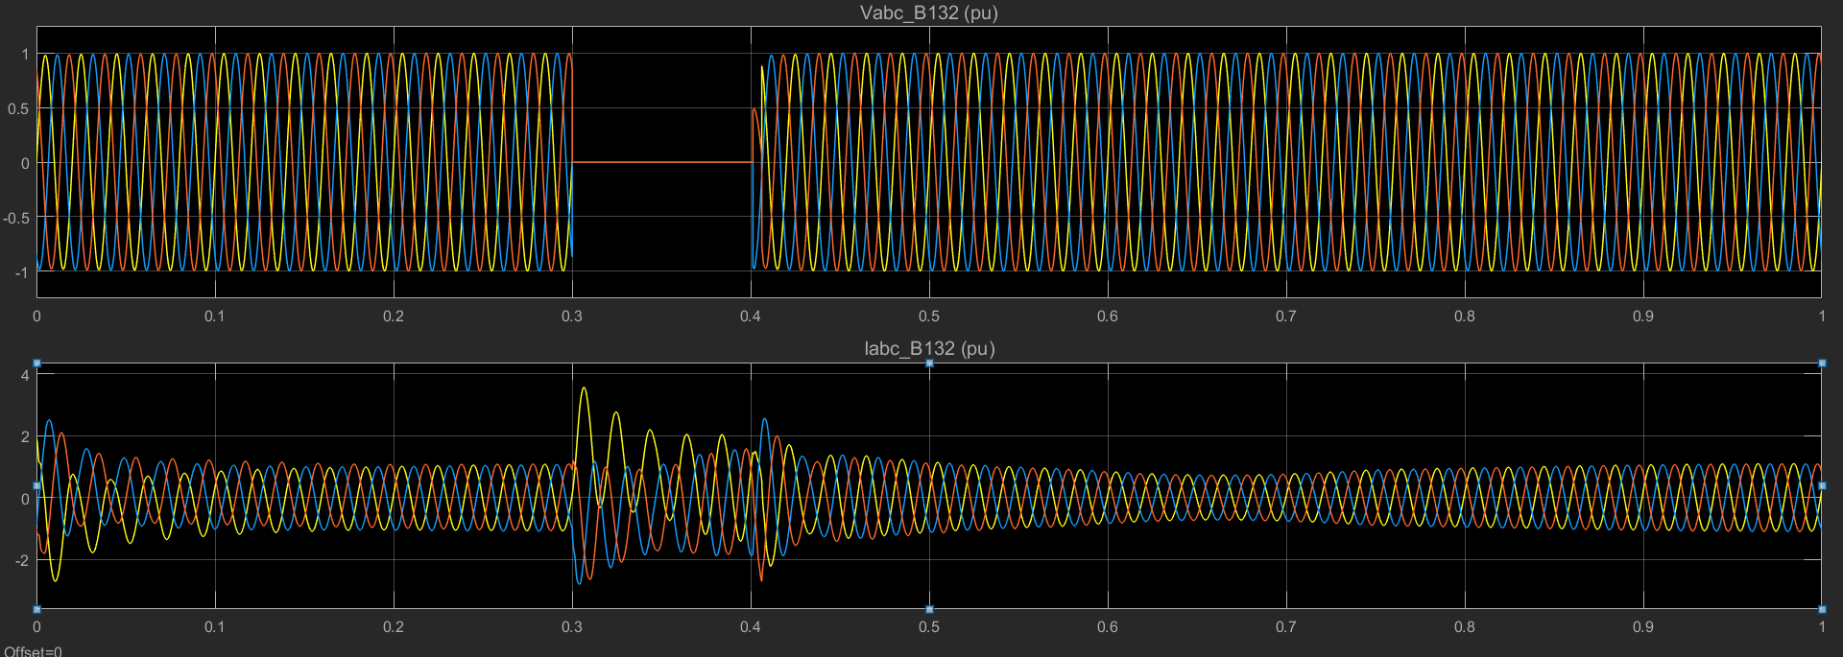
Fig 12. Symmetrical fault at 132 kV bus

The results of the voltages during the fault conditions completely resembles the boundary conditions of the balanced fault i.e during the fault voltages in all phases will drop to zero. Voltage results are similar to that of the fault at Collector bus.
Since the current during the fault increase abruptly and a marginal decay has been observed. Fault current decays more slowly as compared to the fault current decay at generator terminal. This is due to the fact that time constant for the fault current decay is less than that of the balanced fault at generator terminal because of the addition fault loop impedance provided by the cable and transformer impedance.
Since it has already been discussed that the DFIGs are not equipped with Capacitor compensating devices, but on the other hand capacitor banks are connected to the collector bus zone of wind farm and generator gird side converters of DFIG provide the reactive power to the fault, which causes current transients to last for few cycles after the fault clearance.

