Analysis of electromagnetic properties of ores on the example of regolith
Prof Roman V. Meshcheryakov, PhD, ICS RAS, Russia
Dr Alexander Timofeev, PhD, ICMR RAS, Russia
Dr Pavel Ananiev, PhD, CIMT, Russia
Anna Anannieva, CIMT, Russia
Konstantin Belyakov, TSU, Russia

Abstract (300 word limit)
Now, for mining processing enterprises, the task is to create deserted industries based on deep digitalization of technological processes. This will require the creation of fundamentally new sensors for software and hardware systems that provide express determination of the material composition and characteristics of the structure of ore materials. One of the most important factors influencing the efficiency of the beneficiation process is the content of the useful component in the ore and the degree of its disclosure after grinding. Determining the size of mineral grains is a laborious process. Not currently, there are express methods for their evaluation. The number of magnetite particles will determine the magnetic properties of the ore material (regolith, for examle), such as saturation magnetization, remnant magnetization and coercive force.
The saturation magnetization is determined by the maximum magnetic field induction in the material, placed in a magnetic field with increasing intensity. Remanence – induction magnetic field in the material after turning off the external magnetic field. Coercive force shows in what field of tension a pre-magnetized material should be placed in order to completely demagnetize it. The principle of operation of the device is based on weighing a sample in gravitational field and in a controlled constant electromagnetic field of varying intensity, not exceeding the saturation field of the components. Calculation correspondence between the results of weighing and the mass fraction of the magnetic material in the sample is carried out according to a graduated dependence built according to standard samples.

Image
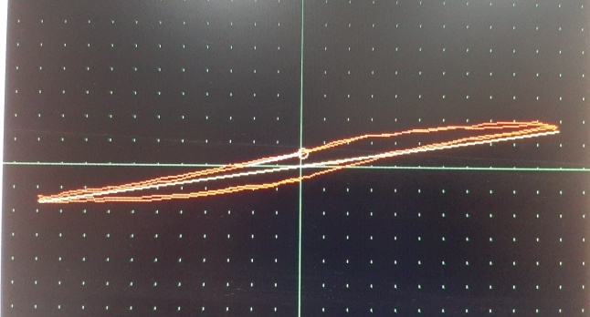
Fig 1 An example of a constructed hysteresis loop with a device of the "Ferrograph" type

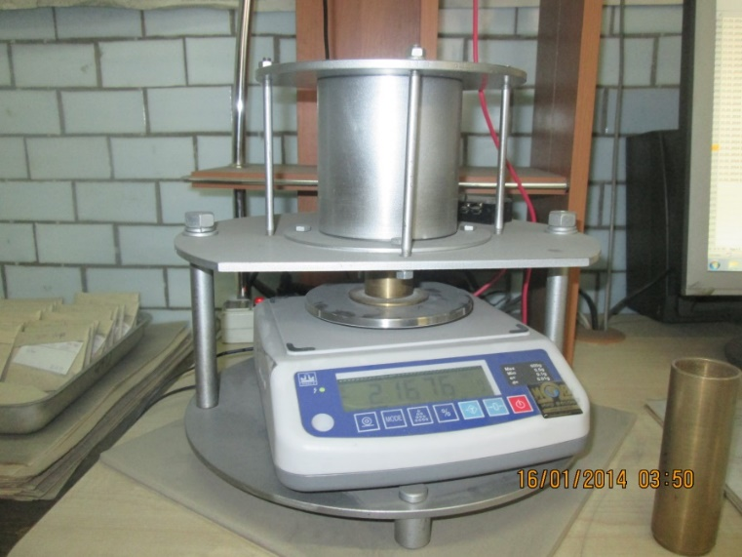
Fig 2. Measuring stand
Recent Publications (minimum 5)
- Stephen J. Indyk, Haym Benaroya (2017) A structural assessment of unrefined sintered lunar regolith simulant Acta Astronautica 140. 517–536.
- P.W. Weiblen, M.J. Murawa, K.J. Reid (1990), Preparation of stimulants for lunar surface materials/ Engineering, Construction and operation in Space II, pp. 428-435, American Society of Civil Engineers, New York, NY.
- A.N. Scott, C. Oze, Y. Tang, A. (2017) O’Loughlin Development of a Martian regolith simulant for in-situ-resource utilization testing // Acta Astronautica, Volume 131, February 2017, pp.45-49. URL: http://dx.doi.org/10.1016/j.actaastro.2016.11.024
- Pavel Petrovich Ananiev, Anna Valerievna Plotnikova, Pavel Veniaminovich Larionov, Roman Valerievich Meshcheryakov, Konstantin Olegovich Belyakov (2020) METHOD FOR SELECTIVE CONTROL OF NOBLE METAL ORES PROPERTIES. Patent
- P.P. Ananiev, A.V. Plotnikova, A.S. Timofeev, R.V. Meshcheryakov, K.O. Belyakov (2021) Problems of testing robotic systems for moving around space objects // Robotics and technical cybernetics. - V. 9. - No. 3. - St. Petersburg: TsNII RTK. - 2021. - P. 180-185.

Photograph

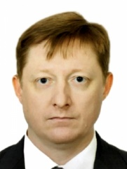Biography (150 word limit)
Professor Roman Meshcheryakov is a winner of the Russian Government Award in Education. Professor Meshcheryakov graduated from Altai State Technical University in 1997, majoring in Information Processing and Measurement Equipment and Technology. Professor Meshcheryakov has been working at TUSUR University since 2000. In 2001 he was promoted to senior lecturer, in 2002–2012 worked as the Associate Professor of the Department of Complex Information Security of Computer Systems. In 2001 he became the Deputy Director of the TUSUR Center of Security Technology and Head of its Laboratory of Security Systems, in 2008 he was appointed Deputy Director of the Institute of System Integration and Security. In January 2013 Professor Meshcheryakov became the Head of the Department of Information System Security at the TUSUR Faculty of Security. In 2011-2014 he was the Deputy Head of the Research Administration. Now He work at V. A. Trapeznikov Institute of Control Sciences of Russian Academy of Sciences – Head of Cyber-Physical Lab. Professor Meshcheryakov pursues research in processing, analysis and synthesis of speech and text, system analysis, information security, mathematical modeling. The research of Professor Meshcheryakov is published in over 400 papers/ Professor Meshcheryakov has been a member of the Russian Acoustic Society since 2002, he is a Senior Member IEEE – Member of Information Theory Society, and one of the founders of the Russian section of the IEEE Information Theory Society.
Email: mrv@ieee.org

Notes/Comments:

