Nanoantenna’s geometry comparison for high contrast dielectric optical metasurface design metric.
Hosna Sultana, University of Alabama, United States.

Abstract (300 word limit)
Using the benefit of flat optics dielectric metasurface as a wavefront shaping technique, various applications have emerged in recent years for holography, stoke imaging, machine vision, and multispectral imaging. Optical sensing technique such as LiDAR uses point cloud to visualize the 3D configuration of the object. Thanks to the 2D flat optics, which help the compact portable integration of photon collection optics. As light-matter interaction happens at the interface between two media, the structured surface known as the metasurface can tune the photon's intensity, phase, and momentum. The development of nanotechnology made it possible to design the nanoscale artificial structure precisely. So, controlling the light beam using the metasurface-based nanoantenna becomes reasonable technology to utilize as a sensing method. Spatially controlled projection of intensity based on the incidence polarization state of light is a benchmark of dielectric metasurface design in recent works of literature. This computational study explores the dielectric metasurface design metric with Finite Difference Time Domain simulation to optimize the layer combination and geometric shape to make a phase-based assembly of the nanoantenna and configure their mutual interaction of deflecting light path for the incident electric field orientation-controlled transmission metasurface at 532 nm working wavelength and also, the best choice of material for the optimized shape. For optimization of a rotationally symmetric and asymmetric element, which could have more control on the light intensity, this work will continue to implement different geometric features, which may improve the efficiency by combining different nanoantenna geometry.

Image
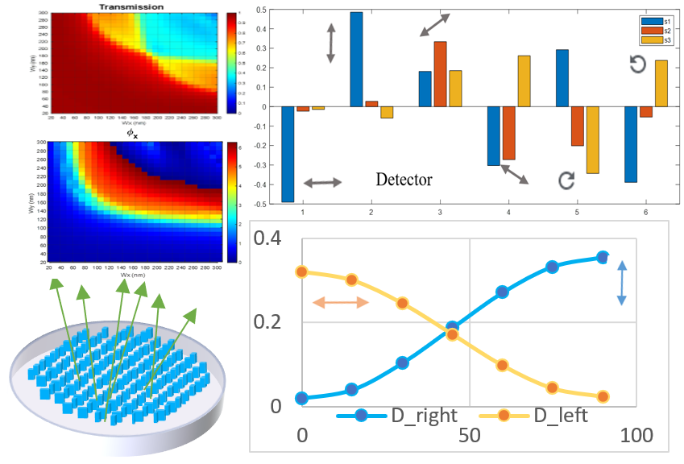
Recent Publications (minimum 5)
- Rubin N A, D’Aversa G., Chevalier P, Shi Z, Chen W T, Capasso F, (2019) Matrix Fourier Optics Enables a Compact Full-Stokes Polarization Camera. 10.1126/science.aax1839
- Ei S H W, Ang Z H Y, (2017) Design of Ultracompact Polarimeters Based on Dielectric Metasurfaces Opt. Lett. 42, 1580-1583.
- Arbabi A, Horie Y, Bagheri M, Faraon A, (2015) Dielectric Metasurfaces for Complete Control of Phase and Polarization with Subwavelength Spatial Resolution and High Transmission. https://doi.org/10.1038/nnano.2015.186.
- Spägele C, Tamagnone M, Kazakov D, Ossiander M, Piccardo M, Capasso F, (2021) Multifunctional wide-angle optics and lasing based on supercell metasurfaces. NatCommun, https://doi.org/10.1038/s41467-021-24071-2
- Jin Y, He, L, Wen Z, Mortazavi B, Guo H, Torrent D, Djafari-Rouhani B, Rabczuk T, Zhuang X, and Li Y (2022). Intelligent on-demand design of phononic metamaterials. Nanophotonics, https://doi.org/10.1515/nanoph-2021-0639

Photograph

Biography (150 word limit)
I am a doctoral student currently doing my research on optical metamaterial mainly of metasurface design for both plasmonic and dielectric material platforms. My work is related to simulation and algorithms. Before this, I worked on the first principle calculation for atomistic simulation. My experimental work involves NIR and green Lidar, thin-film and lithographic nanofabrication, sodium and lithium-ion battery electrode, and characterization of hard magnetic material.
.
Email: drXXXXXXX@xxxmail.com

Notes/Comments:

