Reconfigurable RF/Microwave Plasma Photonic Crystal and Antenna
Dr Rana Pratap Yadav, Assistant Professor, Thapar Institute of Engineering and Technology, Patiala, India
Gurkirandeep Kaur Kamboj, Ph.D, Thapar Institute of Engineering and Technology, Patiala, India

Abstract

Plasma based reconfigurable RF devices are always being a research interest because of its innovative range of applications and potential advantages over the conventional RF devices. It has unprecedented applications in the field of defense electronics and communication. The reconfigurable RF/Microwave Plasma Photonic Crystal (PPC) and antenna are devices similar like mantellic antenna, where plasma is used as a guiding medium for the propagation of EM waves. The characteristic of plasma based RF devices can be reconfigured by changing the plasma properties. Plasma is basically pre-ionized gas that contains equal numbers of positive and negative charged particles whose collective behavior is neutral. The physical properties of plasma like permittivity, permeability, conductivity etc. mainly depends on the plasma density which can be dynamically changed with the change of ionization potential and gas pressure. Therefore, characteristics of PPC and plasma antenna can be electronically controlled. In our experiments, we have developed a plasma column which has been used as a PPC and plasma antenna. Plasma sustained inside the column in two different states in which one state is full length plasma and another state is plasma striations called plasma blobs. These states can be achieved by having critical combination of power and gas pressure. The characteristics of PPC and plasma antenna depend on the numbers of blobs and plasma properties which has been tested by using RF coupling and verified for its reconfigurable behavior. The test results reveal the interesting behavior of the plasma antenna in its reconfigurability sense. A photograph of the experimental setup is shown in Fig. 1. The developed setup includes plasma and vacuum setup, RF signal source and automated radiation measurement system. Presentation includes the comprehensive discussion on the development of plasma antenna and PPC with the help of experimental setup.

Image
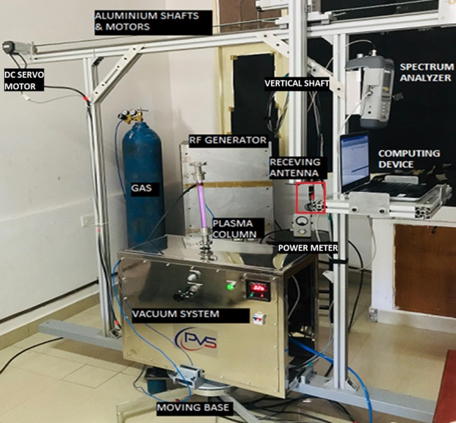
Figure 1: Experimental setup of reconfigurable plasma photonic crystal and antenna.
Reference:
- Gurkirandeep Kaur Kamboj; Rana Pratap Yadav; Abhinav Jain; Rajinder Singh Kaler; (2019). Design and Development of Capacitively Coupled Plasma Monopole Antenna, IEEE Canadian Conference of Electrical and Computer Engineering (CCECE), Edmonton, AB, Canada, 2019, pp. 1-4. doi: 10.1109/CCECE.2019.8861549
- Tanvi Mittal; Rana Pratap Yadav; Dhiraj Bora; (2017). Analysis of trapped oscillation modes in magnetized PPC and its tunability for variable plasma parameters: Optics Communications. 382. 7-12. 10.1016/j.optcom.2016.07.063.
- Tanvi Mittal; Rana Pratap Yadav; Abhinav Jain; (2016). Analysis of 1-D magnetized plasma photonic crystal band gap characteristic for variable plasma parameters. 4577-4581. 10.1109/PIERS.2016.7735691.
- Gurkirandeep Kaur Kamboj; Rana Pratap Yadav (2016). Study of the radiation characteristic of plasma antenna using 2-D FDTD method. 847-851. 10.1109/PIERS.2016.7734500.
- Abhinav Jain; Rana Pratap Yadav; Sunil Kumar (2018). Design and Development of high power matching network for variable load. 1-4. 10.1109/IMaRC.2018.8877143.

Photograph

 Biography
The lab group of Dr. R. P. Yadav has been exhaustively working in the areas of microwave device development over past 6-years. He has received his Ph.D degree from Institute for Plasma Research (IPR), Gandhinagar Gujrat-382428, India. During his PhD tenure, he has been associated with developing 1.5 MW, continuous wave (CW), for RF heating in fusion reactor. In recent, he has worked as a post-doctoral researcher at University of Oxford, UK under the prestigious accolade i.e. Prince of Wales foundation fellowship. Dr. Yadav has successfully developed a multi-static harmonics RADAR system for tracking of pollinators, which is an interest of high power RF/microwave engineering. He has established a sponsored research Lab for the high power RF testing at TIET, Patiala India.
Email: rpyadav@thapar.edu

