Polaritonic nonideal supercrystals formed by 1D and 2D arrays of microcavities containing ensembles of quantum dots
Dr Vladimir V. Rumyantsev, A.A. Galkin Donetsk Institute for Physics and Engineering, Ukraine

Designing and utilization of novel materials for manufacturing of the sources of coherent irradiation is currently a vast interdisciplinary area, which spans various theoretical and fundamental aspects of laser physics, condensed matter physics, nanotechnology, chemistry as well information science. Physical realization of corresponding devices requires the ability to manipulate the group velocity of propagation of electromagnetic pulses, which is accomplished by the use of the so-called polaritonic crystals. The latter represent a particular type of photonic crystals featured by a strong coupling between quantum excitations in a medium (excitons) and optical fields [1-3].
We considered 1D and 2D polaritonic crystals as a topologically ordered systems – arrays of coupled microcavities containing quantum dots. It is of substantial interest to investigate electromagnetic excitations in a non-ideal one-dimensional microcavity lattice subjected to a uniform elastic stress [4,5]. The one-sublattice array of identical cavities contains randomly embedded quantum dots of two types. Moreover, these microcavity-resonators are also randomly removed at distances between the nearest neighbors. In order to calculate polaritonic spectrum of such a system we shall adopt the virtual crystal approximation, which is based on diagonalization of the averaged Hamiltonian. The peculiarities of polariton spectrum in the 1D and 2D lattices of microcavities caused by the presence of the structure defects and uniform elastic deformation (described by tensor ) of the micropores array with quantum dots are studied. In this case, the random location of pores containing quantum dots is determined by concentrations 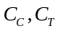in composition and position respectively,. The presence of deformation and of structural defects may lead to an increase of the effective mass of corresponding excitations and therefore to a decrease of their group velocity. The results of numerical calculation performed on the basis of the constructed model contribute to modeling of the new class of functional materials – photonic crystalline system constituted of couple microcavities..
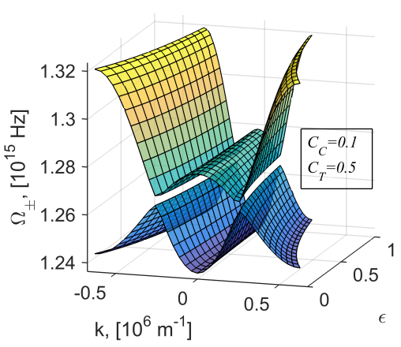
Figure 1. Dispersion dependencies 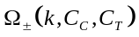 of polaritonic excitations in a one-sublattice quantum-dot-containing chain of unevenly spaced microcavities plotted for different values of concentrations
.
- Lodahl P., Mahmoodian S. and Stobbe S. (2015) Rev. Mod. Phys. 87: 347.
- Tighineanu P, Sørensen A. S., Stobbe S. and Lodahl P. (2017) The Mesoscopic Nature of Quantum Dots in Photon Emission, in: P. Michler (Ed.), Quantum Dots for Quantum Information Technologies. Nano-Optics and Nanophotonics, Springer: Cham, 165–198.
- Joannopoulos J.D., Johnso S.G., Winn J.N., Meade R.D. (2008) Photonic Crystals. Molding the Flow of Light / Second Edition. Princeton: Princeton University Press.
- Rumyantsev V.V., Fedorov S.A., Gumennyk K.V., Gurov D.A,, Kavokin A.V. (2018) Effects of elastic strain and structural defects on slow light modes in a one-dimensional array of microcavities. Superlattices and Microstructures. 120: 642-649.
- Rumyantsev V.V., Fedorov S.A., Gumennyk K.V., Paladyan Yu.A. (2019) Electromagnetic excitations in a non-ideal two-sublattice microcavity chain. Physica B 571: 296-300.

Biography
Prof. Vladimir V. Rumyantsev is Head of Department of Theory of Complex Systems Dynamic Properties at A.A. Galkin Donetsk Institute for Physics and Engineering (DonIPE). He is Professor of Theoretical Physics and Nanotechnology Department at Donetsk National University (DonNU). He received PhD in Theoretical Physics (1988) from DonNU and Dr. Sci. in Condensed Matter Physics (2007) from DonIPE. Prof. Rumyantsev has authored/co-authored 4 books, 2 chapters in books and more than 270 scientific publications. He is a member of the American Physical Society as well as Mediterranean Institute of Fundamental Physics (MIFP, Italy) and Editor-in-Chief of Journal of Photonic Materials and Technology (Science PG, USA).
Email: 380957931135@yandex.ru

Notes/Comments:

