Preparation of Cs_{0.2}WO_{2.7}/polypyrrole nanocomposite and investigation of its UV-Visible and near infrared shielding effect

Prof. Seyed Hossein Hosseini, Nika Pooyesh, Strategic Sciences Research Institute, NBP Economic Group, Tehran-Iran
Ali Azimi, Department of Chemistry, Faculty of Science, East Tehran Branch, Islamic Azad University, Tehran, Iran
Dr. Sama Sadat Hosseini, Faculty of Veterinary Medicine, Science and Research Branch, Islamic Azad University, Tehran-Iran

Abstract

Hexagonal tungstate oxide nanoparticle (NPs) has received much attention because of its tunnel structure [1]. Alkali-doped tungsten bronze, MxWO₃ is composed of the arrays of octahedral unit WO₆ interconnected with their corners as is the case with tungsten trioxide ionic and electronic conductivities, which property has prompted studies seeking possible applications to sensors and superconductivity in Na_{x}WO₃ [2] and Cs_{x}WO₃ [3]. The tungsten bronzers (M_{x}WO₃) with diﬀerent ions were synthesised and their electrochromic, near-infrared (NIR), nanostructure electricaloptical properties and photothermal oblation cancer trapped were studied, too [4]. We have synthesised new compounds showed that suitable nanocomposites as multi absorption in both TIR and MW [5,6]. In this work, The Cs_{x}WO₃/PPy nanocomposites are prepared by solvothermal and interfacial polymerisation. The research results were studied for both UV-Vis (200–800 nm) and NIR (780–2400 nm) absorptions. Cs_{x}WO₃ nanoparticles were successfully synthesised via solvothermal and its nanocomposites with polypyrrole and diﬀerent thicknesses were prepared via interfacial polymerisation. The UV-Visible and near-infrared (UV-Vis-NIR) of Cs_{x}WO₃ products were studied. The Cs_{x}WO₃ and its nanocomposites characterised by X-ray diﬀraction (XRD), scanning electron microscopy (SEM), energy dispersive X-ray spectrometer (EDX) and FTIR. The results indicated that the NIR absorption property of Cs_{0.3}WO_{2.7} is better than CsWO₃ and increased by increasing thicknesses. The microwave absorbing properties of nanocomposites with the coating thickness of 1 mm investigated by using vector network analyzers in the frequency range of 8-18 GHz, that this range is contained X and Ku bands. The results for PANI, [(WO₃)_{0.5}-PAA]-PANI_{0.5}, [(Cs_{0.3}WO_{2.7})_{0.5}-PAA]-PANI_{0.5}, [(WO₃/Cs_{0.3}WO_{2.7})_{0.5}-PAA]-PANI_{0.5}, and [(WO₃/Cs_{0.3}WO_{2.7})_{0.25}-PAA-(Cu/CI)_{0.25} –PAA-(CNFs)_{0.2}-PAA]-PANI_{0.3} (as final nanocomposite) are shown in Figure 1 and Figure 2 shows the NIR reflection spectra (900-2500 nm) of WO₃, Cs_{0.3}WO_{2.7}, Cu, CI and CNFs with 1mm thickness.

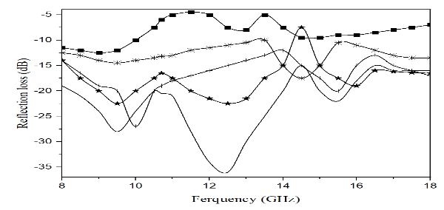

Figure 1. Microwave absorbing results for [(Cu)_{0.5}-PAA]-PANI_{0.5,} CI_{0.5}-PANI_{0.5}, [(CNFs)_{0.5}-PAA]-PANI_{0.5,} [(Cu/CI)_{0.5}-PAA]-PANI_{0.5} and [(WO₃/Cs_{0.3}WO_{2.7})_{0.25}-PAA-(Cu/CI)_{0.25} –PAA-(CNFs)_{0.2}-PAA]-PANI_{0.3} with 1mm thickness.

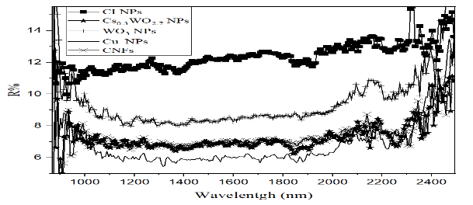
Figure 2. NIR spectra analysis of WO₃, Cs_{0.3}WO_{2.7}, Cu, CI and CNFs with 1mm thickness.

References:
- Xingliang L., Wanjun M., Xiang X., Bijun L. Shunzhong L (2014) Strontium adsorption on tantalum-doped hexagonal tungsten oxide, J. Hazardous Materials, 264:386-396.
- Hariharan V., Gnanavel B., Aroulmoji V (2018) Simultaneous structural and optical control of tungsten oxide (WO₃) nanoparticles through cobalt doping for super conducting applications, Int J Adv Sci Eng, 698:698–706.
- Xingyu X., Weilong Z., Yan H (2017) Preparation and overall energy performance assessment of wide waveband two-component transparent NIR shielding coatings, Sol Energy Mater Sol Cells, 168:119–129.
- Hosseini SH, Azimi A, Dolabi MB (2020) Study of UV-Visible and near infrared absorption CsXWO₃/polypyrrole nanocomposite, Materials Research Innovations 24:335-340.
- Dolabi MB., Azimi A, Hosseini SH (2020) Preparation of thermal infrared and microwave absorber using WO₃/MnFe₃O₄/polyaniline nanocomposites, Materials Research Innovations 24:326-334.
- Hosseini SH, Zamani P (2016) Preration of thermal infrared and microwave absorber using SrTiO₃/BaFe₁₂O₁₉/Polyaniline nanocomposites, J. Magn. Mat. 397:205-212.


Seyed Hossein Hosseini is Professor of Organic Chemistry and Polymer Science. His research interests cover toxic gas sensors, conducting polymers (synthesis and applications), polymer nanocomposites with magnetic and electrical materials, conductive liquid crystalline polymers, electromagnetic absorbing materials for industry, military and medicine applications. He has received numerous awards and he has more than 100 research publications in reputed international journals. His new main researches is focus on industrial researches such as cold cracking on extra heavy oil, lubricants and modified resins.
dr.shhosseini@gmail.com

