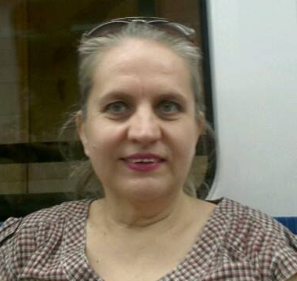
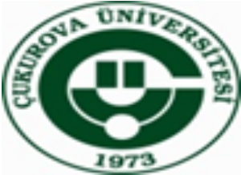

In children aged 9-11, examining the health and medical staff perception with the method of projective illustration

Emine Ercin Senay Cetinkaya

Cukurova University Faculty of Health Sciences, Adana, TURKEY

Picture is an important tool and an effective way on the development of children's spiritual, physical and at the same time personality. Drawing pictures in childhood is an important communication process for children's self-knowledge and introducing themselves. Projective narrative images: the lines that they draw, the colours that they use give us message about children’s mood, angry, aggressive, happy, sad, etc. Thus, the world that is created by children can be understood easily through picture. For the research, 30 children who have chronic diseases in the Family Medicine Unit and 30 healhty children in a primary school will be selected by random with sampling method. Firstly, a survey will be applied to the child and his/her mother about their socio-demographic characteristics. Then, it will be said that drawing pictures throughout 30 minutes about health-nurse-doctor by giving them 12 color crayons and drawing paper. Questions will be asked to the children about the pictures they draw.
The health workers, communication tools, teachers and parents have great responsibility for the formation of concepts related to health in children. Health education formed for this purpose can be a good option. We need qualitative research for a better understanding of children's perceptions of nurses and doctors and ensuring that the behavioral changes in the right direction.
Key words: Healthy and sick children, health conscious, health-nurse-doctor perception, projective drawing method

Biography
Senay Cetinkaya, has completed her bachelor of nursing, master's degree, and PhD in Ege University. In 1988 she was employed as nurse in ICU at the cardiovascular surgery clinic in Ege University. In the mean time she has completed her postgraduate and PhD (1999) on pediatric nursing. Currently she is working at the Faculty of Health Sciences at Cukurova University as associate proffessor. She has international articles (10), international books chapters (6), translation on a vocational book (thesaurus of skills), national chapters of book (2), has led postgraduate thesis (13), research profects (4), and posted many scientific papers (30) in periodicals.

