

Title:
Volumetric overload shocks in the patho-etiology of the transurethral resection prostatectomy syndrome and acute dilution hyponatraemia.

Authors:
Salma A. Ghanem¹, Nisha Pindoria² from London, UK. Khalid A. Ghanem³, Ahmed N. Ghanem^{4*} from Mansoura, Egypt.
1. Salma Ghanem
Barts & The Royal London NHS Trust
Royal London Hospital
Whitechapel road, Whitechapel
London E1 1BB
Email: salma.ghanem@outlook.com
Mobile: +44 7404911573
2. Nisha Pindoria
North Middlesex University Hospital
Sterling Way
London
N18 1QX
Email: nishapindoria@hotmail.com
Mobile: +44 7958 009310
3. Khalid A. Ghanem
Mansoura University Hospital, Mansoura 35511, Egypt
khaledghanem899@hotmail.com
Mobile: +201067787333
4. Presenting Author
Ahmed N. Ghanem, MD, FRCS
Retired Consultant Urologist
No1 President Mubarak Street, Mansoura 35511, Egypt.
an_ganem@hotmail.com
Mobile: 00201020883243

Abstract
The transurethral prostatectomy syndrome (TURS) is defined as severe vascular hypotension reaction that complicates endoscopic surgery as a result of massive irrigating fluid absorption causing severe acute dilution hyponatraemia (HN) of <120 mmol/l. The vascular shock is usually mistaken for one of the recognized shocks and Volumetric Overload Shock type 1 (VOS1) is overlooked making Volumetric Overload Shock Type 2 (VOS2) unrecognizable. In adults VOS1 is induced by the infusion of 3.5-5 litres of sodium-free fluids and is known as TURS or HN shock. VOS2 is induced by 12-14 litres of sodium-based fluids and is known as the adult respiratory distress syndrome. The most effective treatment for VOS1 and VOS2 is hypertonic sodium of 5%NaCl or 8.4% Sodium Bicarbonate. The literature on TURS is reviewed and the underlying patho-etiology is discussed. As Starling’s law for the capillary-interstitial fluid transfer, which underlies the principles of fluid therapy, proved wrong an alternative mechanism was found by studying the hydrodynamics of the porous orifice (G) tube akin to capillary. Incorporating the G tube in a chamber (C), representing the interstitial space surrounding a capillary, demonstrated a rapid dynamic magnetic field-like fluid circulation between the C and G tube lumen. The G-C phenomenon is autonomous having both filtration and absorption forces making a true replacement for Starling’s law in every tissue and organ of the body.
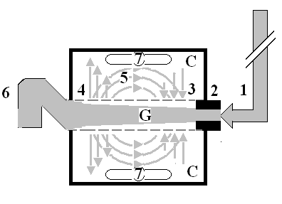
Figure: shows Diagram of the porous orifice (G) tube enclosed in chamber (C) based on several photographs demonstrating the magnetic field-like G-C circulation phenomenon induced by the negative pressure gradient on the G tube wall and affected a net negative pressure in C.
Biography
Dr Ahmed Nasr Ghanem was qualified from Mansoura University, Egypt 1974. Passed is FRCS in 1983 and obtained his MD degree from Mansoura University in 1988. He worked as Consultant Urologist Surgeon in Egypt, Saudi Arabia and United Kingdom. He has over 30 articles published in peer reviewed Journals. Now he is happily retired in Egypt.
Presenting author Ahmed N. Ghanem, MD, FRCS
Retired Consultant Urologist
No1 President Mubarak Street, Mansoura 35511, Egypt.
an_ganem@hotmail.com
Mobile: 00201020883243
Session name/ number: Category: (Oral presentation)
Title: Volumetric overload shocks in the patho-etiology of the transurethral resection prostatectomy syndrome and acute dilution hyponatraemia.

