Management of Maxillary Midline Diastema following Post- orthodontic Treatment
Abu-Hussein Muhamad
DDS, MSc D, MSc, M Dent Sci (Paed Dent )
Athens,Greece

Abstract

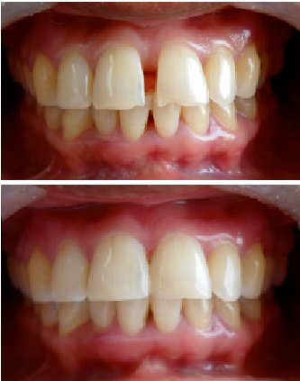
Maxillary midline diastema is a common esthetic complaint of patients. It can be one of the most negative factors in highly self conscious patients. Midline diastema can be defined as a space greater than 0.5 mm between the proximal surfaces of the two central incisors. These can be either corrected orthodontically or can be prosthetically restored. Treatment is mainly for esthetic and psychological reasons, rather than functional ones. The restoration of anterior teeth with diastema usually presents an aesthetic and functional challenge after the patient has undergone the pains of orthodontic treatment relapse. Such defects were usually treated by composite veneers, porcelain veneers or full crown coverage. Many a times teeth that could have been saved with the use of a conservative laminate veneer are destroyed by full crown reduction. When properly executed, porcelain veneers for cosmetic dentistry are the best option.

Photograph

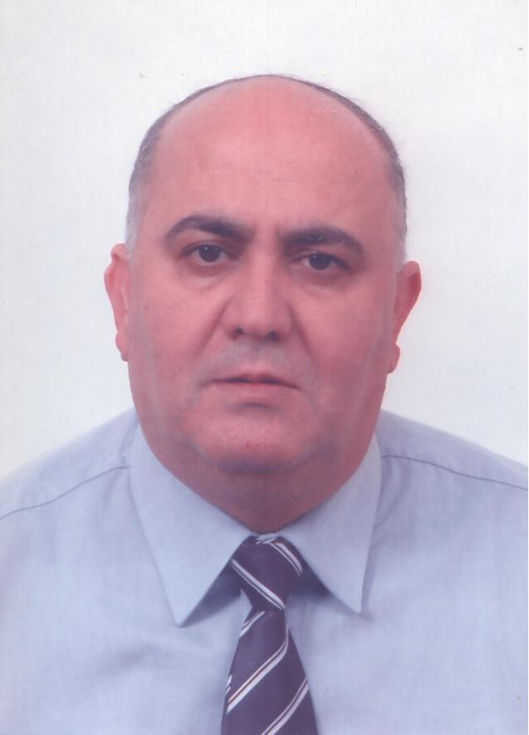 Biography

DR. ABU-HUSSEIN MUHAMAD
Limited to Pediatric Dentistry
DDS,MSc,MScD,Cert.Ped.
Athens-Greece

-DDS 1986 ,DPD(Drodont)Dentistry for Children1988
-International Short-Term Programme in Orthodontics1994,6WEEKS Aarhus,Denmark
-Postgraduate taught course (two-years) in Oral Biology/Pathology, Dental Faculty, University of Athens 1998

-Master of Biostatistics,School Mathematics/Medicine,Athens2001
Postgraduate Bioesthetic Dentistry. OBI,International Faculty
-Diploma. Roth/Williams Center for Functional Occlusion
-Short course: Molecular Epidemiology of Chronic Disease and the Exposome,30 Sep, 2001 to 04 Oct, 2001, Utrecht University
-2003- 2005 : New York University College of Dentistry Implants "Aesthetics and Occlusion Oral Rehabilitation in Current Concepts in American Dentistry in continuing Dental Education Program"Athens,Greece
-Certificate of Attendance the course on: “Orthodontic treatment with the magic lingual system – theoretical basis and clinical practice”,Prof.Ol.Sorel,Ispringen,
Dentaurum,Germany,June 30th-10July 1st,2007
-OVER 3000 HOURS WITHIN THE LAST 10 YEARS, RELATED TO ENDODONTICS,PROSTHODONTIC,PERIODONTOLOGY, DENTAL IMPLANT, IMPLANT BIOMECHANICS, OCCLUSION AND COSMETIC DENTISTRY.
-400publications as author or co-author in peer-reviewed journals/bookchapters
-250 lectures and CE courses(Cleft lip/palate,Pediatric Dentistry) in many countries .
Email ;abuhusseinmuhamad@gmail.com

Notes/Comments:

