Presenting author’s details:
Email address: cindy.yeoh@moffitt.org
Postal address: Department of Anesthesiology, Moffitt Cancer Center, 12902 USF Magnolia Drive, Tampa FL 33612
Daytime phone number: 917-207-2559
E-poster presentation

Authors: Cindy B. Yeoh, MD¹, Michelle Epps², MD, Wendy Yang, MPH³, Kathleen J. Lee, MD⁴

Affiliation details: 1. Department of Anesthesiology, Moffitt Cancer Center, Tampa FL, USA 2. Department of Anesthesiology, University at Buffalo, Buffalo NY, USA 3. Morsani College of Medicine, University of South Florida, Tampa FL, USA 4. Department of Anesthesiology, Roswell Park Comprehensive Cancer Center, Buffalo NY, USA.

Title: Temporary tracheal stenting as an extubation strategy in a patient with large anterior mediastinal mass

Anesthetic management of patients with large anterior mediastinal masses (AMM) aims at preventing complications associated with airway compression. Even carefully managed AMM can lead to morbidity and death. Existing literature is replete with strategies for preoperative planning and induction of these patients. However, less attention is given to extubation strategies; specifically in instances where a patient has undergone general anesthesia for a procedure other than complete AMM resection.

As Interventional Pulmonology and Radiology techniques expand, more procedures are done outside the operating room. Patients with AMM are presenting in these non-operating room settings, requiring general anesthesia and extubation post-procedure with compressive mediastinal tumors still in place; thereby posing a threat of airway compression upon extubation. We report the use of a temporary tracheal stent as a strategy to improve extubation success and provide symptomatic relief in a patient with a large AMM.

A 72-year-old woman with recently diagnosed lymphoma and an 8x7x6cm AMM with mid-trachea and superior vena cava compression presented for definitive tissue biopsy. She presented with a choking sensation and cyanosis with minimal reclining position. Awake fiberoptic intubation was performed, and a reinforced endotracheal tube was placed beyond the tracheal compression. Positive pressure ventilation and paralysis were gradually initiated without incidence. The patient remained hemodynamically stable throughout.

The surgical procedure was completed in the supine position albeit with worsening neck and facial edema. Due to concerns for safe extubation, decision for tracheal stent placement was made to relieve compression. A 18x40 mm endo-tracheal stent was placed, and the patient was extubated in the recumbent position while maintaining spontaneous ventilation. She was monitored overnight and discharged home the next day without complications. The biopsy demonstrated diffuse large B-cell lymphoma. Chemotherapy was initiated with good response and the tracheal stent was removed one month later after significant improvement in symptomatology.

References:

Blank, Randal S., and Duncan G. de Souza. "Anesthetic management of patients with an anterior mediastinal mass: continuing professional development." Canadian Journal of Anesthesia/Journal canadien d'anesthésie 58.9 (2011): 853-867.

Erdös, Gabor, and Irene Tzanova. "Perioperative anaesthetic management of mediastinal mass in adults." European Journal of Anaesthesiology| EJA 26.8 (2009): 627-632.

Matsumoto, Ryoichi, Mitsuoka, Masahiro, Hashiguchi, Toshihiro, et al. “Temporary airway stenting for giant anterior mediastinal tumor biopsy: Two case reports.” International Journal of Surgery Case Reports 64 (2019):157-160.

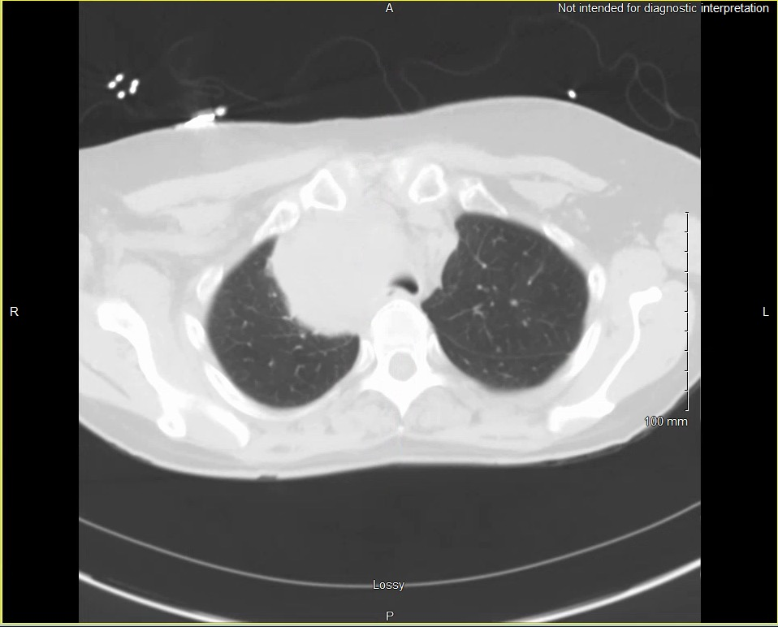

Fig.1 CT chest (axial view) demonstrating mass effect on right anterior aspect of trachea

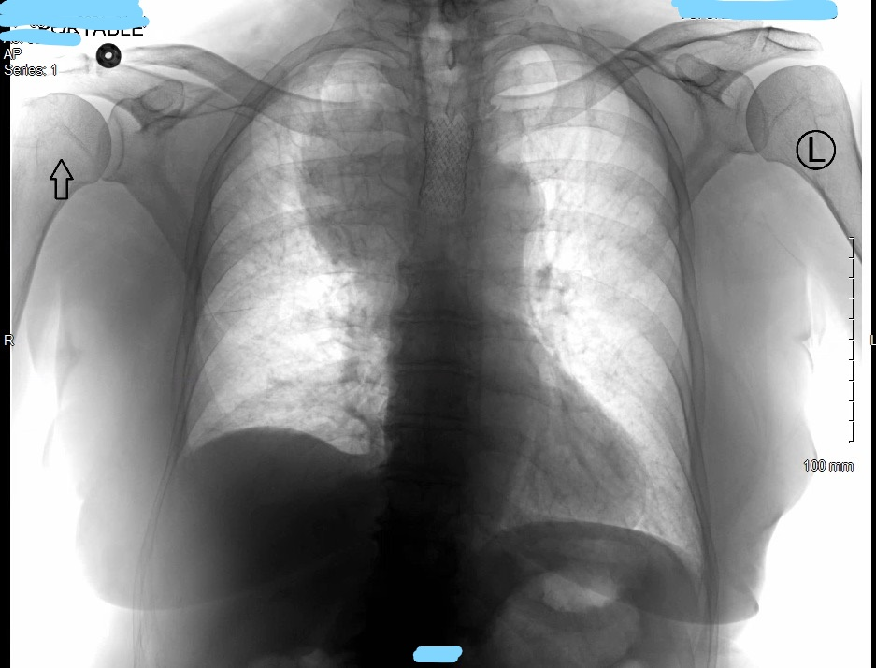

Fig.2 CXR with stent in place post-extubation

