Yes-Associated Protein (YAP) is a target for invasive breast carcinoma
Mohamed Ahmed Eladl¹, Jibran Sualeh Muhammad¹, Maha Guimei²
¹Basic Medical Sciences, College of Medicine, University of Sharjah, Sharjah, United Arab Emirates
²Department of Pathology- University of Alexandria, Egypt

Abstract (300 word limit)
Yes-associated protein (YAP) is an oncoprotein encoded by YAP1 gene. Hippo pathway activation results in sequestration of YAP in the cytoplasm and degradation. Whereas, when the Hippo pathway is deactivated, YAP is translocated into the nucleus and promotes transcription of downstream genes stimulating growth and inhibiting apoptosis. Numerous studies showed that overexpression of YAP induces epithelial-mesenchymal transition, inhibits apoptosis and increases cancer stem cells number in-vitro. Levels of YAP were found to be elevated in many human cancers and related to poorly differentiated tumors. Therefore, YAP has emerged as a prime target for developing anti-cancer drugs. This study aims to investigate the immunohistochemical expression of YAP in breast cancer tissue compared to benign tumors and normal breast tissue. The nuclear expression of YAP was evaluated in six cases of benign fibroadenomas, 6 cases of in-situ ductal carcinomas, 6 cases of normal breast tissue samples as well as 60 cases of invasive breast carcinoma, 57 ductal (IDC) and 3 lobular (ILC). Staining was analyzed and blindly scored. Nuclear staining of more than 20% of the nuclei was considered positive. Cytoplasmic staining was scored according to its intensity as (+1 mild, +2 moderate, +3 strong). The results were then correlated with grade, stage and hormone receptor positivity in each of those tissues. All cases of normal, benign and in-situ carcinomas depicted no nuclear YAP expression. YAP expression in these cases was mostly cytoplasmic and varied in expression between mild, moderate or strong. On the other hand, 60% of invasive breast carcinomas cases showed positive nuclear staining suggesting that YAP is active in these tumors and could have possible carcinogenic role. Our data showed that YAP is highly active in breast adenocarcinoma and suggest that further studies are required to investigate the exact pathway responsible for YAP activation and its involvement in carcinogenesis.
Image
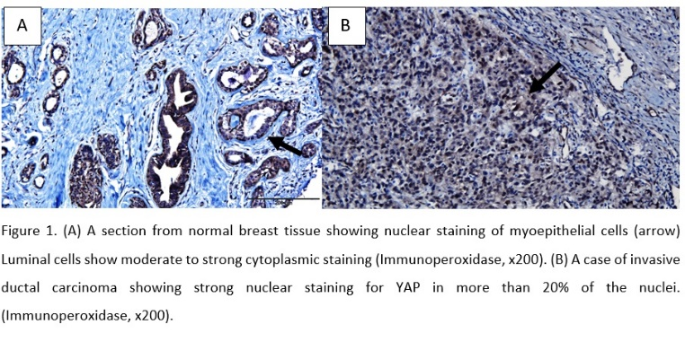
Recent Publications (minimum 5)
- Abdalla, M. E., & Eladl, M. A. (2019). Student perception of the effect of problem familiarity on group discussion quality in a problem-based learning environment. GMS journal for medical education, 36(3).
- Muhammad, J. S., Eladl, M. A., & Khoder, G. (2019). Helicobacter pylori-induced DNA Methylation as an Epigenetic Modulator of Gastric Cancer: Recent Outcomes and Future Direction. Pathogens, 8(1), 23.
- Guimei, M., Eladl, M. A., Ranade, A. V., & Manzoor, S. (2019). Autophagy related markers (Beclin-1 and ATG4B) are strongly expressed in Wilms' tumor and correlate with favorable histology. Histology and histopathology, 34(1), 47-56.
- Eladl, M. A., Abdalla, M. E., & Ranade, A. (2018). A mixed method study to validate a two-way feedback between student and faculty to improve learning of anatomy. Anatomy & cell biology, 51(2), 98-104.
- Mohamed, I. N., Sarhan, N. R., Eladl, M. A., El-Remessy, A. B., & El-Sherbiny, M. (2018). Deletion of Thioredoxin-interacting protein ameliorates high fat diet-induced non-alcoholic steatohepatitis through modulation of Toll-like receptor 2-NLRP3-inflammasome axis: Histological and immunohistochemical study. Acta histochemica, 120(3), 242-254.
- Elsaed, W. M., Bedeer, R. F., & Eladl, M. A. (2018). Ameliorative effect of vitamin B12 on seminiferous epithelium of cimetidine-treated rats: a histopathological, immunohistochemical and ultrastructural study. Anatomy & cell biology, 51(1), 52-61.

Biography

Dr. Mohamed Eladl is a medical graduate holding M.Sc. and Ph.D. degrees in Human Anatomy and Embryology. He has extensive experience in human anatomy education at graduate and post-graduate levels in the Middle East and USA. His main research interests are medical education besides basic biomedical research focusing on exploring complex human diseases on the cellular level in addition to investigating the biological differences between normal cells and pathological cells including cancer cells targeting applicable therapeutic approaches.
Email: meladl@sharjah.ac.ae

Notes/Comments:

