The role of an Anatomical Pathology Technologist- Behind the scenes of an NHS Hospital Mortuary
Robert William Cast BSc (Hons) MRSB MAAPT

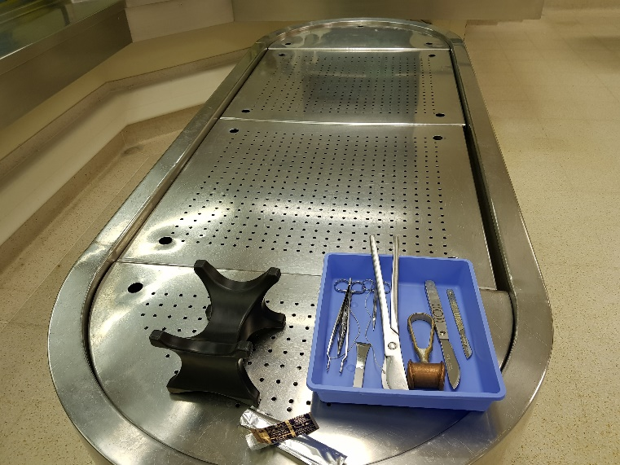

“The postmortem examination”, the words would make most people cringe and recall thoughts of their favorite crime drama or CSI TV Show with fancy suits and blood splattered across every wall and floors.
However, for those who work or have ever witnessed a postmortem examination, they can attest that this is far from the truth….well on most days. In the UK, the role of evisceration (removal of organs) and reconstruction of deceased left in the capable hands of APT’s, skilled technicians who assist pathologists with the procedure.
Their role in the mortuary usually goes unnoticed and underappreciated but from post mortem assistance to the daily task of looking after each and every deceased in our care, our role demands care, dignity, respect and, at times…a little light humor and a cup of tea.
Our role spans far beyond the post mortem suite and today I am happy to be able to speak and educate others about the working life of an APT and answer any and all questions. I am always happy to help and no question is too difficult or gory!

- “The effects 27-hydroxycholestrol on intracellular calcium concentration in MDAMB-231 breast cancer cells”
- “Fas pathway as a critical mediator of cardiac myocyte death and MI during ischemia reperfusion in vivo”


Biography
After spending the past three years working as a trainee at King’s College Hospital NHS Trust in South East London, Robert has recently qualified as an Anatomical Pathology Technologist (APT). He graduated from University College Cork, Ireland with a BSc. Hons in Physiology. Robert’s career aspirations including completing his senior APT training as well to continue his anatomical training at both MSc and PHD level. Alongside the Association for Anatomical Pathologist’s UK, Robert hopes to educate other healthcare professionals about the little known role of APT’s and assist with their professional recognition.
Email: Robert.Cast@nhs.net

Notes/Comments:

