Human gametes: activation, attraction and transport: a review and a new concept

Mostafa Kandil Mohamed Soliman, MD/PHD,
Human Anatomy and Embryology
College of Medicine, KFMC, KSA

Abstract

Human gametes (oocytes and spermatozoa) have to be activated after quiescence before puberty. Oocytes acquire the ability to fuse with sperm when they reach 20 µm in diameter and they are arrested at the prophase of meiosis II. Only spermatozoa that have passed through the epididymis are mature enough to be capable of motility. In humans, the mature oocyte contains the supporting elements capable of sustaining the development of the embryo, while a primary contribution of the spermatozoon is to provide the centrosome. Movements of the oocyte after release from mature Graffian follicle and catchment by fimbriae of infundibulum helped by tubal fluid, beating cilia and muscular contractility of uterine tube. Gamete activation is also defined as sperm capacitation and oocyte preparation procedures carried out to aid fertilization. The current hypothesis of mammalian gamete binding postulates a set of proteins. The sperm-specific protein, Izumo, is essential for sperm-egg plasma membrane binding and fusion. On the oocyte side, juno recognizes the sperm Izumo, facilitating fertilization and acts as polyspermy block. fertilization is far from random. Theories put for mechanisms of attraction ,Thermal, hormonal, sonic, and olfactory. Sperms are attracted toward eggs of their species only. Oocytes control not only the type of sperm they attract, but also the time at which they attract them. We propose a new concept of electromagnetic field (EMF) attraction based on the fact that every living cell is an electromagnetic unit. Oscillations of meiotic spindle may generate EMF waves transmitted to and received by sperms

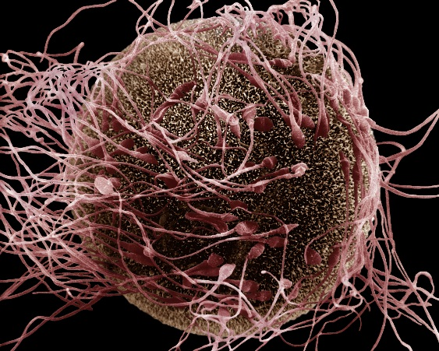

A scanning electron micrograph shows the moment of fertilization involving a human egg and spermatozoa. Historically, the egg has often been portrayed as passive while the sperm jockey in competition, but new findings suggest that the egg may screen out sperm with unsuitable genes.
D. Phillips/Science Photo Library

Recent Publications
- Ai J‐S, Li M, Schatten H, Sun Q‐Y. (2009). Regulatory mechanism of spindle movements during oocyte meiotic division. Asian Aust J Anim Sci 22: 1447–1486.
- Tosti E, Ménézo Y. (2016). Gamete activation: basic knowledge and clinical applications. Human Reproduction Update 22 420–439. (10.1093/humupd/dmw014)
- G D Palermo, C L O’Neill, S Chow, S Cheung, A Parrella, N Pereira, Z Rosenwaks (2017) Intracytoplasmic sperm injection: state of the art in humans. Reproduction. Dec; 154(6): F93–F110. Published online 2017 Dec 5. doi: 10.1530/REP-17-0374.PMCID: PMC5719728.
- Georgadaki K, Khoury N, Spandidos DA, Zoumpourlis V. (2016) The molecular basis of fertilization (Review). International Journal of Molecular Medicine.;38(4):979-986. doi:10.3892/ijmm.2016.2723.
- Ezzati M, Djahanbakhch O, Arian S, Carr BR. (2014) Tubal transport of gametes and embryos: a review of physiology and pathophysiology. J Assist Repro’d Genet; 31:1337–1347

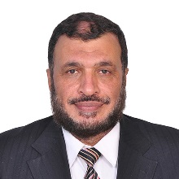

Prof. Mostafa Kandil has his expertise in Human Gross Anatomy &Embryology research and teaching for medical students. He is interested in studying the ultrastructure of vital organ tissues exposed to biochemical and biophysical hazards namely electromagnetic fields.

Email: msoliman@kfmc.med.sa

Notes/Comments:

