Protective Effect of Garden Cress Seed Extract on Histopathological Changes of the Ventral Prostate in Diabetic Rats
Mehran Kamani¹, Mozafar Khazaei²
1. mehrankamany@yahoo.com 2. mkhazaei1345@yahoo.com
1,2. Fertility and Infertility Research Center, Kermanshah University of Medical Sciences, Kermanshah, Iran.

Abstract

Statement of the Problem: Diabetes mellitus is a common serious metabolic illness occurring worldwide that may lead to male infertility. Various plants have been used in the treatment of diabetes. The aim of this study was to assess protective effect of Garden Cress seeds extract on histopathological changes of the ventral prostate in diabetic rats. Methodology & Theoretical Orientation: Fifty male adult Wistar rats (280-320 g) were randomly selected into five groups. Group 1: control group which received only 0.1 ml normal saline via gastric gavages. Rats in other group (2-5) received an intraperitoneal injection of STZ (60 mg/kg) and those with FBS >250 mg/dl were considered diabetic. Group 2 didn’t received anything, group 3: diabetic rats received insulin (3U/100 g body weight) while in Groups 4 and 5 diabetic rats received of 200 and 400 mg/kg respectively of Lepidium sativum seeds extract by gavage daily (4 weeks). The prostate was removed and weighed and transfer to Bouin᾿s solution for histological studies. Conclusion & Significance: Administration of the 200 and 400 mg/kg doses of Lepidium sativum seed extract increased epithelium height and decreased interstitial volume density and fibromuscular thickness of the prostate meaningly (p=0.05). Also, the volume density of the epithelium, fibro muscular, lumen, and interstitial tissues were changed significantly (p=0.05). Lepidium sativum seed extract has protective effects against the harmful effects of diabetes on the prostate gland of diabetic male rats.

Image
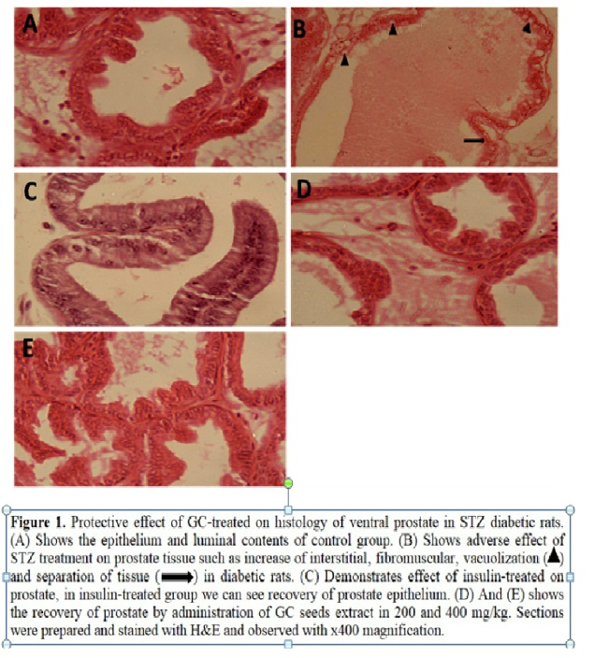
Recent Publications
1. Kamani, M., et al., Protective Effect of Lepidium sativum Seed Extract on Histopathology and Morphology of Epididymis in Diabetic Rat Model. International Journal of Morphology, 2017. 35(2).
2. Kamani, M., et al., Protective Effect of Alcoholic Extract of Garden Cress Seeds on the Histopathological Changes of the Ventral Prostate in Streptozotocin Diabetic Rats. International Journal of Morphology, 2017. 35(3).

Photograph
 mehrankamany@yahoo.com
Biography
Dr Mehran has her expertise in evaluation and passion in improving the treatment of diabetic animals. His open and contextual evaluation Diabetic Models. His surveys creates new phatways for treatment of diabetic disease.

