The Comparison of Different Gel Composition and Staining Agents for gel electrophoresis of Fluorescent Protein

Elif Tugce AKSUN TUMERKAN, PhD, University of Exeter, UK.

Abstract (300 word limit)

Fluorescent proteins are unique in that they are self-sufficient in forming chromophores with a visible wavelength from 3 amino acids sequence within their own polypeptide structure. The development of fluorescent proteins (FPs) and their applications is an outstanding example of basic science leading to practical biotechnological and medical applications. Fluorescent proteins have several applications in science and are used as important indicators in molecular biology and cell-based research, and as effective biosensors. While these proteins occur in numerous marine species, FPs from anthozoans are the best-understood models for experimental cell biology. For clarifying functional properties of fluorescent protein, sodium dodecyl sulphate polyacrylamide gel electrophoresis (SDS-PAGE) analysis is used essentially. In protein- based research, many technique are used for determining functionality of protein, however, SDS-PAGE analysis can only provide a molecular level assessment of the proteolytic fragments. In this study, variations of fluorescent protein band mobility compared based on resolving gel composition and for determination of visualizing of protein band, different staining agents evaluated. For this aim, fluorescent proteins were obtained from the symbiotic sea anemone (Anemonia viridis) tentacles and protein bands determined which depend on molecular weight by SDS-PAGE analysis. For SDS-PAGE analysis, protein bands run 3 different composition of resolving gels (7.5, 10 and 12%). After gel electrophoresis process the protein bands are visualized with Coomassie brilliant blue staining and silver nitrate. Then the gels are then destained in KCl. The results showed that variations in protein migration with slightly different depend on resolving gel structure. The best mobility property was found in 12% resolving gel. For visualising, the coomassie brilliant blue was found the best staining agent. Depend on obtained result, it can be pointed out that gel structure and staining procedure have influence on fluorescent protein gel band quality and visibility
Image
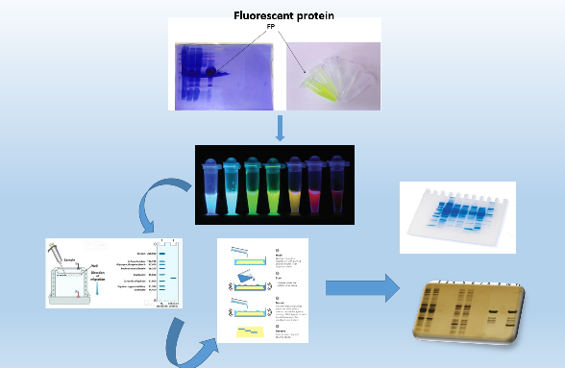
Recent publications (minimum 5)
- Yazgan, H., Ozogul, Y., Durmuş, M., Balikçi, E., Gökdoğan, S., Uçar, Y. & Aksun, E. T. (2017). Effects of oil-in-water nanoemulsion based on sunflower oil on the quality of farmed sea bass and gilthead sea bream stored at chilled temperature (2±2° C). Journal of Aquatic Food Product Technology, 26(8), 979-992.
- Ozogul, F., Aksun, E. T., Oztekin, R., Lorenzo J.M. (2017) Effect of lavender and lemon balm extracts on fatty acid profile, chemical quality parameters and sensory quality of vacuum packaged anchovy (Engraulis encrasicolus) fillets under refrigerated condition. LWT - Food Science and Technology,84, 529-535.
- Aksun, E. T., (2016) Using Smart Packaging in Fish and Fish Based Product. Shock 29:377.
- Karakaya Tokur, B., Sert, F., Aksun, E. T., and Özoğul, F. (2015). The effect of whey protein isolate coating enriched with thyme essential oils on trout quality at refrigerated storage (4±2°C). J. Aquat. Food Prod. T. 24 (4): 585--596
5. Özyurt, G., Şimşek, A., Karakaya, B. T., Aksun, E. T., and Yeşilsu, A. F. (2015). Functional, physicochemical and nutritional properties of protein from klunzinger's ponyfish extracted by the pH shifting method. J.Food Process. Pres.


Biography (150 word limit)
Elif Tugce AKSUN TUMERKAN has her expertise in proteomic and biotechnology. Her studies generally based on gel electrophoresis, fluorescent protein and their potential uses in cell biology. After she finished PhD, she has a scholarship from Turkish Government that related to genetic diversity in marine and aquatic organism in University of Exeter. She is doing research related to fluorescent protein from marine organisms. And potential approach in different cell tissue.
Email:ea386@exeter.ac.uk

Notes/Comments:

