A modern approach towards Anabolic Androgenic Screening in Athletes
Introduction: Urinalysis has been the mainstay technique used to screen athletes for the anabolic steroid use before athletic events. Although urinalysis provides sufficient evidence of anabolic steroid use there are still major disadvantages that have caused controversy in the past. One of the main setbacks is that urinalysis can only detect steroid use in the short term period before athletic events which makes it difficult to predict whether or not athletes have used steroids in during training and discontinued in the short period before their screening. Another problem is that sometimes urinalysis could result in a false positive due to an accidental isolated event consumption. This has led to the exploration of other techniques to screening with hair analysis being at the forefront of primary research. Hair analysis has been shown to provide more consistent and long term results for anabolic steroid consumption. Methodology and Results: Hair samples from 180 participants were taken and analyzed using ELISA AND LC-MS/MS for confirmation. The technique screened 19of the participants as a positive for steroid use (16 for nanodrolone and 3 for stanozolol )and the control was an athlete who had admitted to steroid use. Conclusion: The results confirmed that hair analysis provides a wider detection window and is more specific allowing for only small amounts of hair specimens. This technique is also less invasive and more efficient than urinalysis.
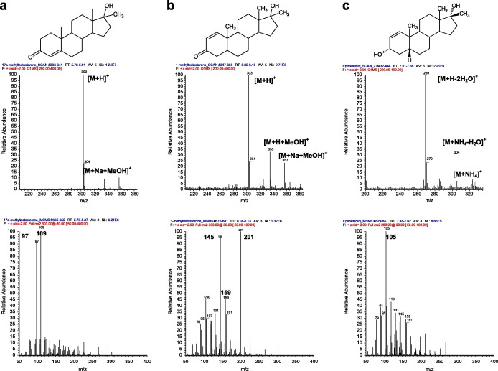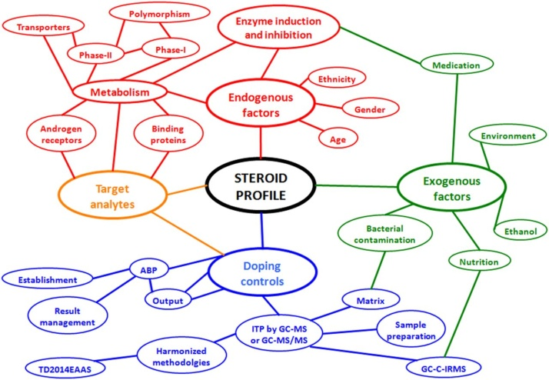


Biography: Ahmad AbuHasna is a current clinical pharmacist Student at the University of Jordan. Being an athlete himself, AbuHasna has taken on a strong interest in the use of steroids among athletes. His main focus is on the proper and more efficient use of screening techniques for athletic events. AbuHasna has also taken advantage of his strong background in healthcare to help educate athletes on the potential harms that steroids may place them at risk for. AbuHasna hopes to make a positive change in the Jordanian

