Design and fabrication of electrochemical supercapacitors with use of modified carbon mesoporous.

N, Bahrami Adeh^{1,*}Keivan Pourreza¹,N, Mohammadi¹
- Academic Center of Education Culture and Research- Tehran Branch (ACECR)
B_adeh@yahoo.com
Abstract
ABSTRACT
In 2016, the Ms. Bahrami and her coworkers(1) succeed to make highly defective mesoporous carbon with high surface area. The studies show that defective mesoporous carbon (DMC) has good electro-catalytic properties in comparison to other carbon Nano tubes and Graphene. High porosity and Low pore size distribution is the main advantages of these Nano pores. All these featureshas lead that DMC becomes the most exciting topic of research in the field of super capacitors. For this purpose we are trying the following sections:
- With the change in the carbonic precursor from sugar to other precursor such as nitro genic precursor we could synthesis the DMCwith nitrogen hetero atom that has red/ox properties.
- With the adding of metal oxides to DMC we could modified the capacitance behavior of DMCmetal oxides have catalytic and red/ ox properties metal oxides are such as manganese oxide, cobalt oxide,…
- Conductive polymers because of the red/ox reaction both in the balk of the polymer and in its surface can modify the performance of super capacitor so it is interesting field of research to investigate.
To make the DMC electrode we use DMC, Carbon black as filler and poly Tetra-fluoro Ethylene as binder of DMC to nickel foam. the calculated capacitance for DMC is 290 F/g that shows good value as super capacitor.

Keywords: Super capacitor, Defective meso porous carbon(DMC), metal oxide, conductive polymer

REFERENCES

[1]. N, Mohammadi: N, Bahrami Adeh: M, Najafi. RCS Advances2016,RSC Adv., 2016,6, 33419-33425
Professional Biography (100-150 words)

- Keivan pourreza study his PhD at the age of 32 years from Academic Center of Education Culture and Research- Tehran Branch (ACECR) and my MSc course from IASBS university.

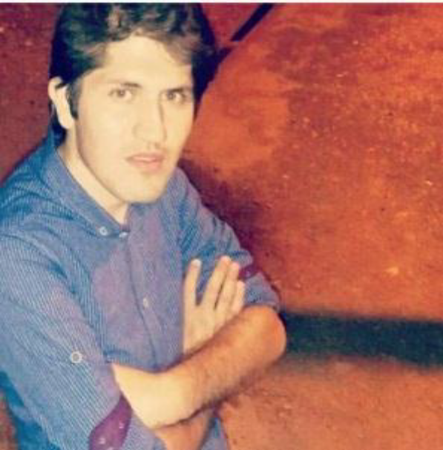

Email Id:k1ekar6194649@gmail.com

Any Comments:

