Chemical and sensory quality of extra virgin olive oils sold in American and Japanese markets
Dr Giuseppe Di Lecce, PhD, Oleificio Zucchi S.p.A., ITALY

Abstract (300 word limit)
Olive oil markets, both traditional and new ones, are changing rapidly, particularly in countries new to this product like USA and Japan. The increasing interest is mainly linked to the health benefits and sensory properties of extra virgin olive oils (EVOOs). According to the European regulations (European Commission Regulation - EC Reg. - n. 2568/91 and subsequent modifications) olive oil must comply with strict chemical and sensory quality parameters. Variability in EVOOs characteristics is linked to three main domains: agronomy/environment (state of olive grove and olive cultivars, pedoclimatic factors, fruit ripening, cultivation techniques, water resources), technology (e.g. extraction system and malaxation conditions), and storage conditions (e.g. temperature, air and light exposure). Oil price represents one of the most determinant variables for purchase decision. Often a positive relation between olive oil quality and price is expected, despite the fact that a few studies have been conducted to document this relationship yet. The present study aimed to analyse the chemical and sensory quality of twenty -two olive oils sold as “extra virgin” in American and Japanese markets at different price (ranging from 5.0 to 21.0 $/l). A multi-method approach was applied and the EVOOs were investigated for sensory and chemical parameters strictly related to olive oil quality and authenticity (quality parameters, phenolic compounds, fatty acid and sterols composition and some contaminant like glycidol ester and mineral oils). Three out of twenty-two oils did not comply the chemical parameters for the category of the extra virgin. When including the sensory analysis, six samples were found irregular. A positive relationship between overall quality and price was confirmed for most samples, in particular in the USA market.

Image
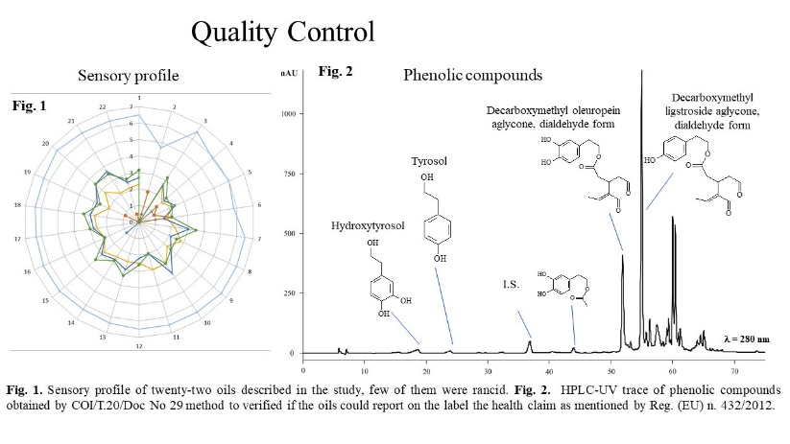
Recent Publications (minimum 5)
- European Commission (1991). Commission regulation (EEC) no 2568/91 of 11 July 1991 on the characteristics of olive oil and olive-residue oil and on the relevant methods of analysis. Official Journal of the European Communities, 248, 0001–0083.
- Boselli E, Di Lecce G, Strabbioli S, Pieralisi G, Frega NG, (2009). Are virgin olive oils obtained below 27 °C better than those produced at higher temperatures? Food Science and Technology 42, 748-757.
- Carbone A, Cacchiarelli L, Sabbatini V (2018). Exploring quality and its value in the Italian olive oil market: a panel data analysis Agricultural and Food Economics 6, 3-15.
- Cabrera ER, Arriaza M, Rodríguez-Entrena M (2015) Is the extra virgin olive oil market facing a process of differentiation? A hedonic approach to disentangle the effect of quality attributes. Grasas y Aceites, 66, 664.
- Fiorini D, Boarelli MC, Conti P, Alfei B, Caprioli G, Ricciutelli M, Sagratini G, Fedeli D, Gabbianelli R, Pacetti D (2018). Chemical and sensory differences between high price and low price extra virgin olive oils. Food Research International 105, 65-75.

Photograph

Biography (150 word limit)
Dr. Di Lecce is a food technologist with a pronounced aptitude and expertise in analytical chemistry and sensory sciences. In 2009 he obtained a PhD in food and health. His main research topics are: food lipids (especially their composition); lipid analysis of food related to human health; lipidomic and lipid oxidation in model and in vitro system; degradations caused by processing and preservation; chemical analysis of food and food-stuffs; qualitative and quantitative determinations of bioactive compounds in agri-food by-products and waste. He is currently Head of the chemical and sensorial laboratory at the Oleificio Zucchi, where more than 50,000 analysis are carried out every year to check the quality of the raw materials and blends then placed on the market. Author and co-author of more than forty articles published in national and international scientific journals.
Email: leccegius1980@gmail.com

Notes/Comments:

