Mapping and Coding Organic Chemistry
Mapping Elemental Nutrient Pathways and Coding Pigment Colour DNA
Susan M. Kerridge
Researcher / Pigments 129C Mackays Road Coffs Harbour NSW, Australia
Index
Abstract
We are covering two fields of science the first scientifically based and the second exploration of colour sequencing. It would seem that the two are very much aligned and should be researched simultaneously. In this paper the main focus is on Coding Organic colour /pigments and the relevance to DNA and chemical sequencing. Using colour (Pigments/pH/chromatins/other) as an extra descriptive, organising the identity data base bars adds value / relevance to the identification process. It may directly align DNA itself with colour, for this reason there may very well be a readable configuration that matches DNA / Nutrients with a Colour chart. Aligning colour with the DNA code will create colour patterns that are more predictable. Also arranging the elements and percentage of elements in their order of descendant, also adds a far greater mechanism for sorting. Example: HBCNOnaMgPSClKCaMnFeCoCuZnMo(SiSe), 6%C 12%H 6%O.
This has highlighted the need for the Scientific Naming System and Mapping of the Elemental Nutrient Pathway to be bypassed. As the scientific world has developed in part of an entire picture. This part development has led to the naming of organic chemical exchanges individually. This has meant that the flow (interpretations) of the elemental nutrients through the organic pathways have been lost in the jargon. Names have changed the nutrient transfers along the way, thus a more comprehensive Overview / Scientific Name Mapping for Elemental Nutrient Pathways is required for a complete picture and the exploration of Colour Coding Pigments for possible sequencing.

Introduction
“ Description without figure is generally difficult to be comprehended; description and figure are in many instances still defective; but description, figure and colour combined form the most perfect representation and are next to seeing the object itself.” (Werner 1821)
In writing Mapping and Coding Organic Chemistry two areas of science in need of development have arisen, although not the intention, initially aiming at only colour / pigment Coding, so my apologise for two papers in one: Mapping Elemental Nutrient Pathways and Coding Pigment Colour DNA.
We are covering two fields of science the first scientifically based and the second exploration of colour sequencing. It would seem that the two are very much aligned and should be researched simultaneously. In this paper the main focus is on Coding Organic colour /pigments and the relevance to DNA and chemical sequencing. Using colour (Pigments/pH/chromatins/other) as an extra descriptive, organising the identity data base bars adds value / relevance to the identification process. It may directly align DNA itself with colour, for this reason there may very well be a readable configuration that matches DNA / Nutrients with a Colour chart.
As we have evolved from different climatic areas on the globe, we have also developed adaptations and sequestrations from our individual environments. This is evident in our various pigmentations and genetic formations. As a generalisation most dark skinned pigmented people have throughout historical time and recently been associated with nomadic movement with strong Forrest culture and connectedness to the land. As opposed to the more building orientated people form colder climates that wore shoes / clothing and lived mostly indoors. These influences have affected Humanity over time. And we ourselves have evolved in many different ways.
Stemming back from the beginning of civilisation, Mankind has needed to draw to communicate. In the modern day Art has developed in various ways. One way has been to paint landscapes. Landscape paintings try to capture the real appearance of the scenery at a micro level. Landscape paintings now have the capacity to be painted using most of the real life materials. Ochres and vegetable dyes etc. In a similar way we now have the ability to code real life colours into a scientific colour chart / data base. This chart will have the potential to determine chemical applications.
This is a broad area and really covers Organic chemistry as a whole or its entirety. Mapping and correct colour coding of nutrients is required for more accurate mathematical transparency. All the information is now available and should be collated to form a more readable equated format / organic chemistry data base. To enquire new development /change in these areas a fundamental approach is required as well as new funding arrangements. Bringing attention to certain facts that support the need for a bigger picture, some examples are common knowledge facts whilst others are scientifically cited.
Methods / Reason
Aligning colour with the DNA code will create colour patterns that are more predictable. Also arranging the elements and percentage of elements in their order of descendant, also adds a far greater mechanism for sorting. Example: HBCNOnaMgPSClKCaMnFeCoCuZnMo(SiSe), 6%C 12%H 6%O. ( Stern 2000)
A correct colour value chart is applied to the organic samples.
- Mapping: Examples to support the new name mapping pathway.
- Coding: The focus is the need of exploration and covers the reasons, tools and methods for the exploration and interchangeability.
Even though there are two sections, all aspects of quantitate information is set out in the following diagrams 1,2,3 below. Notice that all previous information is also retained. Each section will be divided and labelled into respectfully allowing for moveability.

Diagram 1.
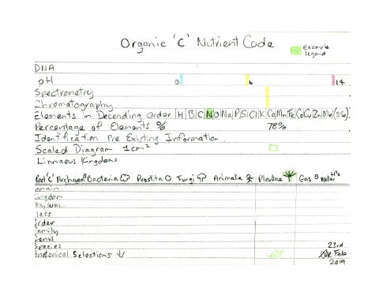
Diagram 2.
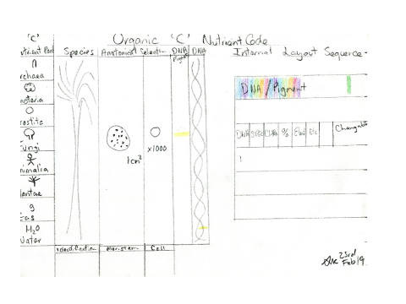

Diagram 3.
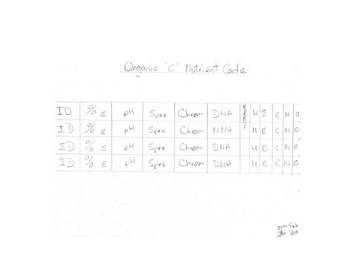
- Mapping. An example of how terminology changes; is Street naming. In China one road can change its name multiple times. This eventuated from different families living along the road. Each section of the one road changes its name according to the historical family inhabitants. A person is left wondering what road am I really on? The same can be said for present day Organic chemistry science. The flow of the nutrient pathway needs to be more descriptive and more relevant to its chemical constitutions. This allows a more mathematical approach that may override or join but does not eliminate previous naming of organic chemical processes. By naming the map example: Nutrient flow map. Then name the nutrient and add numbers / estimated percentage, we can follow the nutrient more accurately as it moves into different cellular structures. There has long been the need to map Elemental Nutrient Pathways in particularly in Organic Chemistry.
- Coding. To explore Colour and DNA relationships more closely we must also consider pH, light spectrum, chromatography, Organic pigment charts, tables and evolution. This will allow reasoning to draw further on the gathering of information and to code it according to its accurate / real colour and not a legend invented /shaded by us.
In the natural Living World, colour represents an interchange of light and nutrients. Colour is present all around us and apparent in all life. Colour change is used in chemistry as a means of determining chemical effects. The pH colour changes represent readable analysis for acids or base. Algae tests etc. Colour varies in degrees similar to mathematics and can go on infinitely. Chemistry is similar although the Earth provides a closed system to work with.
Background
Diagram 4.
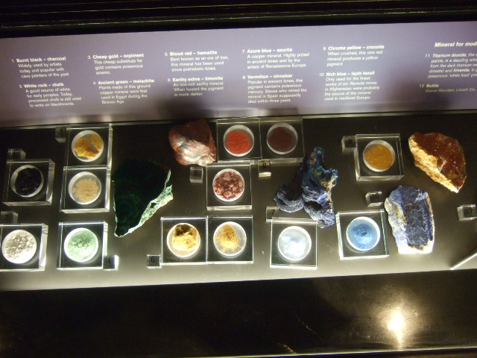

In diagram 4, Here we can see the domination of the colours Iron red, Sulphur Yellow and Azure blue some of these pigments are present in the Organic nutrients in life. These are listed in a new order taken from Stern 2000 in diagrams 1,2,3. Pigments used over the history of time, they all have a chemical composition as given in the Dictionary of Art. (Jane Turner 1996 ) They are susceptible to change the same as the change in colour in the paper lichens Acid or Base. (Jane Turner 1996 )It is this very incredible action that is present in most living things. The pH test kits are in themselves are form of Chromatography. For the reason ‘Colour’ is very relevant in science and may be far more important than first realised.
By dividing the Earths Living world chemistry into Organic and Non Organic with Carbon C determining the differences. We can divide the Organic Carbon again into Living Cellular (OCC) and Non Living Non Cellular (ONCC). This is included in diagrams 1,2,3. Other colour Tables including plants, flowers, seaweeds, spices, fruit etc could be provided as proof of colour pigments etc.
Adding divisions into the diagrams 1,2,3.
Division : Organic (cellular OCC)(non cellular ONCC)
- Cellular (OCC): Animals, plants, flowers, insects and vegetables.
- Non Cellular (ONCC): Oceans, sky, soils, rivers etc.

Discussion
Using accurate colour to represents the nutrient and or the DNA asking of a nutrient. It may ultimately achieve a nutrition chart that explains DNA sequencing. Using a computer generated universal chart or similar is one way to begin to align cellular colour / pigment or known compounds. The methods should be uniform / Microscope and grouped by formal appearance of colour.
The relationship can be strengthened between DNA, Nutrition and Colour. Some Broad explanations relating strongly to the topic, unravel and open up many very interesting forms of research that are still in their infancy and undoubtable will always need to remain flexible with error margins.
The relevance to pH is very high and at every reading pH average should be given strong consideration. As pH variations may indicate far more than first thought.
Starting with CCOCC may prove a pattern, although I think this may have been tested and the reason it failed is due to minerals attaching to the organic compounds and them not always aligning. Minerals would need to be coded separately.
Conclusion
This paper validates reasons that colour coding chemistry is very tangible, and should be taken much further, encouraging the broader study of science and having a large data base to accumulate the information.
It has highlighted the need for the Scientific Naming System and Mapping of the Elemental Nutrient Pathway to be bypassed. As the scientific world has developed in part of an entire picture. This part development has led to the naming of organic chemical exchanges individually. This has meant that the flow (interpretations) of the elemental nutrients through the organic pathways have been lost in the jargon. Names have changed the nutrient transfers along the way, thus a more comprehensive Overview / Scientific Name Mapping for Elemental Nutrient Pathways is required for a complete picture and the exploration of Colour Coding Pigments for possible sequencing.
Definitely the quality of Habitat loss with wildlife, different stresses and a change in the chemical habitat composition has led to their decline and ultimately their extinction. This research may help to tell us more about the world and ourselves / nutrient requirements and the vital importance of the Organic processes. It may ultimately lead to survival as the Corporate World is so environmentally Ignorant / negligent at present.

Acknowledgements
I would like to thank Euro SCiCON for hosting this event and inviting Novice ideas into the field of Chromotograpghy and spectrometry. I have been aiming at my Masters by thesis on this very topic but found it hard for any University to host as they only had selected items.
America offers many scholarships for independent studies / Masters. Many more should be made available. My intention is to help the Scientific Data Base and Science for a better understanding and to encourage more employment.
References
(Werner 1821) Werner’s NOMENCLATURE OF COLOURS by Patrick Syme second edition Edinburgh 1821
The Dictionary of Art 24 Pandolfini to Pitti Editor Jane Turner Macmillan Publishers Limited 1996
Stern 2000 Introduction to Plant Biology. America
Diagram 4. London Natural History Museum UK.

Evolution
According Professor Brian Cox: ‘DNA coding sequencing relates directly to the evolution tree’. And there for we are able to tell what came first the chicken or the egg? Professor Ian Stewart puts forward that Flowers and colour in the plant and insect kingdoms did not develop until around the Mammalian times. Well after the Jurassic period. Before then it was Conifers and ferns (GREEN) etc. An interesting comparison of Moth’s and Butterflies; as the Leaf looks partly like a Moth’s DNA or Carbon fabric. It is amazing how seeds can fly and some have developed wing like structures. As Moths are mostly colourless – this may sit the Moth in the Jurassic time scale? The Flower colour indicates that it evolved well after the Jurassic time period, and may sit before the Butterfly on the DNA time scale?

