Mapping and Coding Organic Chemistry
Mapping Elemental Nutrient Pathways and Coding Pigment Colour DNA
an Artistic / Scientific perspective
Inorganic Ochres Plant Elements pH colour range / crayons
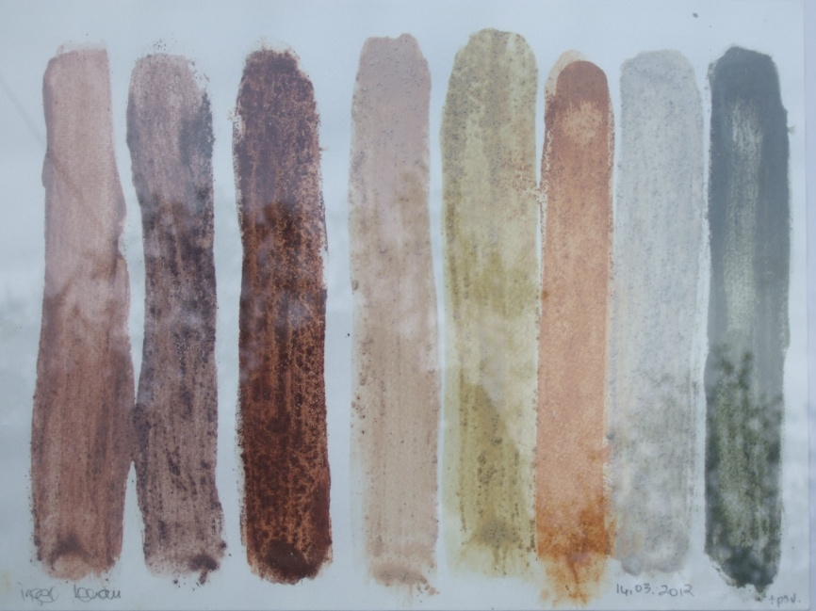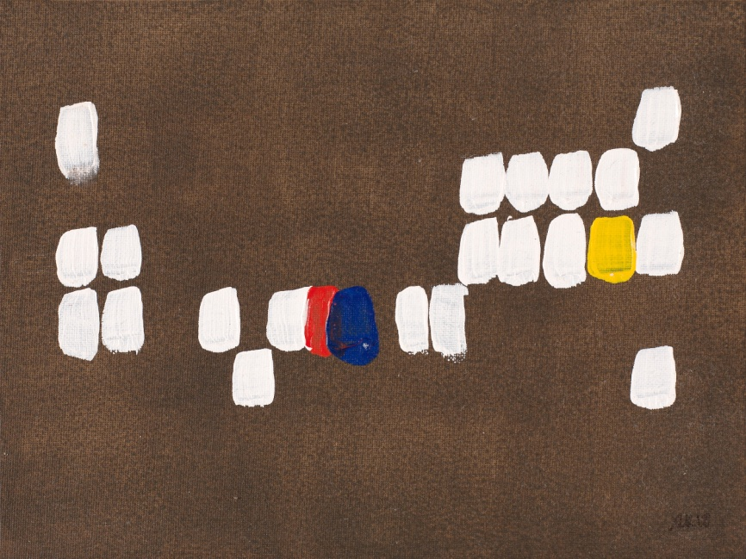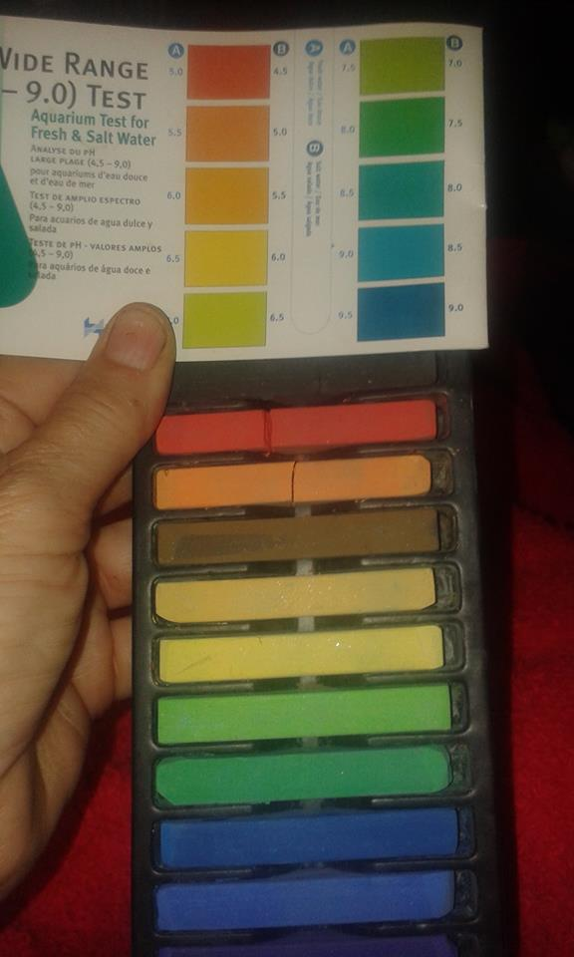
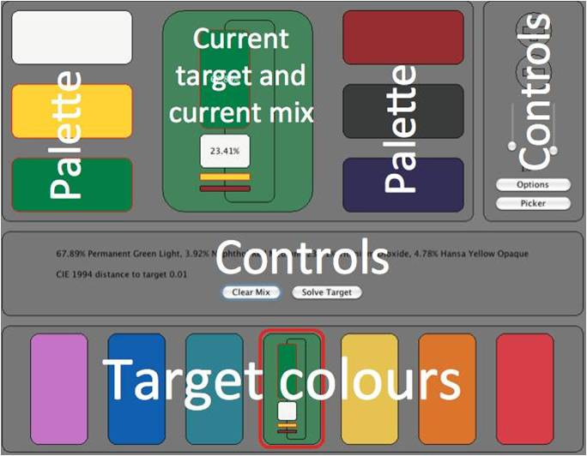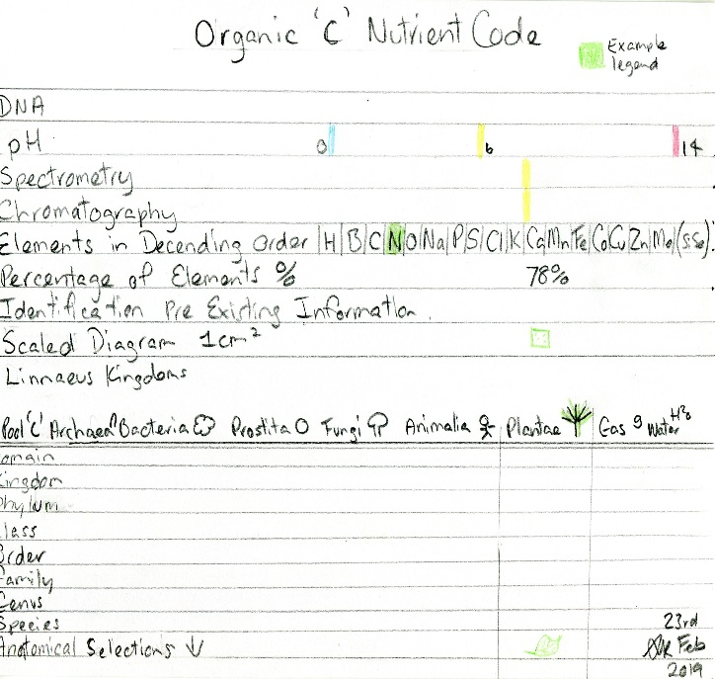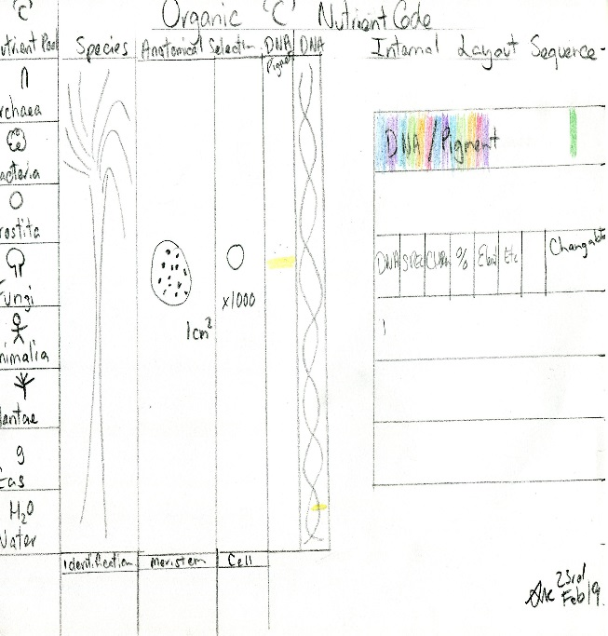
- Pigments can be black, white or coloured. To understand how they appear, you must consider the nature of light.
- White light is made up of coloured lights, from blue in the shortwave end (400nm) to red the long wavelength (700nm).
- Depending on their molecular structure, pigments absorb some of the light spectrum whilst reflecting or transmitting other parts.
- White pigments deflect most of the light whilst black pigments tend to absorb light.
- The rate of refraction is determined by the change in velocity of the propagation of the radiation. The speed of light dependent on the density of the medium. The refractive index, n. Most pigments lie between 1.5 and 2.8n. Isotropic have one index (ultramarine), whilst some materials can have more anisotropic, making them birefringence (azurite).
- Pigments are affected by acids and alkalis.
- Inorganic pigments include earths and minerals and Organic from animals and plants
- A prerequisite for a compound to be a pigment is that it is insoluble in water and in the binding medium. This distinguishes them from dyes. This precondition of insolubility is how oxides and hydroxides are found.

Paint Tutor App by Jean Pretorious
Ochre Art Inger Lenau
The Dictionary of Art 24 Pandolfini to Pitti Editor Jane Turner Macmillan Publishers Limited 1996 Macmillan Publishers Limited, London Grove’s Dictionary Inc. New York GROVE
Poster and life elements painting presentation by Susan M. Kerridge Australia Feb 2019

