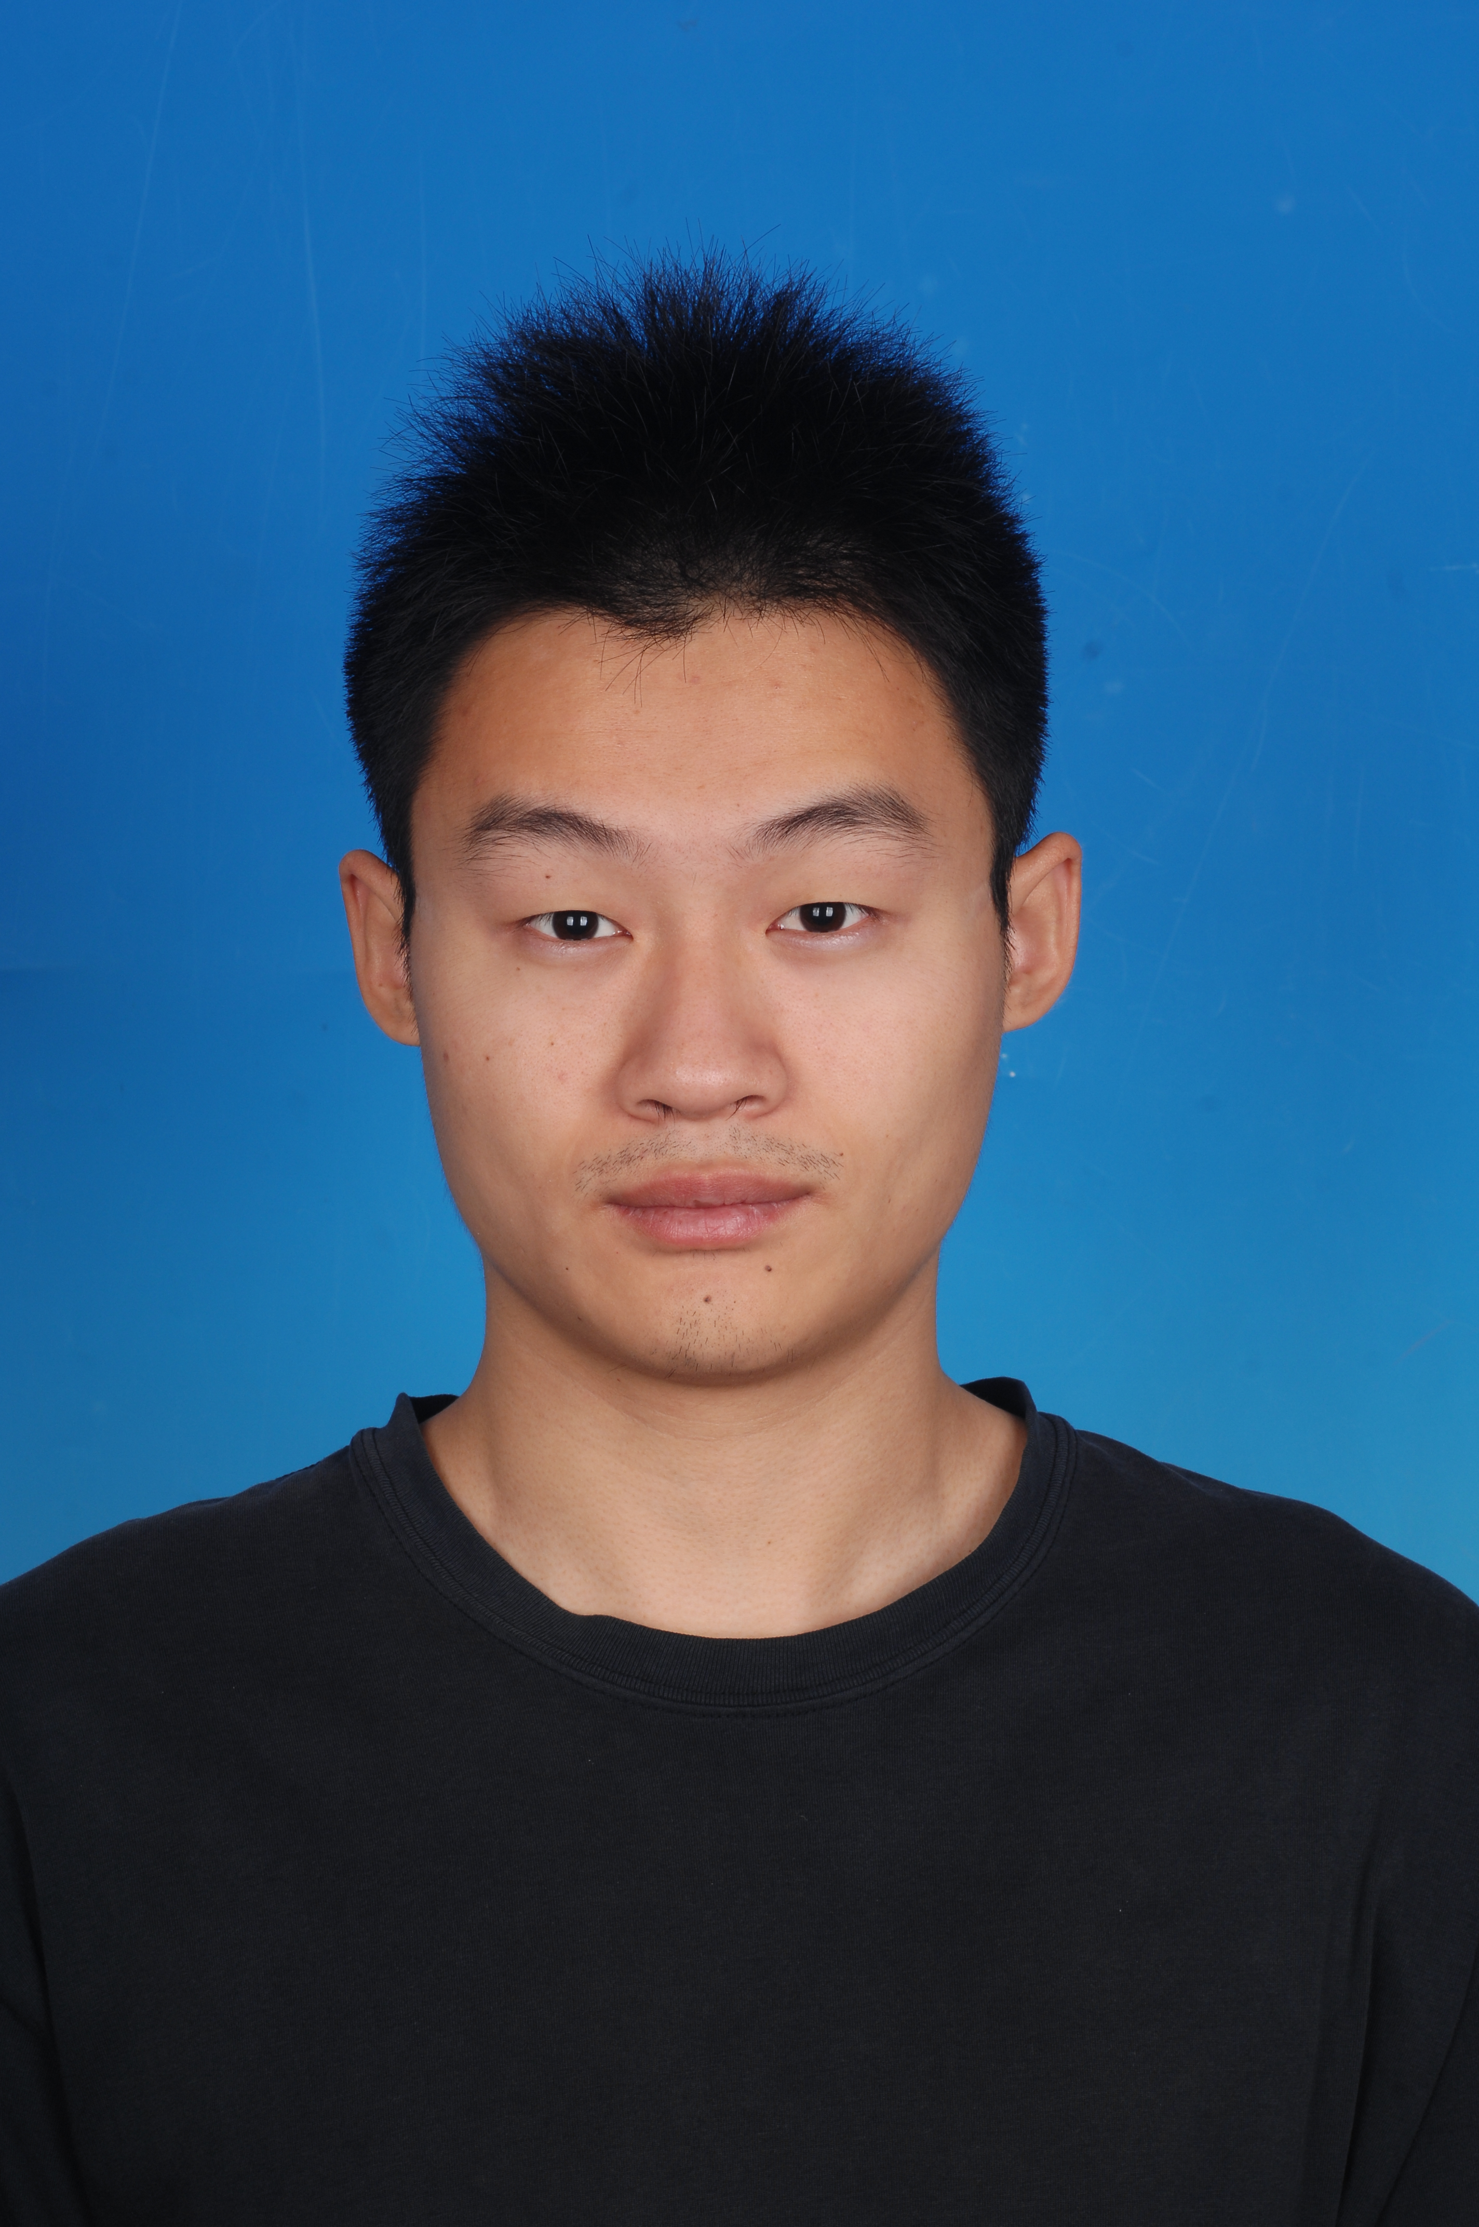

Title: Revealing Interfacial Molecular-Level Structures of Biomacromolecules using Sum Frequency Generation Vibrational Spectroscopy
Name: Xu, Li and Xiaolin Lu*
State Key Laboratory of Bioelectronics, School of Biological Science & Medical Engineering, Southeast University, Nanjing 210096, Jiangsu Province P. R. China
Abstract (250-300 words)
As a second-order nonlinear optical spectroscopy with interfacial selectivity and sub-monolayer sensitivity, sum frequency generation (SFG) vibrational spectroscopy is a powerful tool for investigating surfaces and interfaces. Furthermore, SFG can be used to detect chiral structures at interfaces with chiral-active polarization combinations. Two case studies are given with respect to molecular-level interfacial structures in this abstract, i.e. silk fibroin (SF) and oligonucleotide.
For SF, above critical overlapping concentration (C*), no ordered protein chiral structures could be detected at the hydrophobic polystyrene (PS)/SF solution interface; only adding methanol can induce formation of antiparallel β-sheet structure. Below C*, antiparallel β-sheet could be detected without adding methanol. Adding methanol could induce formation of an extended helical structure besides β-sheet structure. This demonstrates that chain-chain interaction or spatial confinement plays a vital role for formation of interfacial molecular-level secondary structures for protein molecules. For oligonucleotide, by using the lipid bilayer as a soft substrate to accommodate duplex oligonucleotide, both chiral and achiral water vibrational signals showed similar concentration-dependent intensity changes over a broad range of Ca²⁺ concentrations. However, when the Ca²⁺ concentrations were adjusted to be within the range comparable to those in the human serum, chiral water signals remained nearly unchanged, whereas achiral water signals still changed, as a function of Ca²⁺ concentration. This result supports possible protection function of chiral hydration layer against Ca²⁺ ions, which generally exist in cell sap.
Biography(100-150 words)

Xu Li received his B. S. degree in Biomedical engineering from Hebei University of Technology, China in 2014. He is currently pursuing the Ph.D. degree at the School of Biological Science and Medical Engineering, Southeast University, China, under the supervision of Prof. Xiaolin Lu. His current research interests include nonlinear vibrational spectroscopy, buried soft interfaces, interfacial ultrafast dynamics and polymer thin film relaxation. He has published 5 papers as the first author in Macromolecules, Soft Matter and Langmuir.

Presenting author details
Full name: Xu Li
Session name/ number: Spectroscopy/9
Category: Oral (Oral/ Poster)
Email id: 230179155@seu.edu.cn
Contact number: 86-15150548836

