Abstract Template
Abstract Title: Opportunities for domestic monitoring of children with an electronic stethoscope with automatic auscultation sound analysis system.
Honorata Hafke-Dys^{1,2}, Anna Zelent²

¹Institute of Acoustics, Faculty of Physics, Adam Mickiewicz University in Poznań, Umultowska 85, 61-614 Poznań, Poland
² StethoMe, Winogrady 18A, 61-663 Poznań, Poland
³ Department of Pediatric Pneumonology, Allergology and Clinical Immunology, K. Jonscher Clinical Hospital in Poznań, Poznań University of Medical Sciences, Poland, Szpitalna 27/33, 60-572 Poznań

Abstract (not more than 300 words)

In case of children suffering from chronic diseases of respiratory system, including asthma, it is very important to track any changes in the respiratory system condition. Domestic patient monitoring is becoming more and more popular. It is much more comfortable for patients who are less stressed, being relieved from any necessity to attend doctor’s offices, and are not exposed to pathogens present in medical facilities. Furthermore, it is also important for the attending physician who is provided with documented data. Until now, any aggravation of a past disease has been reported by children’s parents during medical appointments. Such method for providing information entails potential miscommunication, misjudgement and highly biased evaluation. A solution might be an electronic stethoscope, providing easy way to examine children in domestic conditions and to record auscultation results. Currently, it is possible to record auscultation sounds, provide a doctor with remote access to such records, and also to report any appearance of specific sounds and their intensity. Based on collaboration with scientific centres, there is a solution being developed: StethoMe®, a smart stethoscope, designed to provide a patient with a method for domestic auscultation. This system enables recording of auscultation sounds, submitting them to a physician and automatic classification of recorded sounds in four classes: wheezes, fine crackles, coarse crackles and rhonchi, according to [1]. A physician may see a panel with provided access to sounds, their spectrograms, being visualisations of sounds facilitating their interpretation, and also an algorithm report, related to potential appearance of specific pathologies. This solutions is currently under development and in a testing phase in Europe.

[1] Pasterkamp, H. , Brand, P.L.P., Everard, M., Garcia-Marcos, L.,Melbye, H.,Priftis, K. N., Towards the standardisation of lung sound nomenclature,. European Respiratory Journal 2016; 47: 724-732.

Keywords — Allergy, Diagnostic, Tryptophan metabolism

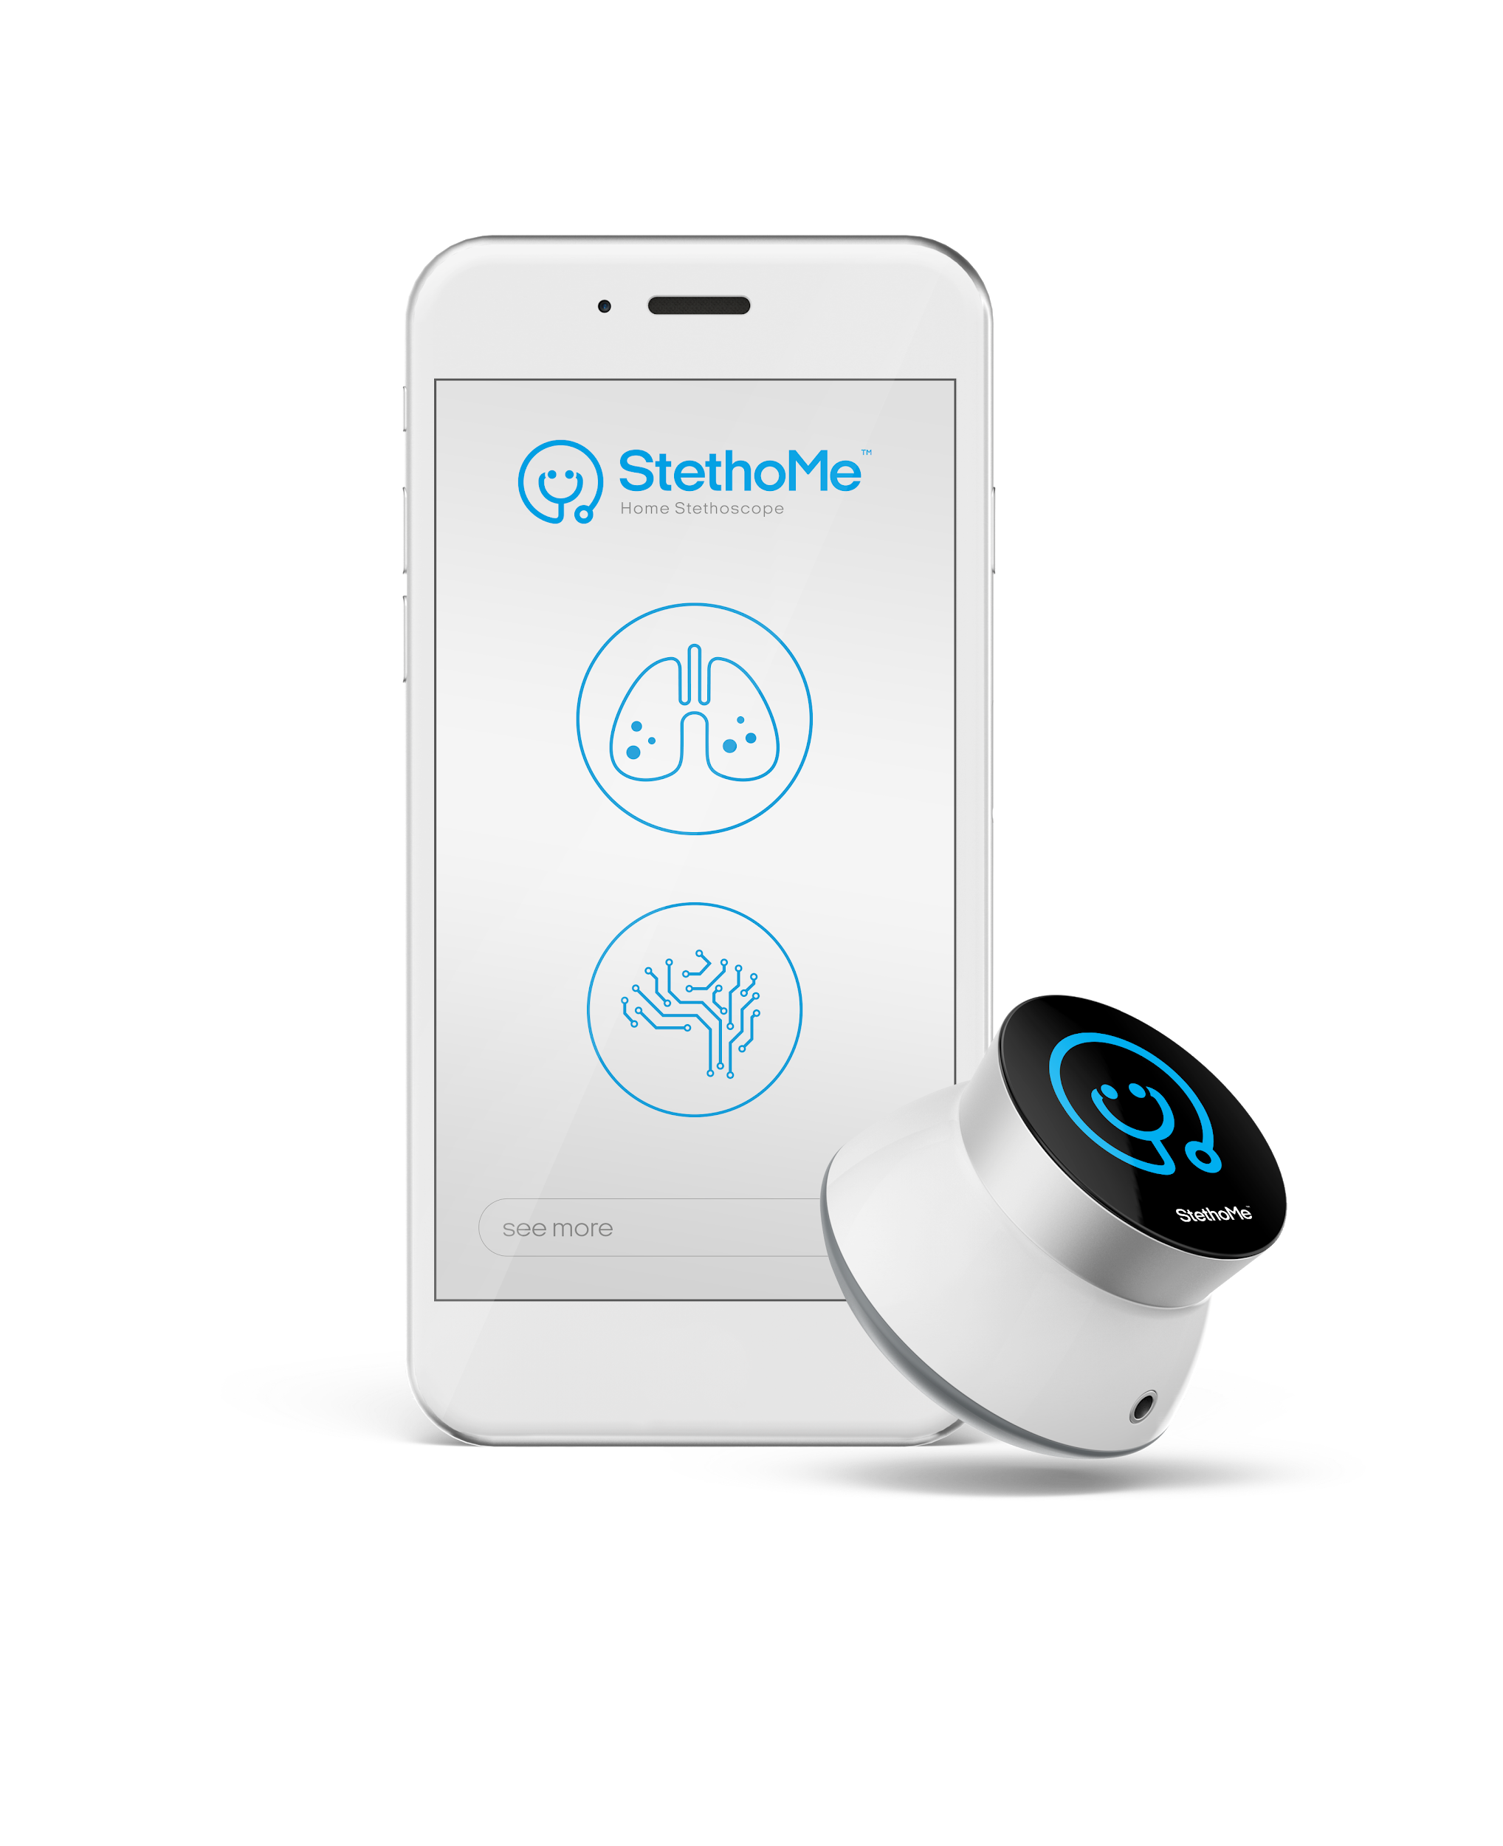

Professional Biography (100-150 words)

Honorata Hafke-Dys earned a PhD degree in biophysics. She received a degreee in optics, and later majored in acoustics at the Department of Physics at the Adam Mickiewicz University in Poznan. Currently, she works as a Postdoctoral Researcher at the Institute of Acoustics. She is also a co-founder and senior researcher at StethoMe company - the winner of the IoT Innovation World Cup® 2018 - Healthcare category, the European winner of Startup World Cup & Summit 2018 - BioTech Award, the 3rd Place Winner Future X Healthcare start-up Award 2017 - Audience Award. Since January 2017, StethoMe® project has been co-financed by the European Regional Development Fund which supported the development of sound analysis algorithms.

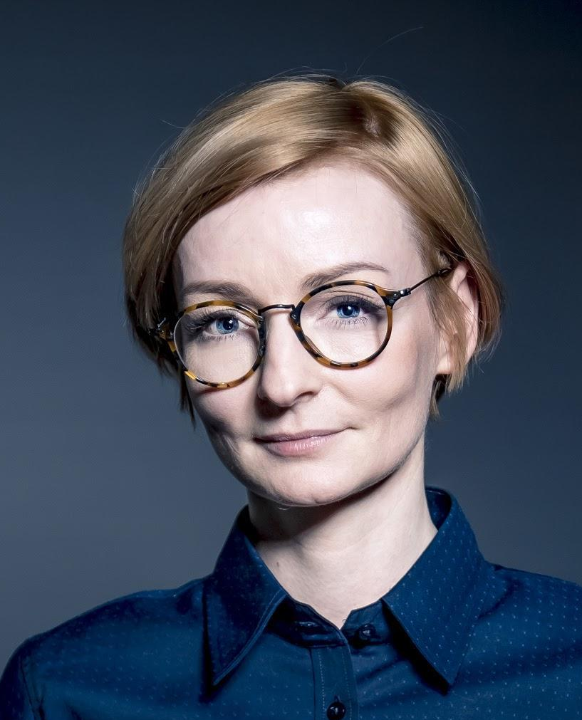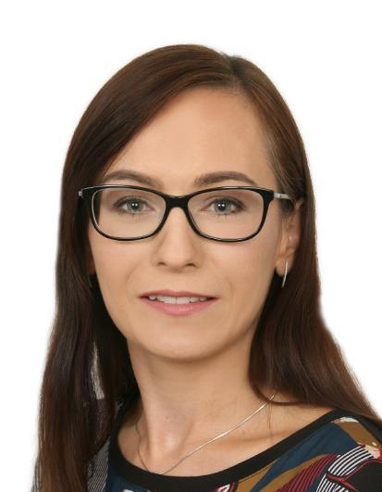
Honorata Hafke-Dys Anna Zelent

Honorata Hafke-Dys earned a PhD degree in biophysics. She received a degreee in optics, and later majored in acoustics at the Department of Physics at the Adam Mickiewicz University in Poznan. Currently, she works as a Postdoctoral Researcher at the Institute of Acoustics. She is also a co-founder and senior researcher at StethoMe company - the winner of the IoT Innovation World Cup® 2018 - Healthcare category, the European winner of Startup World Cup & Summit 2018 - BioTech Award, the 3rd Place Winner Future X Healthcare start-up Award 2017 - Audience Award. Since January 2017, StethoMe® project has been co-financed by the European Regional Development Fund which supported the development of sound analysis algorithms.
Anna Zelent
She graduated from Poznan University of Medical Sciences, earned a medical degree, then became specialist in paediatrics. She is a paediatrician with extensive experience in hospital and clinical settings. Currently, she works in the Department of Paediatric Pulmonology, Allergy and Clinical Immunology. Her allergology specialty training is in progress. She is a co-author of several medical publications and researches in the field of paediatrics, pulmonology and immunology.

StethoMe® is implementing a project co-financed using support from the European Regional Development Fund. Priority axis: Support for execution of R+D works by enterprises; activity: R+D projects of enterprises, subactivity: Industrial research and development works executed by enterprises.

Project title: “Worldwide unique technology of identification and classification of sounds from auscultation carried out in home conditions, employing intelligent algorithms and supporting remote diagnostics and monitoring of respiratory system diseases.”



Email Id: media@stethome.com

Any Comments:

