MAST CELL LEVEL IN PATIENT WITH REVERSAL REACTION OF LEPROSY
Yuniati R.^{ψ}
^{ψ}Lecturer of Department of Dermatology and Venereology, Medical Faculty Diponegoro University

ABSTRACT
Background Reversal reaction (RR) is an acute on chronic episode which frequently contribute to withdrawal of treatment and disability in leprosy patients. Previous study showed that mast cell in the reactive tuberculoid lesions biopsy had lower density than non reactive tuberculoid lesions. Granulomatous lesions in leprosy patients with high level density of mast cells were more vulnerable to become severe reversal reaction.
Objective To understand mast cell level in reversal reaction patients (RR) dan non-reactional leprosy patients (non-RR)
Methods 56 leprosy patients consist of 28 with reversal reactions and 28 non-reactional leprosy were assessed for level of mast cell by immunohistochemistry staining. The mast cell levels in both groups were analyzed using independent samples T test.
Results There was a significant difference of mast cell levels in both groups (p<0.05).
Conclusion Mast cell level is associated with reversal reaction of leprosy.
Keywords: multibacillary leprosy, reversal reaction, mast cell

INTRODUCTION
Leprosy is a curable chronic infectious disease which can cause severe morbidity associated with disability. Leprosy is caused by an intracellular obligate bacteria, Mycobacterium leprae. M. leprae infects peripheral nerve, skin, oral mucous, upper respiratory airway, reticuloendothelial system, eyes, muscles, bone, testicles, and all of human organs other than central nervous system. Leprosy reactions are acute exacerbation manifest as activation constitutional symptoms and/or new skin efflorescence. There are 2 types of leprosy reactions: type 1 (Reversal Reaction / RR) and type 2 (Erythema Nodosum Leprosum / ENL). ¹
Reversal reaction is type IV hypersensitivity reaction which is frequently occurred to borderline type of leprosy as a result of cellular immune response to M. leprae antigen and characterized as an acute inflammation of former skin lesion. Approximately 95% of RR occurs simultaneously with diagnosis confirmation or during multi drug treatment (MDT). RR commonly appears on the first six months treatment, particularly in BT and BB leprosy. It also can be found in BL leprosy with longer interval during MDT. Clinical manifestation of RR includes abrupt increased in number and more active lesions with/ or without ulceration, edema, neuritis, and permanent nerve damage. Bacterial index (BI) is frequently negative or remarkably decreased in RR patients. Leprosy patients commonly complain about skin lesion enlargement which is aesthetically disturbing. This causes treatment withdrawal since patients consider it as a treatment failure. ^{1,2}
Mast cell is a constant cellular component on dermis, lamina propria of mucous, serous, and connective tissue.³ In the tissue damage, mast cell degranulation and release of inflammation mediator causes increase of vascular permeability, local edema, leukocytes activation, tissue destruction, and eventually skin lession as a result of inflammation response. Chowdory and Gosh showed that mast cell in the reactive tuberculoid lesions biopsy had lower density than non reactive tuberculoid lesions. Several studies also found that granulomatous lesions in leprosy patient with high level density of mast cells were more vulnerable to become severe reversal reaction.^{4,5} There were no studies which explained roleplay of mast cell to immuno-inflammatory process in RR and non-RR leprosy patients.

MATERIALS AND METHODS
Research design in this study was analytic observational with cross sectional study. Subjects were multibacillary leprosy patients being treated at the Donoharjo Hospital, Jepara. Selection of subject has done by consecutive sampling with double blind treatment. Participants were multibacillary leprosy patients who met WHO criteria and aged between 20-60 years old. Participants were divided into two groups; leprosy patients with reversal reaction group and leprosy patients without reversal reaction. Written informed consents were obtained from all participants. Exclusion criteria was included pregnancy and other acute inflammatory diseases. Based on the sample calculations, total subjects in this study were 56 samples: leprosy patients with reversal reaction group (n = 28) and leprosy patients without reversal reaction (n = 28). Mast cell levels were measured by immunohistochemistry staining using monoclonal antibodies to Human Mast Tryptase antibody (Leica Biotech). It was visualized by DAB and calculated by observing 20 fields of view in 1000x magnifications.
The mast cell levels in both groups respectively were analyzed using independent samples T test. The data were analyzed using normality and homogenity test for age and occupation. Confounding factors in this study were controlled by randomization proccess. The data were significance if p <0,05 with confidence interval 95%. This study was approved by Ethics Committee of Faculty of Medicine, University of Airlangga.

RESULTS
On average, age of study participants, also number of men and women in control group were not much different from reversal reaction group (Table 1).
Table 1. Characteristics of subjects
 |  | Non RR | RR
 | N | 28 | 28
Age | Mean ± Standard deviation | 41,00 ± 8,255 | 42,43 ± 9,126
Sex | Men | 15 (53,6%) | 12 (42,9%)
 | Women | 13 (46,4%) | 16 (57,1%)

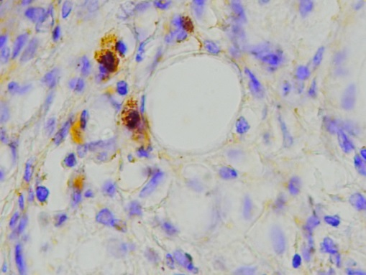
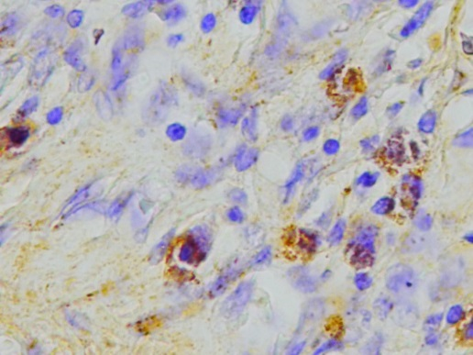
A
B

Figure 1. This picture shows mast cells that give a positive reaction to anti-mast cell through immunohistochemical staining, x400, A: non reversal reaction group, B: reversal reaction group. Black arrow indicates the double stain to anti-mast cell. Red arrow indicates the mast cells that does not give a positive reaction.

Figure 2. The histogram above shows increased expression of mast cell in reversal reaction group compared with the non reversal reaction group

Table 2. Results of independent samples T test
Groups | n | Mean ± SD | p
Non-RR | 28 | 9,29 ± 2,070 | 0,000
Reversal Reaction | 28 | 20,86 ± 4,919 | 0,000

There was a significant increase (p<0,05) in the expression of mast cell in reversal reaction group (mean=20,86) compared with the non reversal reaction (mean=9,29) pada kelompok reaksi reversal.

DISCUSSION
This study was conducted to explain the actual role of mast cells in leprosy reversal reaction. Theoretically, reversal reaction in terms of the germs destruction is a positive thing as it occurs massively. However, it is clinically dissatisfying because of acute inflammatory reaction which is aesthetically disturbing.⁶
Reversal reaction is marked by delayed hipersensitivity to M. leprae antigen (Gell & Coombs type IV reaction) and abrupt increased in immune cell response.⁶ There was an increased in dermis lymphocyte with the disappearance of normal granuloma structure that would decrease bacterial effectivity. In addition, Langhans giant cell could be observed in the next stage of reversal reaction.^{7,8} RR affects 20-30% of leprosy patients.⁶
This research showed that there was a significant difference (p = 0,000) of mast cells in both groups. There was an increase in mast cells amount as well as its activity.
Previous studies examined the relationship between mast cells and lepra bacilli in the foot skin of immunosuppressed mice inoculated by lepra bacilli. The study showed that there were changes in the structure and morphology of mast cells in which structural changes caused by direct infection of leprosy bacilli, whereas the morphological changes such as mastocytosis and massive degranulation were responses to the leprosy bacilli. Changes in density and massive degranulation is commonly found on mast cells in the skin, the affected nerves, muscles, and blood vessels. In human studies involving 118 untreated leprosy cases and 20 healthy individuals, there were a minimal number of mast cells in healthy individuals. The number of mast cells significantly increased in cases of leprosy (p <0.01) and particularly greater in LL type (p <0.05). There is also an increase in degranulation and morphological changes in LL type. These changes can be caused by the release of cytokines from T lymphocytes. In addition, protease release from mast cells may play a role as plasma proteins such as albumin to form a histamine release peptide that will further trigger the activation of mast cells and inflammation. Another study found that LL type had mast cells with the lowest density compared to the BT and BB type. High density mast cells in BT and BB type refers to the role of mast cells in the activation of immune response to M. Leprae infection.^{8,9}
Mast cells have been known inducing variety of cytokines, such as TNF-α, IL-1, IL-4, IL-5, IL-6, and GM-CSF. Bagwan et al found that mast cells in LL type were more dense than in TT type. It was associated with Th2 predominant as a cytokines response in LL type and Th1 predominant in TT type. Moreover, in BL type, both Th1 and Th2 were produced consistent with mast cell density in lesion so that could explain the high incidence of RR in this type. It was found that there were many spindleoid and elongation of mast cells in BT type which indicated that mast cells were ready to degranulate.¹⁰
In this study, some limitations such as research design could affect the study results. There are also a lot of variables associated with reversal reaction that could not be assessed in this study by reason of lack of funding. In addition, insufficient literature about variables studied in leprosy patients leads to the difficulty in determining the normal values of the variables. This study have not discussed about mast cell degranulation prevention which will prevent RR on leprosy, antiinflammation drugs on RR, mast cells role on RR in patients who have completed MDT.

ACKNOWLEDGMENTS
The authors would like to express our gratitude to Department of Dermatology and Venereology, Diponegoro University and Donorejo Hospital, Jepara.

REFERENCES
- Naafs, B. & van Hees, C. L. M. Leprosy type 1 reaction (formerly reversal reaction). Clin.Dermatol. 2016; 34: 37-50.
- Walker, S.L. & Lockwood, D. N. J. Leprosy type I (reversal) reaction and their management. Lepr. Rev. 2008; 79:372-386.
- Abraham SN, St John AL. Mast Cell-orchestrated Immunity to Pathogens. Nat Rev Immunol. 2010; 10:440–452
- Chowdhury SK, Ghosh S. Distribution of Tissue Mast Cells in "Reaction in Tuberculoid Leprosy". Bull Calcuitta School Trop Med. 1968; 16:13-14.
- Chatura KR, Sangeetha S. Utility of Fite-Faraco Stain for Both Mast Cell Count and Bacillary Index in Skin Biopsies of Leprosy Patients. Indian J Lepr. 2012; 84(3):209-215.
- Scollard DM, Joyce MP, Gillis TP. Development of Leprosy and Type 1 Leprosy Reactions after Treatment with Infliximab: Areport of 2 Cases. Clin Infect Dis. 2006;43.
- Ridley DS, Jopling WH. Classification of Leprosy According to Immunity. A Five-Group System. Int J Lepr Other Mycobact Dis. 1966;34(3):255–273.
- Kumar R, Vaidya MC. Mast Cell and Mycobacterium leprae in Experimental Leprosy. Hansenol Int. 1982;7(1):1-7.
- Mysorekar VV, Dandekar CP, Rao SG. Mast Cells in Leprosy Skin Lesions. Lepr Rev. 2001;72(1):29-34.
- Bagwan IN, Khandekar MM, Kadam P, Jadhav MV, Deshmukh SD. A Study of Mast Cells in Granulomatous Lesions of Skin, with Special Emphasis on Leprosy. Indian J Lepr. 2004;76(1):31-37.

