Sexual Risk Behaviors Among HIV-Negative and HIV-Positive Black Individuals Living in Miami-Dade County
Amanda Rosenthal, BAª*, BreAnne Young, MSPH, Sonjia Kenya, EdD
University of Miami, Miller School of Medicine: 1600 NW 10th Ave. Miami, FL, 33136

Abstract
Statement of Problem: Despite the widespread availability of testing and treatment opportunities, Black individuals living in the United States continue to disproportionately suffer from HIV and AIDS. It is the intention of this paper to understand this disproportionate risk. Methodology: Community-Based HIV Testing and Awareness for Minority Populations (CHAMP) collected demographic data and information on sexual and other risk behaviors from 530 individuals living in historically Black communities of Miami-Dade County (MDC) who were subsequently tested for HIV. Results: We identified several behaviors that increased risk of HIV transmission among our female and male populations. These behaviors include sex for drugs, money or other items, men who have sex with men, sex with an anonymous partner, sex with an HIV-positive partner, sex with an anonymous partner, a greater number of sexual partners, history of sexual abuse, spending time in jail or prison, and intravenous drug use. Roughly half of our HIV-positive population were aware of HIV status at the time of testing. Further, among previously diagnosed participants, 60% reported having anal or vaginal sex without a condom and 40% reported having sex with an anonymous partner during the last 12 months. Discussion: CHAMP reported specific sexual behaviors placing Black females and males in MDC at risk for HIV transmission. With the information presented in the present study, it is clear that behavioral interventions that focus on HIV transmission and treatment, targeting both HIV-positive and HIV-negative individuals, needs to be a public health priority.


Biography: Amanda Rosenthal, BA is a third year medical student at the University of Miami, Miller School of Medicine. She is applying to Internal Medicine Residency and will begin her training in summer 2019. Amanda completed her undergraduate education at the University of Pennsylvania where she received a Bachelor of Arts in Health and Societies, with a concentration in International Health. Between undergraduate and graduate school, Amanda was a Community HealthCorps Member through AmeriCorps, the nation’s largest community service-based program, where she served an 11-month service term in Los Angeles, CA. Email: ahr52@med.miami.edu
Keywords: HIV, People Living with HIV/AIDS, African-Americans, sexual risk behaviors

Desired Presentation: Either poster or oral
Corresponding Author Details: Amanda Rosenthal
University of Miami, Miller School of Medicine
Miami, Florida, USA
310-487-2039 (no fax number)
ahr52@med.miami.edu
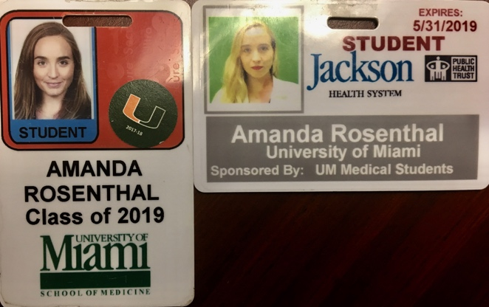
Student Identification:

