Holistic Nursing:
Loendivd Westhuizeen.

Abstract (300 word limit)
Holistic Nursing.
This ideal way of caring for the entire person, not just their physical body, is one that dates back to Florence Nightingale herself. She emphasized the connection between patients and their environment, she is considered one of the first holistic nurses. Nursing has come a long way since the days of Florence Nightingale and her pioneering actions.
As nurses we must be knowledgeable about how diseases affect our patients. Due to the high patient load and often intense time constraints placed on nurses, it can be easy to simply treat the physical being and move on to the next patient. It is important to care for the whole person and to see them as just that. Holistic nursing care involves healing the mind, body, and soul of our patients. It involves thinking about and assisting patients with the effects of illness on the body, mind, emotions, spirituality, religion, and personal relationships. Holistic care also involves taking into consideration social and cultural differences and preferences. The speaker will elaborate on the care of the patient and also demonstrate that nursing care of each patient should be individualized.
As nurses we can not only use holistic nursing care to enrich the lives of our patients, but to enrich our own lives as well. It is physically, mentally, and emotionally draining the nurses at times. One way to increase these experiences and provide better overall care to our patients is through holistic nursing care. The key is not necessarily about how long you spent interacting with a patient, but how you used the time you had with them.
The quote: “They may not remember your name, but they will remember how you made them feel” is a true effect of holistic patient care, and the speaker will stipulate why Holistic nurses are often described by patients as those nurses that “truly care.”



Resent Publications: Recent Publications (minimum 5)
Nurse Researcher: (The International Journal of Research Methodology in Nursing and Health Care):

- Westhuizen L. (2013), Cochrane’s critical contribution. Nurse Researcher. 21, 1, 5.

Improving Practice Guide: - Joanna Briggs Institute


- Westhuizen L. (2012), Clinical Handover among nursing staff in an acute care setting: a best practice implementation project. JBI Fellows Reports. 2009-2012, 22

- Westhuizen L. (2016) Over the counter (OTC) artificial tear drops for dry eye syndrome CNCF Cochrane Review Summaries published in the International Journal of Nursing Studies "Cochrane Corner"

Waiting for publication:


Cochrane Review Summary titled:
- Westhuizen L. (2017) Physical activity for treatment of irritable bowel syndrome
- Westhuizen L (2018) Explore the Preceptor-Preceptee Relationship in a multicultural environment in the Kingdom of Saudi Arabia: A Phenomenological Study:



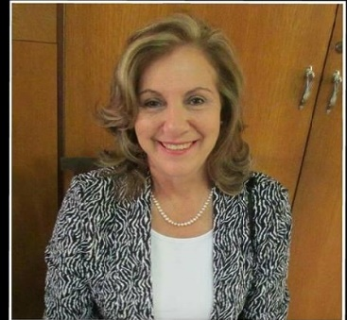

Image

Biography (150 word limit)

Dr.Loendi van der Westhuizen is a multi-skilled Registered Nurse from South Africa, currently working in Saudi Arabia.
As a professional Health Care Consultant, I am passionate about my role in today's increasingly complex environment. With over 40 years of experience in health care operations, administration, education and more than 16 years of international experience as a health care contributor, I am specialized in various different areas.
In 1988, I completed my Bachelor of Social Science in Nursing Administration and has 8 Diplomas in various nursing fields. I also obtained my MA and PhD in Business Administration and is currently working on a Master Degree in Nursing Research and Evidence Based practice. I am also Ophthalmic Specialized Nurse and worked at King Khaled Eye Specialist Hospital as Unit manager.
My dedication never ends and I empower myself to support my collogues and staff to deliver best practice at all times.

Email: avdwplus@gmail.com

Notes/Comments:

Speaker at International Conferences: (10 Oral presentations)

I have done international Conference presentation, speaking for Hospital Management Asia International Conferences for the past 14 years.

