Title: Facial Expression Analysis in elderly persons using thermal imaging
Suparna Rooj, Vrinda Prajapati, Satyajit Nayak, Aurobinda Routray
IIT Kharagpur, Advanced Technology Development Centre, West Bengal, India

The early detection of emotional imbalance is necessary for prevention of mood disorders. Thermal imaging provides a relatively accurate method of emotion recognition. According to Bogren and Buonocore, the blood flow pattern is different in elderly and young people. The changes in the physiological parameters due to emotion are more robust signatures for emotion detection as compared to visual or facial cues. To the best of our knowledge there has not been any work on emotion recognition of older adults from thermal imagery.
This paper attempts to identify and analyse the difference between facial thermal signatures of young and geriatric population during various emotions. The analysis has been performed on thermal and visible video clips of spontaneous emotions elicited by standardised audio-visual videos for six basic emotions of Paul Ekman. The experiment is validated using physiological signals, captured using non-invasive sensors, self-rating and ratings by trained decoders. Analysis of videos has been done in both visual and thermal modality to identify the emotional states of young and older adults. The results indicated that the thermal signatures were less affected by aging affects.
Keywords: Emotion, geriatric population, spontaneous expression, thermal signature

Biography
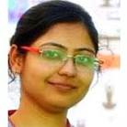Suparna Rooj is currently pursuing his PhD at Indian Institute of Technology, Kharagpur. She completed M.Tech in Electrical Engineering from National Institute of Technology Rourkela, Odisha and B.Tech in Electronics & Communication Engineering from Lovely Professional University, Punjab. Her research interests include Cognitive and Affective Ageing Technology, Computer Vision, and Thermal Imaging.
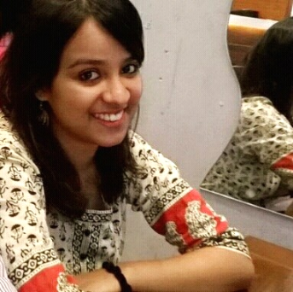 Vrinda Prajapati is currently pursuing a PhD at the Advanced technology development centre of Indian Institute of Technology, Kharagpur. She received an Integrated B.tech- M.tech Degree in Cognitive Neuroscience from Centre for converging technologies in University of Rajasthan, Jaipur. Her research interests include Emotional intelligence, working memory and deep breathing.
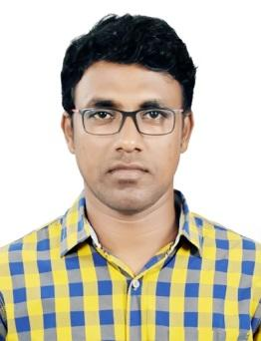 Satyajit Nayak is currently pursuing his PhD at Indian Institute of Technology, Kharagpur. He completed M.Tech in Computer Science from Berhampur University, Odisha and B.Tech in Computer Science & Engineering from Utkal University, Odisha. His research interests include Human-Computer Interaction, computer vision, Cognitive and Affective Ageing Technology, and Data Analytics for Reliability and Quality.

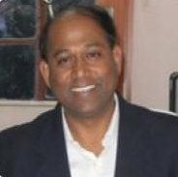 Dr. Aurobinda Routray is currently the professor of IIT Kharagpur in the department of Electrical Engineering. He has around 22 years of experience. He has seven patents (both India and USA) in his name. The primary focus of the group is to develop fast and accurate algorithms for signal detection, classification, information retrieval and then implementation on portable platforms. Many of the lab-models were converted to product prototypes. The major research interests are Human Monitoring, Machine Diagnostics and Prognostics and other products.
Presenting author details
Full name: Dr. Aurobinda Routray
Contact number: 09434041944
Linked In account: linkedin.com/in/aurobinda-routray-22b09915, aurobinda.routray@gmail.com
Session name/ number: Others
Category: Oral presentation

Full name: Suparna Rooj
Contact number: 9434159729
Linked In account: linkedin.com/in/suparna-rooj-6265b165, rooj.suparna1092@gmail.com
Session name/ number: Others
Category: Oral presentation

