Design and Development of Non-Contact Based Health Aware HCI for Assessing and Improving Geriatrics Health-related quality of life (HRQoL)
Satyajit Nayak ¹, Aurobinda Routray^{2,} Monalisa Sarma^{3,} Vrinda Prajapati⁴
¹ Research Scholar, Indian Institute of Technology, Kharagpur
²Professor, Dept. of Electrical Engineering, Indian Institute of Technology,
³Asst. Prof. Subir Chowdhury School of Quality and Reliability, Indian Institute of Technology, Kharagpur
⁴ Research Scholar, Advanced Technology Development Centre, Indian Institute of Technology, Kharagpur
Abstract
Recent advances in medicine and technology allow people to aging and healthier compared to the earlier generations, which brings many challenges to assess the geriatrics health related quality of life [1]. A lot of research review [2], [3] on that field to entitle the old age people to live independently and encourage a sense of overall well-being by using various technological and medical intervention. Although in the evolutionary phase different noninvasive contact based health monitoring methods can help research fraternity to measure the leading health indictors like respiration rate(RR), heart rate(HR), facial blood flow rate(FBFR), blood Pressure(BP), body temperature(BT), and pulse oximetry(SpO₂). But, there is a lack of appropriate analytic research on contact based health indicator measure and how these indicators affect the geriatrics health related quality of life.

The aim of this paper is to fill up this void of a lack of technical and computational approach in existing design. There are two main objectives here we have taken care 1. Developing a Non-Contact based health aware HCI for assessing the physiological parameters of geriatrics, [4], [5] 2. Used some multimodal approach algorithms for analysis in the study are logistic regression (LR) and machine learning (ML) methods, such as decision tree, random forest, and support vector machine [6], [7]. Our experimental and computational process identifies the factors that affect the health-related quality of life (HRQoL) of geriatrics with leading health parameters and afterwards develop from such factors an improved prototype to identify HRQoL
Keywords: RR, HR, FBFR, SpO_{2,} HRQoL, multimodal

Biography
Satyajit Nayak received the B. Tech degree in Computer Sc. and Engg from Utkal University, Odisha, India. Also received the M. Tech degree in Computer Science from Berhampur University, Odisha, India. He is currently pursuing PhD degree at the Indian Institute of Technology (IIT) Kharagpur, India. His current research interests include a) Human-Computer Interaction b) Computer Vision c) Cognitive and Affective Ageing Technology d) Data Analytics for Reliability and Quality. He is having 7 years of UG level teaching experience in the field of Computer Science and Engg.
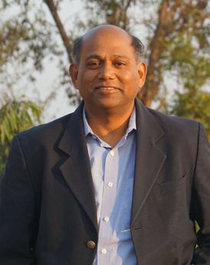
Dr. Aurobinda Routray is currently the professor of IIT Kharagpur in the department of Electrical Engineering. He has around 25 years of professional experience. He has seven patents (both India and USA) in his name. The primary focus of the group is to develop fast and accurate algorithms for signal detection, classification, information retrieval and then implementation on portable platforms. Many of the lab-models were converted to product prototypes. The major research interests are Human Monitoring, Machine Diagnostics and Prognostics and other products.

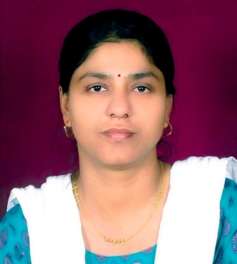
Dr. Monalisa Sarma is Currently working as an Assistant Professor at Subir Chowdhury School of Quality and Reliability, Indian Institute of Technology Kharagpur (WB), India. She has around 21 years of professional experience. Her work covers various field of Computer Science and Reliability and Quality Engineering. Specifically, her research interest is in the areas like Cloud Computing, Big data Analytics, Human Reliability and Software Reliability.

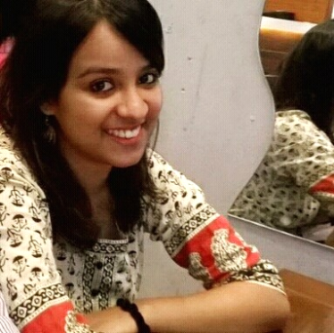
Vrinda Prajapati is currently pursuing a PhD at the Advanced technology development centre of Indian Institute of Technology, Kharagpur. She received an Integrated B.Tech- M.Tech Degree in Cognitive Neuroscience from Centre for converging technologies in University of Rajasthan, Jaipur. Her research interests include Emotional intelligence, working memory and deep breathing.

Presenting author details  Full name: Satyajit Nayak  Contact number: +91-9437629066  Twitter account: @Satyaji18497192  Linked In account:  Session name/ number: Oral Presentation  Category: (Oral presentation/ Poster presentation) | Presenting author details  Full name: Dr. Aurobinda Routray  Contact number: +91-9437629066  Twitter account:  Linked In account:  Session name/ number: Oral Presentation  Category: (Oral presentation/ Poster presentation)

References
- UN, “World population ageing: 1950–2050,” 2001, pp. 11–13.
- Alexandros et al.: Fellow, IEEE, A Survey of Wearable Sensor based Systems for Health Monitoring and Prognosis, IEEE transactions on systems, man, and cybernetics—part c: applications and reviews, vol. 40, no. 1, January 2010
- Parisa Rashidi, Member, IEEE, and Alex Mihailidis, A Survey on Ambient-Assisted Living Tools for Older Adults, IEEE journal of biomedical and health informatics, vol. 17, no. 3, may 2013
- li et al.: Review on Recent Advances in Doppler Radar Sensors for Noncontact Healthcare Monitoring, IEEE transactions on microwave theory and techniques, vol. 61, no. 5, may 2013
- K. Miesenberger et al. (Eds.): ICCHP 2010, Part II, LNCS 6180, pp. 556–559, 2010. © Springer-Verlag Berlin Heidelberg 2010, Human-Computer Interaction and Usability Engineering for Elderly (HCI4AGING): Introduction to the Special Thematic Session
- Debajyoti Pal et al.: Smart Homes and Quality of Life for the Elderly: Perspective of Competing Models, 2169-3536, 2018 IEEE. Translations and content mining are permitted for academic research only. Personal use is also permitted, but republication/redistribution requires IEEE permission.
- Soo-Kyoung Lee et al.: Prediction Model for Health-Related Quality of Life of Elderly with Chronic Diseases using Machine Learning Techniques, Healthc Inform Res. 2014 April;20(2):125-134. http://dx.doi.org/10.4258/hir.2014.20.2.125 pISSN 2093-3681 • eISSN 2093-369X

