Title: Respiration, emotions and emotional intelligence
Vrinda Prajapati, Satyajit Nayak, Aurobinda Routray, Rajlakshmi Guha
IIT Kharagpur, Advanced Technology Development Centre, West Bengal, India

Respiration is vital for survival and plays an important role in enhancing physical, mental and spiritual well- being. It helps in connecting our conscious awareness with the body state. The depth and rate of our breathing affects both our physical and emotional states and can be used as an indicator of our overall wellbeing. The respiratory patterns associated with various emotions can be distinguished on the basis of respiratory rate, inspiratory pause, tidal volume and breathing irregularity. The current literature lacks quantification of emotional states on the basis of breathing patterns, also the relation between parameters of emotional intelligence and emotional arousal has not been explored.
This paper proposes an experiment on emotions, emotional intelligence and respiration pattern. It has the following objectives: (a) Determine the breathing patterns associated with different emotions; (b) Observe the correlation between emotional intelligence and emotional arousal. In this study Ekman’s 6 basic emotions were elicited in the subjects using standardized emotion eliciting videos and the resultant emotional arousal was correlated with the subject’s emotional intelligence, and the breathing patterns measured with the help of non- contact based breath sensors. It was found that different emotional states can be differentiated on the basis of associated breathing patterns. A significant difference was found between the levels of emotional arousal in subjects with high and low scores in emotional intelligence parameters.
Keywords: Breath, respiratory patterns, emotion, emotional intelligence, cognition
Biography
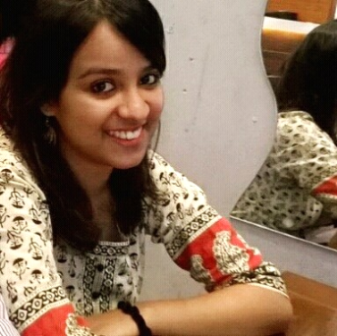 Vrinda Prajapati is currently pursuing a PhD at the Advanced technology development centre of Indian Institute of Technology, Kharagpur. She received an Integrated B.tech- M.tech Degree in Cognitive Neuroscience from Centre for converging technologies in University of Rajasthan, Jaipur. Her research interests include Emotional intelligence, working memory and deep breathing.
 Satyajit Nayak is currently pursuing his PhD at Indian Institute of Technology, Kharagpur. He completed M.Tech in Computer Science from Berhampur University, Odisha and B.Tech in Computer Science & Engineering from Utkal University, Odisha. His research interests include Human-Computer Interaction, computer vision, Cognitive and Affective Ageing Technology, and Data Analytics for Reliability and Quality.
 Dr. Aurobinda Routray is currently the professor of IIT Kharagpur in the department of Electrical Engineering. He has around 22 years of experience. He has seven patents (both India and USA) in his name. The primary focus of the group is to develop fast and accurate algorithms for signal detection, classification, information retrieval and then implementation on portable platforms. Many of the lab-models were converted to product prototypes. The major research interests are Human Monitoring, Machine Diagnostics and Prognostics and other products.
 Dr Rajlakshmi Guha is currently an Assistant professor at IIT Kharagpur in the Centre for educational technology. She received her doctorate degree in social clinical psychology and has various publications in the field of depression, stress and cognitive behaviour therapy. The major research interests are Attentional and Perceptual processes of young adults and its impact on Learning and Memory, Emotional expression, Monitoring and Emotion regulation.
Presenting author details
Full name: Prof Aurobinda Routray
Contact number: +91 9547844717
Linked In account: https://www.linkedin.com/in/aurobinda-routray-22b09915/
Session name/ number: Others
Category: Oral presentation

Full name: Vrinda Prajapati
Contact number: +91 9468949996
Linked In account: https://www.linkedin.com/in/vrinda-prajapati-970526113/
Session name/ number: Others
Category: Oral presentation

