Cellular systems for targeted drug delivery for the treatment of purulent wounds
Berikkhanova Kulzhan, MD PhD, National Laboratory Astana, Nazarbayev University, Kazakhstan.
Daniyeva Nurgul, Researcher, National Laboratory Astana, Nazarbayev University, Kazakhstan.
Zakirov Ernur, MD, Researcher, National Laboratory Astana, Nazarbayev University, Kazakhstan.
Zhilkaidarov Askhat, MD, City Hospital №1, Astana, Kazakhstan.
Bikhanov Nurzhan, MD PhD, University Medical Center, Nazarbayev University, Kazakhstan.
Sultan Yesenkhan, MD, City polyclinic № 30, Almaty, Kazakhstan.

Abstract (300 word limit)
Statement of the Problem: Diabetic foot ulcers are serious complication of diabetes, which lead to significant morbidity and mortality. Statistically, about 20-25% of diabetic patients develop foot ulcers, about 25% of these patients develop infections that lead to amputation. Delayed healing of diabetic wounds is commonly caused by combination of factors, including macro- and microvascular disorders, bacterial infection, local metabolic changes. These disorders lead to change in composition of extracellular matrix, which is mediated by cytokines/chemokines imbalance. Selective distribution of cytokines by targeted delivery can provide greatest effect in diabetic wound healing, local high concentration in pathological tissues without affecting healthy organs. Erythrocyte-based systems are convenient, physiological, simple transport option for targeted delivery due to their safety, ease of receipt, and effective use in clinical practice. Methodology & Theoretical Orientation: We created cellular systems for targeted delivery of cytokines and antibiotics, and developed method for treatment purulent wounds in experimental animals. Drug-loaded erythrocytes were prepared using hypo-osmotic hemolysis procedure. The biopharmaceutical parameters of cellular containers have been studied. Autologous erythrocyte carriers containing cytokines are selectively captured by macrophages in inflamed wound tissue. Release of active drug from erythrocyte container occurs during phagocytosis. Findings: The cytological investigations have shown the implementation of erythrocyte pharmacocytes in combination with primary suturing of purulent wound reduces the inflammatory process and allows a considerable reduction of duration of wound healing.
Conclusion & Significance: These data suggest that pharmacocytes are effective drug carriers for targeted delivery of cytokines and antibiotics to the sites of inflammation, and have a potential for improving the treatment outcomes of purulent diseases. Results of experiments have showen that the use of targeted drug delivery systems based on autologous erythrocytes could provide a new opportunity for the treatment of purulent wounds.

Image
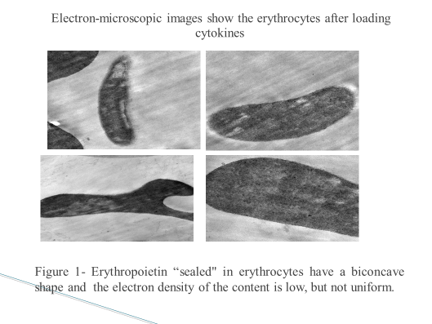
Recent Publications (minimum 5)
- Scientific Proceedings Dedicated to the 10th Anniversary of the Centre for Life Sciences, Nazarbayev University. Chapter 6. Development of innovative technologies for targeted drug delivery to the sites of surgical infections. Zhaxybay Zhumadilov, Kulzhan Berikkhanova, Alexander Gulyayev, Sholpan Askarova. — Nur-Sultan: Foliant, 2020. — 272 б. ISBN 978-601-338-615-7. P. 179-211. https://nla.nu.edu.kz/wp-content/uploads/2021/01/Scientific-Proceedings_compressed.pdf
- Red blood cell ghosts as promising drug carriers to target wound infections. Berikkhanova Kulzhan, Zhumadilov Zh. MEDICAL ENGINEERING & PHYSICS Том: 38 Выпуск: 9 SI Стр.: 877-884. 2016. https://doi.org/10.1016/j.medengphy.2016.02.014
- Changes gentamicin pharmacokinetics when depositing this antibiotic in cell containers. K Berikkhanova - BASIC & CLINICAL PHARMACOLOGY & TOXICOLOGY, 2014; Том: ‏ 115. ‏ SI 1. Стр.: ‏ 104-105. https://www.scopus.com/authid/detail.uri?authorId=56076631900.
- Cytotoxicity reduction of rifampicin by incorporation into red blood cell ghosts. K. Berikkhanova et al. International Journal of Preclinical and Pharmaceutical Research. 2014, Vol. 5(3).-P.147-155. file:///D:/172_147-155(preclinical).pdf
- PHARMACOKINETICS OF CEFTRIAXONE INCLUDED IN CELLULAR TRANSPORT SYSTEM. Berikkhanova, K.12th Congress of the European-Association-for-Clinical-Pharmacology-and-Therapeutics, SPAIN. 27-30, 2015. European Assoc Clin Pharmacol & Therapeut THERAPEUTICS Vol: 37 Issue: 8 S. P.: E62-E62. 2015. DOI:10.1016/j.clinthera.2015.05.187
Acknowledgments
This research is funded by the Science Committee of the Ministry of Science and Higher Education of the Republic of Kazakhstan Grant №AP19676272 and by Nazarbayev University under Collaborative Research Program Grant № 211123CRP1614, A.G."

Photograph



Biography (150 word limit)
Berikkhanova Kulzhan is MD, PhD, Associate Professor, Leading Researcher at the National Laboratory Astana of Nazarbayev University. She has more than 24 years’ experience of a highly qualified surgeon, including clinical experience in the treatment of purulent wounds, as a researcher - 18 years. Her research interests are focused on targeted drug delivery, cellular technology, regenerative medicine, acceleration of healing of purulent wounds. She has 70 scientific publications, including articles in international scientific journals, 1 textbook, 1 monograph, 6 patents. She introduced into clinical practice an innovative method for treatment of purulent wounds, peritonitis using targeted delivery of antibiotics in pharmacocytes.
Email:kberikkhanova@nu.edu.kz

