NEW MAGNETIC NANOPARTICLE CATALYST FOR THE SYNTHESIS OF PHARMACEUTICALLY ACTIVE TETRAZOLOPYRIMIDINES
Oleg M. Demchuk,¹ A. Maleki,² J. Rahimi,² A. Z. Wilczewska,³ R. Jasiński⁴

¹ Pharmaceutical Research Institute, 8 Rydygiera Str., 01-793 Warsaw, Poland
² Department of Chemistry, Iran University of Science and Technology, Tehran 16846-13114, Iran
³ Institute of Chemistry, University of Białystok, Ciołkowskiego 1K, Białystok, 15-245 Poland
⁴ Institute of Organic Chemistry, Cracow University of Technology, Warszawska 24, Cracow, 31-155, Poland

Substituted pyrimidines are very important biologically and pharmaceutically active agents in the medicinal chemistry and drug discovery processes. A multicomponent reaction (MCRs) are ideal synthetic strategy to construct diverse molecular scaffolds of tetrazolopyrimidines starting from a few simple materials or intermediates. In connection with our continuous interest in design new efficient and green protocols of synthesis of new biologically active compounds we developed sonochemical approach for the one-pot four-component synthesis of 5-methyl-7-aryl-4,7-dihydrotetrazolo[1,5-a]pyrimidine-6-carboxylic esters, obtained in the reaction of 2-cyano-guanidine, sodium azide, various aromatic aldehydes and methyl or ethyl acetoacetates in the presence of a catalytic amount of new functionalized hybrid organic-inorganic nanoparticle magnetic metal oxide core–shell based [1] catalyst Fe₂O₃@SiO₂-(CH₂)₃NHC(O)(CH₂)₂PPh₂
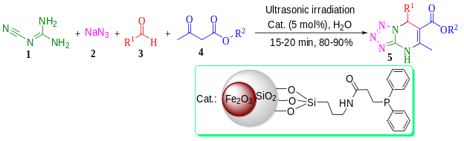
This is the first design, preparation, full characterization and application of the present nanomaterial and also the first ultrasound irradiated synthesis of the biologically and pharmaceutically important heterocyclic compounds in water used as a green solvent. The novel protocol offers several advantages such as high yields, short reaction times, mild reaction conditions, environmentally-friendly reaction media, easily isolation of the products, simple preparation, and recoverability of the nanocatalyst by an external magnet and reusing several times without significant loss of activity.
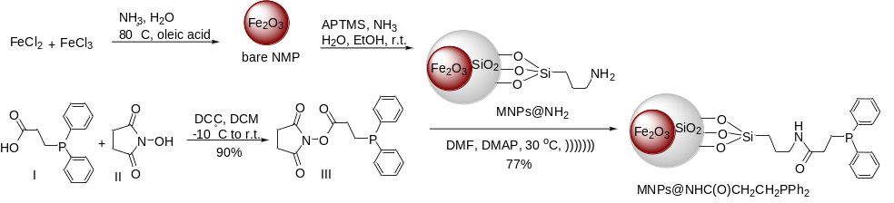
The details of our studies, which describe a scope and generality of the one-pot, simple and high atom economy strategy of synthesis of tetrazolopyrimidine derivatives with respect to various starting materials, will be presented.

[1] A. Maleki, J. Rahimi, O.M. Demchuk, A. Z. Wilczewska, R. Jasiński, Ultrasonics Sonochemistry, 2017, 43, 262

.

Keywords— tetrazolopyrimidine, ultrasonics sonochemistry, environmentally-friendly reaction, magnetic nanoparticle catalyst

Professional Biography (100-150 words)

Originally Ukrainian, he graduated from the I. Franko Lviv State University (Ukraine) in 1997, and took his Ph.D. in organic chemistry from the Institute of Organic Chemistry of Polish Academy of Sciences in 2004. Dr Demchuk accomplished postdoctoral NATO Science fellowship in Prof. Victor Snieckus group at the Queens University (Canada). Dr Oleg M. Demchuk is currently a professor at the Pharmaceutical Research Institute in Warsaw (Poland), where his research interests embrace synthesis and practical application of biologically active compounds, supramolecular and heteroatom and coordination chemistry. Since 2014, Dr Demchuk is the Chief Editor of an international peer reviewed journal, Current Chemistry Letters published by Growing ScienceTM. Dr Demchuk has also participate in the IUPAC as Young Observer in years 2007 and 2009, and next as NR and AM of Division III and CHEMRAWN Committee and eventually he is a Titular Member of IUPAC.


Paste your Photograph here

Email Id:

Any Comments:

