Antimicrobial Resistance pattern and Attributable Burden of Acinetobacter baumannii infection in intensive care unit Patients at level 1 trauma centre in India
Parul singh¹, Aishwarya Govindaswamy ¹, Vijeta Bajpai¹, Rajesh Malhotra², Purva Mathur^{1*}
¹Department of Microbiology, ²Department of Orthopaedics, Jai Prakash Narayan Apex Trauma Centre, All India Institute of Medical Sciences, New Delhi

Abstract: Acinetobacter species especially Acinetobacter baumannii are emerging as a serious cause of healthcare associated infections especially in intensive care units (ICU). Acinetobacter can infect virtually any body site , particularly the lower respiratory tract , the bloodstream, and the urinary tract . Infection is mainly related to inappropriate or previous use of antibiotics and the increase use of invasive devices in the ICU. The rising numbers of multi drug resistant (MDR) Acinetobacter species have limited the therapeutic choices for infections control. The purpose of the study aimed to determine the prevalence of MDR- Acinetobacter baumannii infections and their antibiotic susceptibility pattern.Materials/Methods: This is a retrospective study of the Intensive Care Unit (ICU) of our hospital over a period of seven years (from 2012 to august 2018). Total of 2601 specimens were received, which included respiratory samples (tracheal aspirates/ BAL /sputum), urine, wound specimens, tissue and blood culture .The above samples were processed following standard microbiological procedures.Results: Of the 2601 sample, 84.9% (2207/2601) were from male patients. Among the age wise distribution it has been seen middle age group 18-35 years had 45.1% of the infection rate. The most frequent pathogen isolated was Acinetobacter baumannii while few isolates of Acinetobacter lwoffi also reported. All the isolates had high resistance to amikacin, ampicillin-sulbactum, cefepime, cefepime/tazobactum, ceftazidime, ciprofloxacin, imipenem, meropenem, levofloxacin whereas susceptibility to tigecycline (90%), colistin (98.1%) respectively. Conclusion: The profile of antimicrobial agents used to treat Acinetobacter baumannii infections have changed according to the pattern of resistance .Colistin is the currently most frequently administered antimicrobial agent whereas the uses of of carbapenems were decreased reflecting the current high rate of resistance. Due to limited therapeutic options, prevention and infection control measures are essential .These should include not only traditional infection control measures, but also antibiotic control strategies in the ICU.

Figure 1: sample distribution of ICU patients 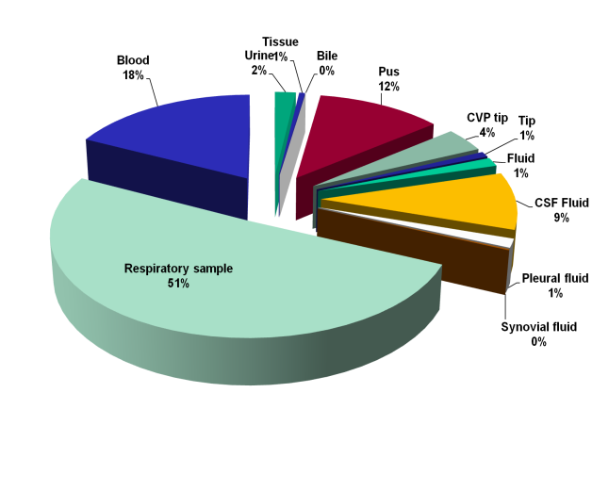

Figure 2: Antibiogram of Acinetobacter baumannii from 2012- 2018

Resistance (%) 2012 - AUG 2018
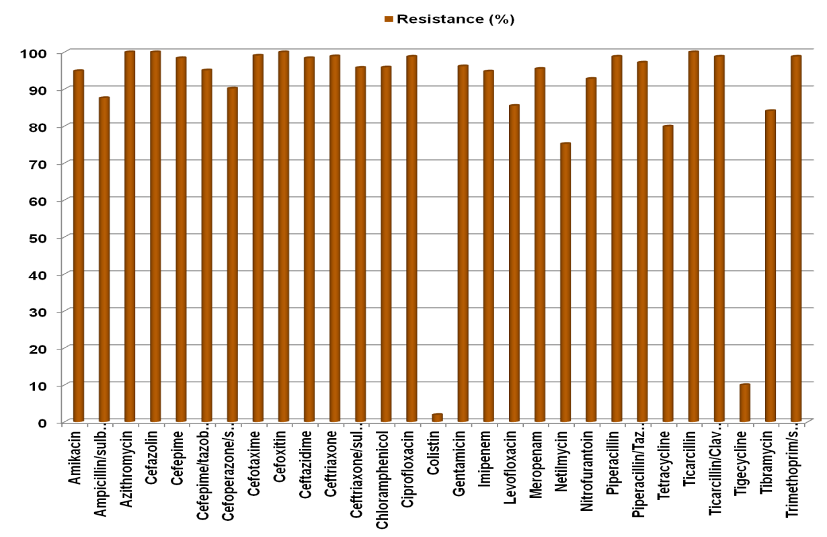
Sensitive (%) 2012 - AUG 2018
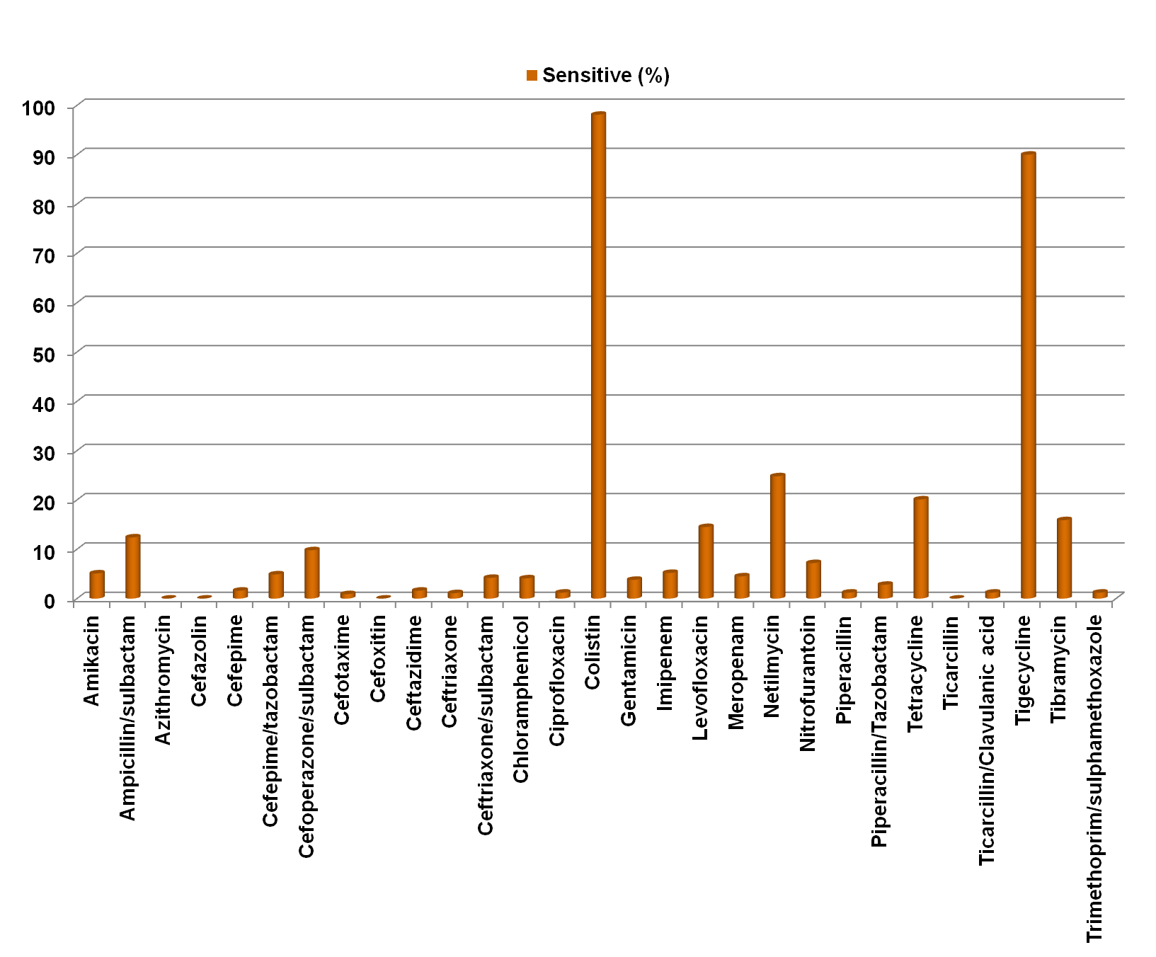

Recent Publications
- Prevalence and Antibiotic Resistance Profile of Cerebrospinal Fluid Pathogens from Neurosurgical Patients from Level 1 Trauma Center in India (AJNS_268_18).
- Intestinal parasitosis and gender distribution in immunocompromised individuals.
Biography
: 
- I have built this model after years of experience in research, evaluation, teaching and administration both in hospital and education institutions. I have expertise in monitoring and identifying microorganisms,monitor and assess samples from range of sources,use a variety of identification methods, including molecular techniques, to test samples,develop and plan methods to prevent the spread of disease,manage and oversee laboratory work.Field of interests include Mycobacteriology, Infectious Diseases and Control, Hospital Infection Control, Antibiotic Policy & Antibiotic resistance Surveillance and research in India
Email ID: parul5fiore@gmail.com

