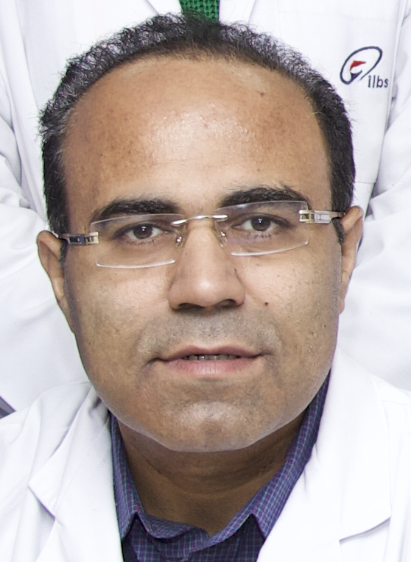
Title: GeneXpert as a Diagnostic tool for Diagnosis of Extrapulmonary Tuberculosis
Authors: Vikas Khillan, Pratibha Kale, Nitya Batra
Department of Clinical Microbiology, Institute of Liver and Biliary Sciences, New Delhi.
Presenting author: Dr. Vikas Khillan
Institute of Liver and Biliary Sciences, New Delhi, India
Category: Poster presentation
Introduction
Extrapulmonary tuberculosis (EPTB), a paucibacillary condition needs to have a strong diagnostic armamentarium. With the advent of newer diagnostic techniques like cartridge based nucleic acid amplification techniques [CB NAAT] (GeneXpert MTB/RIF assay, Cepheid, USA) which has a lower detection limit there is scope in improvement in diagnosing this entity.
Methods
Liver disease patients admitted from June 2017 to June 2018 were investigated for EPTB based on clinical and radiological suspicion. EPTB was diagnosed based on one of the following: (i) histological evidence of caseating granulomas; (ii) smear positivity for acid fast bacilli (iii) CB NAAT (GeneXpert MTB/RIF assay, Cepheid, USA).
Results
A total of 290 EPTB specimens received in the laboratory within the 1year period were included. The extrapulmonary samples that were received included body fluids (n=96) which included ascitic fluid, drain fluids, pus aspirates followed by biopsies (n=82), pleural fluids (n=47), lymph nodes (n=43), urine (n=19) and CSF (n=3). GeneXpert MTB/RIF assay was positive in 10.3% (n=30) samples, whereas negative in 89.7% (n=260) samples. The sensitivity of lymph node TB was 93.3% and specificity was 95.5%, whereas the overall sensitivity of GeneXpert MTB/RIF assay was 59.4% and specificity of 95.7%.
Conclusion
The GeneXpert MTB/RIF assay is a valuable tool which can be used for not only for pulmonary, but also for various extrapulmonary samples. In addition to other tests like smear, culture GeneXpert MTB/RIF assay helps in the confirmation of diagnosis. Also a rapid diagnosis of tuberculosis with overall good sensitivity and specificity especially for lymph node samples makes it a beneficial test.
Keywords: Extrapulmonary tuberculosis, GeneXpert, Histopathology, Paucibacillary, Radiology

Biography and Research Interest:
Dr. Vikas Khillan completed his MBBS, MD from UCMS, Delhi in 1999 and 2002. After working as a senior resident in GTB hospital for 3 years, he joined as a National Head, Department of Microbiology at Dr Lal path labs, New Delhi before joining Institute of Liver and Biliary Sciences (ILBS) in 2008 . At ILBS, he was instrumental in setting up of Departments of Clinical Microbiology and Infection control. Along with handling Bacteriology, Mycobacteriology, Parasitology and Mycology sections of the lab, he is actively involved in antibiotic stewardship, infection control activities and biomedical waste management of the hospital . He developed antibiotic policy, infection control manual and quality manuals for the hospital. He emphasized hand hygiene training, surveillance of OTs and monitoring of infection control indicators like CRBSI, SSI, VAP, and CAUTI at ILBS. He is helping clinicians in rational use of antibiotics during his rounds in critical areas of hospital. He is a coordinator for all NABL related activities of the labs in the capacity of “Technical Manager” laboratory medicine. He is a co-chairman of infection control committee and a member of drug and theuraptic committee at ILBS. He is actively involved in the NABH certification and other hospital certification activities like kayakalp. Started post doctoral certificate course in advanced diagnostic and clinical microbiology.
Mail Id: khillanv@yahoo.com
Contact number: 9810686970

