INFECTION CONTROL MANAGEMENT OF INFECTIOUS DISEASES- A CASE STUDY

Dr.Gampa Vijaya Kumar*, S.Murali² & Kamera.Kishore³

*Professor and Head, Dept. of Pharmacy, KGR Institute of Technology and Management, Rampally, Keesara, Rangareddy,Telangana, India
2&3 Assistant Professors, Dept. of Pharmacy, KGR Institute of Technology and Management, Rampally, Keesara, Rangareddy,Telangana, India

Presenting Author Name: Dr.Gampa Vijaya Kumar  Affiliation: Dept. of Pharmacy, KGR Institute of Technology and Management,  University:Osmania University  Country:India  Scientific Session name / number:  Category: (Oral presentation / Poster presentation/ either) | 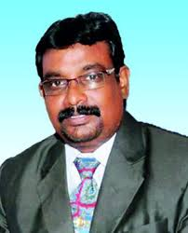

Abstract
This study was designed to provide information regarding the management of patients with specified infectious diseases. The Infection Control Management of Infectious Diseases as an informational guide . Standard precautions (SP) must be applied when caring for any patient regardless of their infectious disease and its consequences. Transmission-based precautions are applied in addition to standard precautions and include the basic parameters, Contact Precautions Transmission occurs by either direct or indirect contact, Direct: involves close contact with a colonized / infected patient with transfer of the organism to the, susceptible host, usually in the course of patient care activities e.g. turning a patient. Indirect: occurs if an infectious agent is transferred via a contaminated intermediate object (fomite) or person e.g. when contaminated patient-care devices are shared between patients without cleaning and / or disinfection between patients. Droplet Precautions Transmission occurs through large (i.e.> >5 microns in size) respiratory droplets that are generated by an infected person who is coughing, sneezing or talking. The droplets do not remain suspended in the air and are propelled a short distance from the source (approximately 1 metre). There is also the potential for indirect contact transmission as the droplets settle on environmental surfaces. Airborne Precautions Transmission occurs by small (i.e.5microns in size) respiratory droplets which are carried through the air. The droplets can remain suspended in the air for long periods and can be dispersed by currents.
Key words: Infectious Diseases, Transmission-based precautions, patients. Droplet Precautions, Airborne Precautions Transmission.

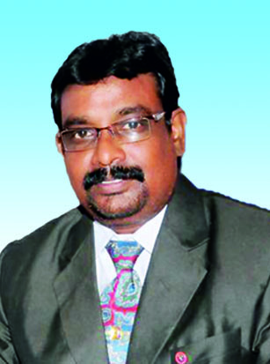
BIOGRAPHY
Dr. Gampa Vijaya Kumar prudent alumni of Bachelor of Pharmacy from Gulbarga University, Gulbarga-1993, attained his M. Tech (Biotechnology) in the year 1996 & accomplished Doctoral Degree in Biotechnology from the Andhra University in the year 2004. His research area of interest is Flavour Ester Synthesis, Plant tissue culture, Protein modelling Studies, Mucoadhesive and Enzymatic Synthesis of chiral drug molecules.
Research works of Dr. Gampa were published in prestigious Scientific Journals, and his works are applauded in many National & International Conference Presentations.
He is invited to deliver several Lectures in Pharmacy meetings and presented his Research papers at International level. He is honourably invited to China-2007, Phillippines-2007, Sweden & Turkey-2009, Lisbon-2010, Hyderabad-2011, Australia-2012 and Spain 2013 for presenting his studious research.
He served as EC member for Several National & International professional bodies.
He is the recipient of prestigious awards and fellowships which includes “Distinguish Alumni award”, from V.L College of Pharmacy, Fellowship award for Association of Biotechnology & Pharmacy, Innovative researcher award from SPER. Apart from regular academics, He is a vigilant guide to Ph. D Scholars; many renowned scholars are awarded under his strenuous guidance.
He is a life time Member to esteemed Professional bodies like
- International Pharmaceutical Federation.
- Asian Association schools of Pharmacy.
- Indian Pharmaceutical Association.
- Indian Pharmacy Graduate association.
- Indian Hospital Pharmaceutical Association.
- Indian Society for Technical Education.
He is active Participant to professional bodies and organized several national seminars.
Last but not least in his service of 24 years he never compromised in his duties and responsibilities in general, academics, in particular discipline.
Presently he is working with KGR INSTITUTE OF TECHNOLOGY AND MANAGEMENT, RAMPALLY, RR-DIST as Professor& Head

