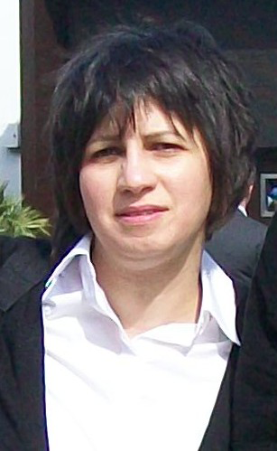

Candida albicans and Non albicans-Candida Single and dual species formed on catheters
O. Benhabib* ^{a,b,} Z. Boucherit-Otmani ª, K. Boucherit ^{a,b}
a: Laboratory Antibiotics Antifungals : Physico-chimical, Synthesis and Biological activities . University of Tlemcen, Bp 119 Imama, Tlemcen,13000, Algeria
b: University Center of Ain Témouchent , 46000, Algeria

Presenting Author Name: Ouassila BENHABIB
Affiliation: LapSab , Tlemcen
University: Centre universitaire Ain Temouchent
Country: Algeria
Scientific Session name / number: Track 13/ Microbial Biofilms
Category: (Oral presentation / Poster presentation/ either)

Abstract
Objective: Only few research attempts to study bi or multi species yeast biofilms, especially Candida albicans vs. non-albicans species. In this context, we planned to search multi-species biofilms of Candida which were formed on the same intravascular catheter taken from patients hospitalized in west Algeria.
Material and methods: For their ability to form biofilms, the prepared single- or mixed-cell suspension were standardized to 10⁶ yeast cells/mL after counting calculated by measuring OD₄₉₂ with a spectrophotometer. And mixed bioﬁlm formation was visualized by Scanning Electron Microscope.
Results: Candida albicans –Non albicans Candida species together formed more complex bioﬁlms compared to the single-species bioﬁlms, clearly pointing to the mutualism interactions of these dual-species bioﬁlms. We observed the morphological and architectural features formed on between dual yeast cells. Non albicans- Candida bioﬁlm, always in close association with Candida albicans hyphae grown on external and inner surface of catheter after an implanted time of 48 hours .
Conclusion: Results point to the need in-depth studies to combat the mixed-species bioﬁlms responsible of catheter infection.

Biography:
PhD Applied Biochemistry,
Passionate about medical mycology, Substitute Teacher of Microbial (fungal and bacterial) biofilms : practical work, workshops and training courses of Master 2 academic ”Biochemistry” University of Tlemcen.

Research Interests: Microbial biofilms
Keywords: Candida albicans; Non albicans-Candida ; Mixed biofilm; Infection; SEM; Catheters
Mail Id: benhabibouassila@gmail.com
Contact Number: +213771338124
Twitter account: (If interested)
Linked In account: (If interested)
Facebook account: (If interested) ouassila Brixi

Suggestions of colleagues/Professors/scholars to send invitation (if any)

Suggestions of Sessions in the conference (if any)

