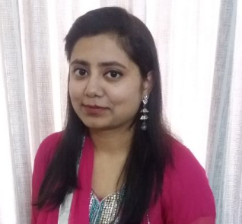
REDUCTION OF SELENITE TO SELENIUM USING BACTERIA ISOLATED FROM POLLUTED AREAS
¹Saima Javed, ¹Muhammad Faisal, ²M. Salman Naeem
¹Department of Microbiology and Molecular Genetics, Faculty of Life Sciences, University of the Punjab, Lahore, Pakistan.
²Faculty of Textile Engineering, National Textile University, Sheikupura Road, Faisalabad, Pakistan.

ABSTRACT
In this work toxic Selenite which is also highly soluble is transformed to Selenium a less toxic element Selenium through biotic transformation using different strains of bacterial like Pseudomonas, Exiguobacterium sp, Bacillus Subtilis and licheniformis. Selenium can exists in different forms like reduced form (Selenide, Se²⁻), water dissolved form (Selenite, So₃⁻²/Selenate SeO₄⁻²) and in the form of element (Seº). Different physical parameters were changed for optimizing conditions like different concentrations of Selenium (Se) varying from 200 to 400 and finally to 600 μg ml⁻¹), temperature, pH, aeration along with incubation time for high reduction of Selenite. It was found that Selenite reduction rate was increased by increasing pH. It was found that at pH 3 around 15-33 % Selenite was reduced and this trend kept on increasing to 28-90% at pH 9. For evaluating optimum temperature for Selenite reduction three levels of temperature were selected (32°C, 37°C and 42°C) were selected. The Selenite reduction was found at different temperatures and the results showed that for optimum reduction of Selenite all strains posses varying preferences. The reduction in Selenite was also checked at different concentrations of Selenite and it was found that maximum reduction of Selenite was observed at lower concentration. This study concluded that in aerobic and anaerobic environment Se can be remediated by using selenite reducing bacteria.
Biography
My name is Saima Javed. I am doing Ph.D from University of the Punjab (Department of Microbiology & Molecular genetics). Currently I am working on screening of biosurfactants and their role in oil biodegradation. I have worked in diagnosis of dengue serotypes by molecular techniques and prevalence of Dengue in Pakistan. I have also worked on heavy metals biotransformation, bioremediation, biodegradation, and phytoremediation. In Future I am interested to join the group in Pakistan to work for the development of vaccination of Dengue virus.
SAIMA JAVED
00923457805609
Oral presentation
Saima88javed@gmail.com

