Study on coconut oil as latent heat storage material for building applications
Milan Ostrý, assoc. prof., PhD, Brno University of Technology, Faculty of Civil engineering, Veveří 95, Brno 602 00, Czech Republic

Abstract
Latent heat thermal energy storage (LHTES) represents advanced technology based on the use of reversible change of phase of materials. LHTES offers significantly higher heat storage density in narrow temperature interval compared to sensible heat storage. Integration of wide range of organic and inorganic of latent heat storage media known as Phase Change Materials (PCMs) was introduced in building industry during last decades as a substitution of heavy-weight structures. Organic PCMs are represented by paraffin or fatty acids, while salt hydrates are typical representatives of inorganic PCMs. Currently the origin of the heat storage materials is starting to play an important role in the design of the heat storage systems. Therefore the environmental impacts such as embodied energy associated with production of PCMs have to be considered too. That is why renewable bio-based non-paraffinic PCMs made from underused feedstock are at the forefront of the development of LHTES. This group of PCMs includes soybean oils, coconut oils and beef tallow.
This paper describes investigation of coconut oil as a representative of promising PCMs because of its availability at domestic market. The samples of coconut oil were subjected to periodical heating and cooling in small environmental chamber. Differential Scanning Calorimetry (DSC) analysis of the samples was performed as well. The results from DSC analysis show that tested coconut oil has melting enthalpy 103 J/g. Temperature ranges of melting and solidification of PCM in Fig. 1 indicate that coconut oil meets one of the conditions for application in buildings. Unfortunately the supercooling effect down to the 20 °C was observed during cooling of the samples. Therefore behavior of coconut oil and its thermal stability will be subject of our future work.
Presented work was supported by the Czech Science Foundation under project No. 19-20943S “Compatibility of plastics and metals with latent heat storage media for integration in buildings”.

Image
Fig.1 Temperature of the coconut oil and water during thermal cycling in environmental chamber
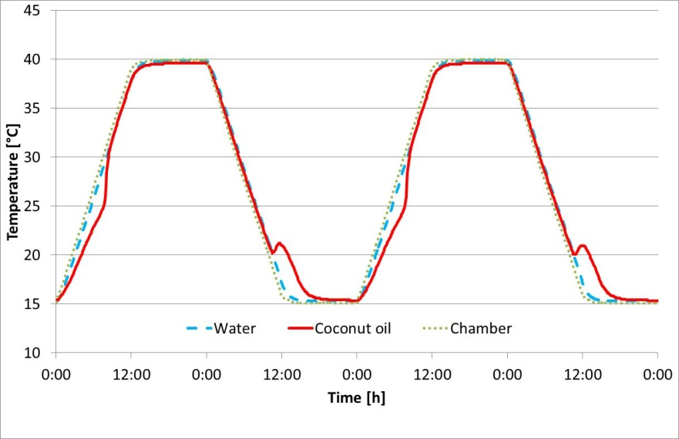

Recent Publications
- Fabiani C, Pisello A L, Barbaner M, Cabeza L F, Cotana F (2019) Assessing the Potentiality of Animal Fat Based-Bio Phase Change Materials (PCM) for Building Applications: An Innovative Multipurpose Thermal Investigation. Energies 12:1-18.
- Jeong SU-G, Chung O, Yu S, Kim S, Kim S (2013) Improvement of the thermal properties of Bio-based PCM using exfoliated graphite nanoplatelets. Solar Energy Materials and Solar Cells 117:87-92
- Ostry M, Charvat, P (2013) Modern building materials, structures and techniques Book Series: Procedia Engineering 57:837-843
- Németh B, Németh A S, Ujhidy A, Tóth J, Trif L, Gyenis J, Feczkó T (2018) Fully bio-originated latent heat storing calcium alginate microcapsules with high coconut oil loading. Solar Energy 170:314-322
- Srivastava Y, Semwal A D, Sajeevkumar V A, Sharma G K (2017) Melting, crystallization and storage stability of virgin coconut oil and its blends by differential scanning calorimetry (DSC) and Fourier transform infrared spectroscopy (FTIR). Journal of Food Science and Technology 2017:45-54
- Wonorahardjo S, Sutjahja I M, Kurnia D (2019) Potential of coconut oil for temperature regulation in tropical houses. Journal of Engineering Physics and Thermophysics 92:80-88.



Biography
Milan Ostrý is associate professor at Brno University of Technology, Faculty of Civil Engineering (Czech Republic). His specializations are thermal engineering, sustainable development and thermal energy storage. He has experience from the national and international projects focused on the thermal energy storage. In the past he also dealt with integration of PCMs into building structures and their performance under real conditions. Currently he is the principal investigator in a research project No. 19-20943S “Compatibility of plastics and metals with latent heat storage media for integration in buildings” supported by Czech Science Foundation.
Email: ostry.m@fce.vutbr.cz

Notes/Comments:

