Rotational Compression as a New Calibrating Test for Damage Function of the Material
Zbigniew Pater, Prof., Lublin University of Technology, Poland

Abstract
One of the major problems of metal forming is material cracking during the process. This phenomenon can be simulated with the so-called damage function, which depends on the stress and strain state. Cracking occurs when this function reaches the critical value, determined experimentally in the calibrating test [1,2]. The currently applied tests are based on compression, tension and torsion. It is also known that the more similar the stress state during the test is to the stress state of the analysed process, the more accurate the material cracking prognostication. Due to this fact, new calibrating tests, dedicated to a chosen metal forming method are constantly sought after. Such a new method is rotational compression of a sample in a channel created by two cooperating tools [3]. At a sufficiently long compression path the strain, with its value changing in the axial area of the sample (compressive to tensile and the other way round), is causing the material to crack as a result of the Mannesmann effect [4-7]. For this reason, the critical values determined in this test are particularly important in the utilitarian manner. Upon conducting a numerical simulation of the test one obtains the damage values for the axial area of the sample, which are then assumed to be the critical damage values. A significant advantage of this calibrating test is the fact that it can be applied in the hot working conditions based on machines (rolling mills) used in the industrial conditions.

Image

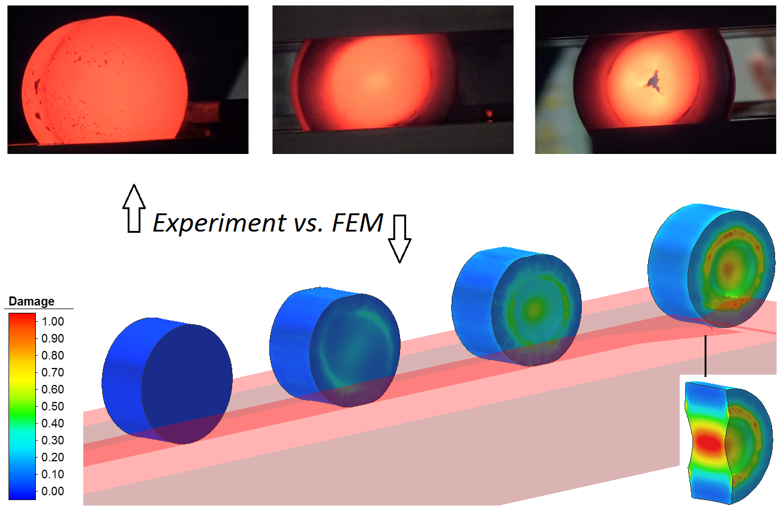

Figure. 1. An example of the usage of the rotational compression in a channel in determining the critical damage function value of C45 grade steel sample, formed at 1000 °C. In the analysis performed in Simufact.Forming the damage function calculated based on the normalised Cockcroft-Latham criterion was utilized.

Recent Publications
- Li H, Fu MW, Lu J, Yang H (2011) Ductile fracture: Experiments and computations. Int J Plasticity 27:147-180.
- Kraisnik M, Vilotic D, Sidanin L, Stefanovic M (2015) Various approaches to defining the criteria of ductile crack in cold bulk forming processes. Annals of Faculty Engineering Hunedoara - International Journal of Engineering 222:259-267.
- Pater Z, Walczuk P, Lis K, Wójcik Ł (2018) Preliminary analysis of a rotary compression test. Adv Sci Technol Res J 12(2):77-82.
- Pater Z, Tomczak J, Bulzak T, Zniszczyński A (2018) The problem of material fracture prediction in cross rolling processes. Adv Sci Technol Res J 12(4):184–189.
- Pater Z, Kazanecki J (2013) Complex numerical analysis of the tube forming process using Diescher mill. Arch Metall Mater 58(3):717-724.
- Tomczak J, Pater Z, Bulzak T (2014) Designing of screw impressions in helical rolling of balls. Arch Civ Mech Eng 14:104-113.
- Pater Z, Tomczak J, Bulzak T, Bartnicki J, Tofil A (2019) Prediction of Crack Formation for Cross Wedge Rolling of Harrow Tooth Preform. Materials 12(2287):1-16.
Biography

Prof. Zbigniew Pater: h–index 16 (according to Scopus), number of citations 933, number of publications 466, number of patents 117 (6 European) – Head of the Computer Modelling and Metal Forming Technologies at Lublin University of Technology, since 2012 the Dean of the Faculty of Mechanical Engineering at Lublin University of Technology, 2008-2012 Vice-Rector for Science at Lublin University of Technology, 1996-99 chief design engineer in SIPMA SA - the leader in the production of agricultural machines; specialist in numerical modelling, virtual prototyping and optimisation of forming processes as well as designing innovative machines used in plastic forming of metals.
Email: z.pater@pollub.pl

Notes/Comments:

