Density functional investigation of structural, electronic and optical properties of CsPb(I_{1-x}Br_{x} )₃ (x = 0.0 − 1.0) compounds

¹Hamid M. Ghaithan, ¹Z. A. Alahmed, ¹Saif M. H. Qaid, ²Mahmoud Hezam, ¹Abdullah S Aldwayyan
¹Physics and Astronomy Department, College of Science, King Saud University, P.O. Box 2455, Riyadh 11451, Saudi Arabia
²King Abdullah Institute for Nanotechnology, King Saud University, P.O. Box 2454, Riyadh 11451, Saudi Arabia.

Abstract:
The structural, electronic and optical properties of the CsPb(I_{1-x}Br_{x})₃ were investigated using the full potential linear augmented plane wave (FP-LAPW) scheme in the frame of generalized gradient approximation (GGA). The two exchange potentials, PBE-GGA and mBJ-GGA are used to study the electronic and optical properties. In this study, we have observed an increase in band gap energy (E_{g}) values by 0.56 eV with complete substitution of I with Br whereas the refractive indices, reflection and real part of dielectric function have shown reverse effects. It is noted that all of the compounds are wide and direct band gap semiconductors with band gap located at M-symmetry point. The optical properties of these compounds like optical conductivities, absorption coefficients, real and imaginary parts of dielectric functions, refractive indices, extinction coefficients, and reflectivities are also calculated. The direct band gap nature and high absorption power of these compounds in the visible ultraviolet energy range imply that these perovskites can be used in optical and optoelectronic devices working in this UV-visible range of the spectrum by replacing I by Br.

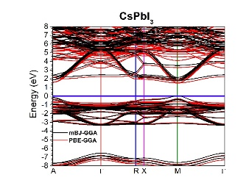
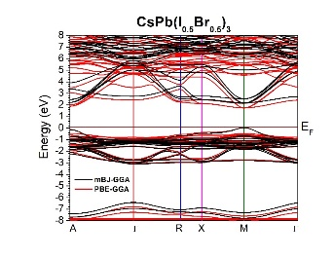
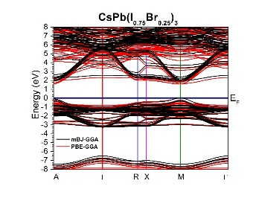
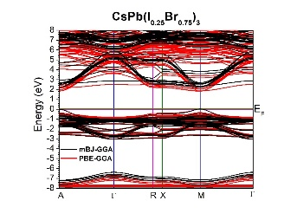
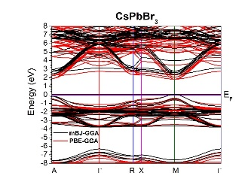

Fig. 2. Calculated band structures of CsPbI₃, CsPb (I_{0.75}Br_{0.25})₃, CsPb(I_{0.5}Br_{0.5})₃, CsPb(I_{0.25}Br_{0.75})₃ and CsPbBr₃ using PBE-GGA and mBJ-GGA approach.

Recent Publications:
- X. Mao, L. Sun, T. Wu, T. Chu, W. Deng, and K. Han, “First-Principles Screening of All-Inorganic Lead-Free ABX3 Perovskites,” J. Phys. Chem. C, vol. 122, no. 14, pp. 7670–7675, 2018.
- M. Maqbool et al., “Structural, electronic and optical properties of CsPbX3(X=Cl, Br, I) for energy storage and hybrid solar cell applications,” J. Alloys Compd., vol. 705, pp. 828–839, 2017.
- R. A. Jishi, O. B. Ta, and A. A. Sharif, “Modeling of lead halide perovskites for photovoltaic applications,” J. Phys. Chem. C, vol. 118, no. 49, pp. 28344–28349, 2014.
X. Chen, D. Han, Y. Su, Q. Zeng, L. Liu, and D. Shen, “Structural and Electronic Properties of Inorganic Mixed Halide Perovskites,” Phys. Status Solidi - Rapid Res. Lett., vol. 12, no. 8, pp. 0–6, 2018.
5. M. Zhang, Z. Zheng, Q. Fu, Z. Chen, J. He, S. Zhang, L. Yan, Y. Hu, W. Luo, Growth and characterization of all-inorganic lead halide perovskite semiconductor CsPbBr3 single crystals, CrystEngComm. 19 (2017) 6797–6803.

Biography:
Hamid M. Ghaithan has his expertise in density functional theory (DFT), WIEN2k package. Structural, electronic and optical properties of inorganic perovskite materials are analyzed by DFT. He can use DFT to study structural, electronic and optical properties of perovskite after doing the doping. He also has an experience in fabrication and characterization of Dye Sensitized Solar Cells (DSSCs). He built a new technique to study the electron dynamics in solar cells. He is a researcher at King Saud University, College of science, Physics & Astronomy Department, Saudi Arabia, Riyadh. (orcid.org/0000-0001-5126-4477).
Email: hghaithan@ksu.edu.sa

