Antitumor Performance Regulation of Drug-conjugated Gold Nanoparticles: Structure-Efficacy Relationship Studies
Ya Ding, PhD, China Pharmaceutical University, Nanjing, CHINA

Abstract: 300 words
Drug-conjugated nanoparticle is a uniquely structured drug delivery system. In each conjugate, the nanoparticle acts as a core to crosslink more than 100 prodrug molecules and prodrug is composed of its parent drug molecules covalently connected on the surface of nanoparticles via proper spacers. This system can be seen the assembly of prodrugs in the nanoscale and show the advantages of both prodrug and nanoparticles. To investigate the structure-efficacy relationship of this system, gold nanoparticles (GNPs) and Doxorubicin (Dox) are selected as the demonstrations to construct Dox-conjugated GNPs. Polyethylene glycol (PEG) is used as the spacer to improve the solubility, biocompatibility, and body circulation of the system. Here, the position of Dox, size of gold core, and molecular weight of PEG are adjusted to regulate the in vitro properties and in vivo performance of Dox-conjugated GNPs systematically.
According to the structure-efficacy relationship studies of Dox-conjugated GNPs, it allows to reveal the internal mechanism that guides therapy of tumor treatment, explore physicochemical and material science approaches to improve the therapy efficacy of nanoconjugates, and promote the theoretical and practical researches of nanoparticle-based drug delivery system as the candidate for tumor treatment.
Image:
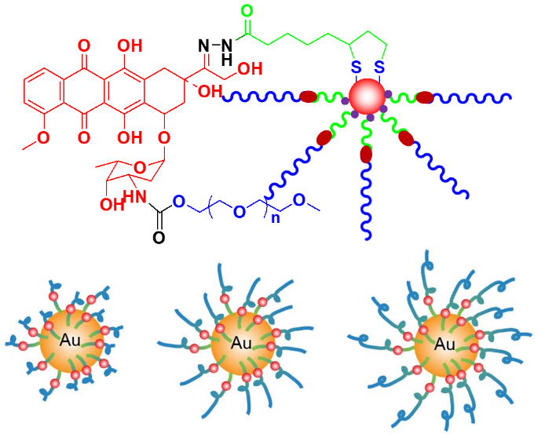
Recent Publications: (Minimum 5)
- Dong-Yan Wu, Huai-Song Wang, Xiao-Shuang Hou, Huan Chen, Yu Ma, Yanglong Hou, Jin Hong, Ya Ding (2018) Effects of gold core size on regulating the performance of Doxorubicin-conjugated gold nanoparticles. Nano Research 2018, 11: 3396-3410.
- Yuan-Yue Gao, Huan Chen, Ying-Ying Zhou, Lin-Tao Wang, Yanglong Hou, Xing-Hua Xia, Ya Ding, Intraorgan targeting of gold conjugates for precise liver cancer treatment. ACS Applied Materials & Interfaces 2017, 9: 31458–31468.
- Teng Cui, Juan-Juan Liang, Huan Chen, Dong-Dong Geng, Lei Jiao, Jian-Yong Yang, Hai Qian, Can Zhang, Ya Ding, The performance of doxorubicin-conjugated gold nanoparticles: regulation of drug location. ACS Applied Materials & Interfaces 2017, 9: 8569–8580.
- Ning Zhang, Huan Chen, Ai-Yun Liu, Jia-Jia Shen, Vishva Shah, Can Zhang, Jin Hong, Ya Ding, Gold conjugate-based liposomes with hybrid cluster bomb structure for liver cancer therapy. Biomaterials 2016, 74: 280-291.
5. Ya Ding, Ying-Ying Zhou, Huan Chen, Dong-Dong Geng, Dong-Yan Wu, Jin Hong, Wen-Bin Shen, Tai-Jun Hang, Can Zhang, The performance of thiol-terminated PEG-paclitaxel-conjugated gold nanoparticles. Biomaterials 2013, 34: 10217–10227.

Figure. The structure of Doxorubicin-conjugated gold nanoparticles
for Structure-Efficacy Relationship Studies


Biography:
Prof. Ya Ding is a professor of Pharmaceutical Analysis at China Pharmaceutical University, China. She obtained her Ph.D. degree in Analytical Chemistry from Nanjing University in 2007. She was a postdoctoral fellow from 2008-2012 in Department of Biology, Nanjing University and a visiting scholar from 2013-2014 in Department of Chemistry, at University of Massachusetts-Amherst. Her research interests include smart drug delivery based on gold nanoparticles, study on the quality standard of nanomaterials, and spectroscopic study of nanomaterials. She has the awardees of Program for New Century Excellent Talents in University (2010) and Science Technology Achievement Award, Higher Institution (Natural Science Award, the first prize, 2011). (orcid.org/0000-0001-6214-5641)
Email: dingya@cpu.edu.cn

