Investigation of half metallic ferromagnetism in doped cubic perovskite structures: A DFT perspective
M.Mohamed Sheik Sirajuddeenª
ª - Dept. of Physics, B.S.Abdur Rahman Crescent Institute of Science & Tech, Chennai, india
Corresponding author email : msheiksiraj@crescent.education
Abstract :
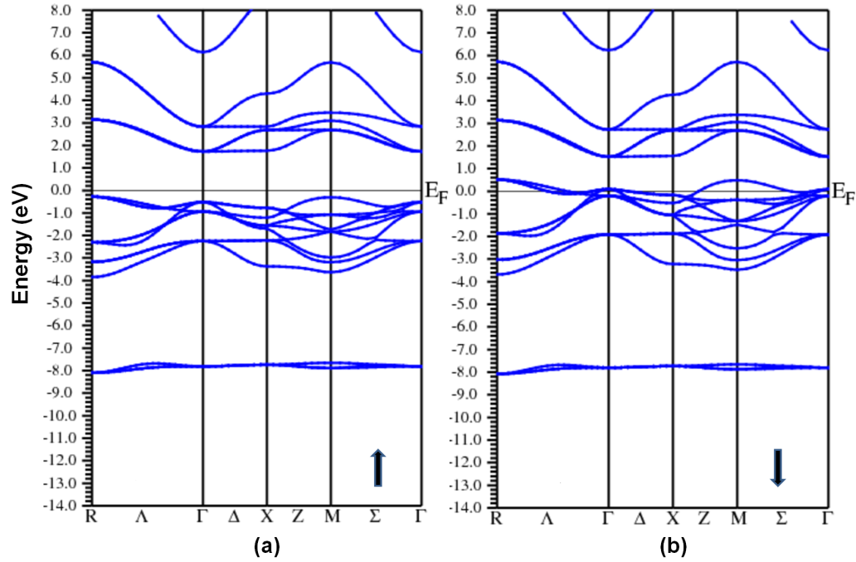
Band structure calculations have been carried out on nitrogen doped perovskite compounds such as ABO₃ (where A=Rb, B=Se,Ti) to investigate the electronic and magnetic properties. The computational DFT based calculations were carried out using Full Potential-Linearized Augmented Plane Wave Method (FP-LAPW). The electronic property such as half metallic ferromagnetism is predicted in this work where nitrogen atom is substituted in the place of one oxygen atom in the formulation of ABO₃ compound. The band structure and density of electronic energy states plots exhibit the existence of spin energy gap in one of the spins while in the other metallic characteristics is predicted. The formation of energy gap in one of the spins qualify the material to be called as half metallic ferromagnetic compound which is suitable for futuristic spintronic applications.

Figure 1 Band structure plots of RbTiN₁O_{x-1} in spin up and down directions
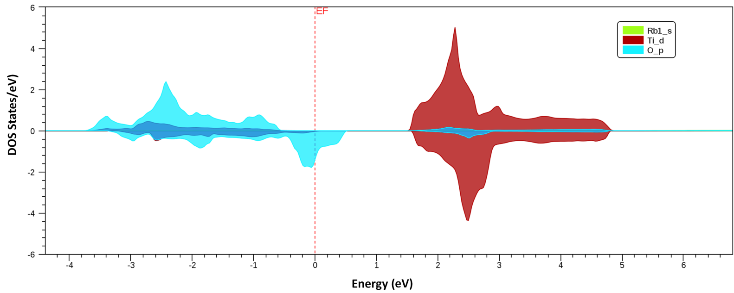

Figure 2 Density of States (DOS) plots of RbTiN₁O_{x-1} in spin up and down directions

The band structure and DOS plots as shown in Figures 1 & 2 exhibit the half metallic characteristics of RbTiOx-1N1 compound where there is energy band gap at the Fermi level in the spin up direction whereas in spin down direction bands are seen to cross the Fermi level predicting a metallic behavior.
References :

[1] De Groot, R. A., F.M. Muller, P.G. Van Engen and K.H.J. Buschow, “New class of materials: Half metallic ferromagnets”, Phys. Rev. Lett., 50, 2024-2027 (1983).
[2] De Groot, R. A., F.M. Muller, P.G. Van Engen and K.H.J. Buschow, “Half-metallic ferromagnets and their magneto-optical properties”, J. Appl. Phys. 55, 2151–2154 (1984).

[3] S.V.Ryabtsev, V.M.Ievlev, A.M.Samoylov, S.B.Kuschev, S.A.Soldatenko, "Microstructure and electrical properties of palladium oxide thin films for oxidizing gases detection", Thin Solid Films, Volume 636, 251-259, (2017).

[4] V. Cassina, L. Gerosa, A. Podestà, G. Ferrari, M. Sampietro, F. Fiorentini, T. Mazza, C. Lenardi, and P. Milani, "Nanoscale electrical properties of cluster- assembled palladium oxide thin films", Phy. Rev. B:Condens.Matter Mater.Phy., 79, 115422 (2009).
[5] Hua-Qing Yang, Chang-Wei Hu, Chao Gao, Meng-Yao Yang, Fang-Ming Li, Cai- Qin Li, Xiang-Yuan Li, "Theoretical study on the gas-phase reaction mechanism between palladium monoxide and methane", J Comput. Chem., 32(16), 3440-55, (2011).
[6] Saima Sadiq, Zahid Ali, Iftikhar Ahmad, Imad Khan, Gul Rehman, Muhammad Sadiq, and Najeeb Ur Rehman, "Structural, Mechanical and Magneto-Electronic Properties of the Ternary Sodium Palladium and Platinum Oxides", Zeitschrift fur Naturforschung a (Z NATURFORSCH A), 70(10), (2015).
[7] Nilsson, " Optical properties of PdO in the range of 0.5-5.4 eV", Journal of Physics C: Solid State Physics, Volume 12, 7, (1979).

[8] AtanuDas, Danny HsuKo, Chia-HsinChen, Liann-BeChang, Chao-SungLai, Fu- ChuanChu, LeeChow, Ray-MingLin, "Highly sensitive palladium oxide thin film extended gate FETs as pH sensor", Sensors and Actuators B: Chemical, 205, 199- 205, ( 2014).
[9] Xiaoqing, Huang Shaoheng, Tang Xiaoliang, Mu Yan Dai, Guangxu Chen, Zhiyou Zhou,Fangxiong Ruan, Zhilin Yang and Nanfeng Zheng, " Freestanding palladium nanosheets with plasmonic and catalytic properties", Nature Nanotechnology, volume 6, 28–32, (2011).

[10] Vinod Kumar Gupta, Ali Fakhri, Shilpi Agarwal, and MahsaNaji, "Palladium oxide nanoparticles supported on reduced graphene oxide and gold doped: Preparation, characterization and electrochemical study of supercapacitor electrode", Journal of Molecular Liquids, 249, 61-65, (2018).

[11] Shivam Kansara, Deobrat Singh, Sanjeev K Gupta, Yogesh Sonvane, "Density functional Studies of structural, electronic and vibrational properties of palladium oxide” Solid State Commns., 245, 36-41, (2016).
[12] Muhammad Z Sialvi, Roger J. Mortimer, Geoffrey D. Wilcox, Asri Mat Teridi, Thomas S Varley, K. G. Upul Wijayantha, and Caroline A. Kirk, "Electrochromic and Colorimetric Properties of Nickel(II) Oxide Thin Films Prepared by Aerosol-Assisted Chemical Vapor Deposition", ACS Appl. Mater. Interfaces, 5 (12), 5675–5682, (2013).
[13] Newman R and Chrenko R. M, "Optical Properties of Nickel Oxide", Phys. Rev. 114, 1507, (1959).
[14] Hubbard J, "Electroncorrelations in Narrow Energy Bands", Proceedings of the Royal Society of London, 276, 238 - 257(1963).
[15] Volker.B, Elliot H Lieb, and Jan P Solovej, " Generalized Hartree-Fock theory and the Hubbard model", Journal of Statistical Physics, Vol. 76, issue 1-2, 3-89 (1994).
[16] Lieb.E.H and Wu.F.Y, "The one-dimensional Hubbard model: A reminiscence, Physica A, 321, 1-27 (2003).
[17] Kuhner.T, and Monien H, "Phases of the one-dimensional Bose-Hubbard model", Phy.Rev. B, 58 (22), R14741 (1998).
[18] P. Hohenberg, W. Kohn, Phys. Rev. 136, B 864-871, (1964).
[19] W. Kohn, L.J. Sham, Phys. Rev. 140, A 1133-1138, (1965).
[20] P.Blaha, K. Schwarz, G.K.H. Madsen, D.Kvasnicka, J. Luitz, WIEN2k, An Augmented plane wave plus local orbitals program for calculating crystal Properties, Vienna, University of Technology, Austria, 2001.

