Investigation of half metallic ferromagnetism in doped cubic perovskite structures: A DFT perspective
M.Mohamed Sheik Sirajuddeenª
ª - Dept. of Physics, B.S.Abdur Rahman Crescent Institute of Science & Tech, Chennai, india
Corresponding author email : msheiksiraj@crescent.education
Abstract :
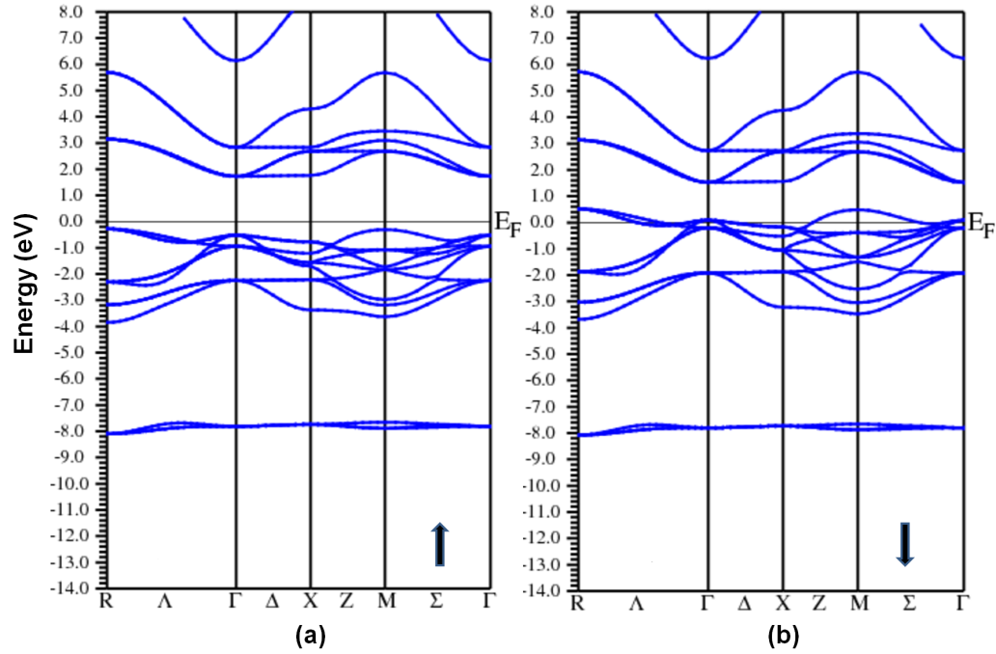
Band structure calculations have been carried out on nitrogen doped perovskite compounds such as ABO₃ (where A=Rb, B=Se,Ti) to investigate the electronic and magnetic properties. The computational DFT based calculations were carried out using Full Potential-Linearized Augmented Plane Wave Method (FP-LAPW). The electronic property such as half metallic ferromagnetism is predicted in this work where nitrogen atom is substituted in the place of one oxygen atom in the formulation of ABO₃ compound. The band structure and density of electronic energy states plots exhibit the existence of spin energy gap in one of the spins while in the other metallic characteristics is predicted. The formation of energy gap in one the spins qualify the material to be called as half metallic ferromagnetic compound which is suitable for futuristic spintronic applications.

Figure 1 Band structure plots of RbTiN₁O_{x-1} in spin up and down directions

