Synthesis and Characterization of a Nanocrystalline Equimolar Multicomponent Metal Oxide Spinel - (AlNiMnCrFe)₃O₄
N. Sreenivasulu, Subramshu S. Bhattacharya*
Nano functional Materials Technology Centre (NFMTC), Department of Metallurgical and Materials Engineering,
Indian institute of Technology Madras, Chennai India.

Abstract

Mixed transition-metal oxides (MTMOs) have been recently receiving increased research interest worldwide due to the striking properties arising from its spinel structure. MTMOs (generally referred to as A_{x}B_{3-x}O₄; A, B = Zn, Co, Ni, Fe, etc.) have either stoichiometric or non-stoichiometric compositions. Going a step further from mixed transition metals to mixed transition and post-transition metals, an equimolar multicomponent metal oxide (EMMO) system has been synthesized using reverse co-precipitation (RCP) method for the first time. In this study, the EMMO system was successfully synthesized in a single-phase Fe₃O₄-type (Fd-3m) structure. The EMMO system with spinel type structure is a combination of 5 different cations (Ni, Mn, Cr, Fe and Al) from transition and post-transition groups, taken using certain criteria that relates Pauling’s ionic radii rule for substitutions in the tetrahedral and octahedral sites. Heat treatment was optimized to form a single phase nanocrystalline EMMO. X-ray diffraction (XRD) studies revealed the formation of a single phase spinel system. TG (Thermo-gravimetric) analysis revealed that the system was stable throughout the scanning temperature (50 – 1200 ºC) and that there was no effect of entropy stabilization. Further characterization studies were carried out using Vibrating Sample Magnetometer (VSM) and Scanning Electron Microscopy (SEM) that revealed the magnetic properties, and microstructure and morphology respectively. The results of these studies are presented and discussed.

Biography

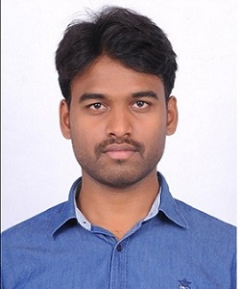 N Sreenivasulu is currently a research scholar (PhD) at Indian Institute of technology Madras. He has a keen interest in nanomaterials and its applications in various fields of science and technology. At present, he is working in nanocrystalline equimolar multicomponent oxides.
Email: snandyala007@gmail.com
 Subramshu S. Bhattacharya
*corresponding author
Email: ssb@iitm.ac.in

