Application of conducting polymer polypyrrole as electrochromic sensor of pH and CO₂
Vilma Ratautaite
Gintautas Bagdžiunas
Arunas Ramanavicius
Almira Ramanaviciene
Institute of chemistry, Faculty of Chemistry and Geosciences, Vilnius University, Vilnius, Lithuania

Conducting polymer polypyrrole (Ppy) has a long history of application in electrochemical sensor design. The polypyrrole has the following key features: low cost, easy preparation by chemical or electrochemical polymerization methods on various types of electrodes, it is a very suitable and convenient polymer as matrix for immobilization of biomolecules or for molecular imprinting [1,2,3].
In present investigation we studied the application of the Ppy as an electrochromic sensor. Polypyrrole was electrochemically polymerized on the indium tin oxide coated glass (ITO) electrode. In previous studies it was demonstrated, that electrode surface modification affects the polymer film adhesion to electrode. So adhesion of Ppy on the surface of ITO was alternated by ITO surface modification with two types of silanes. In previous studies were shown that initial electrochemical polymerization conditions principally determine the redox behavior of Ppy. These properties of the obtained Ppy layer are closely related to the electrochromic properties of the polymer. Therefore several electrochemical polymerization techniques were applied to obtain the Ppy on the ITO electrode. Hereby we compared cyclic voltammetry, potential pulse sequence and alternating current initiating electropolymerization method. Alternating current initiating electropolymerization method gives the ability to obtain thickest polypyrrole layer, but this layer was less stable on ITO electrode. All obtained Ppy layers were evaluated as possible candidates for the development of pH and CO₂ sensor.

Keywords: Polypyrrole; Electrochemical synthesis; pH sensor; Gas sensor; Electrochromism.

Acknowledgement

This research was funded by a grant (No. S-LAT-17-1) from the Research Council of Lithuania.

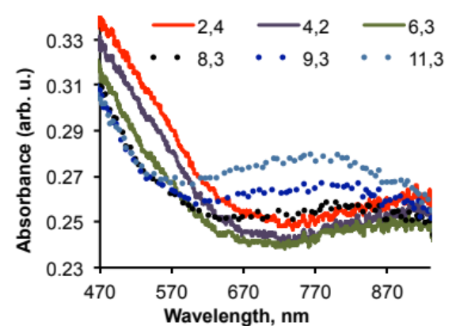Figure. The dependence of UV/Vis absorbance spectra of Ppy layer on the pH value from pH 2.3 to pH 11.3. Ppy was electrochemically polymerized by potential cycling on the surface of ITO electrode.
Recent Publications:
- Ratautaite, V.; Plausinaitis, D.; Baleviciute, I.; Mikoliunaite, L.; Ramanaviciene, A.; Ramanavicius, A. (2015) Characterization of Caffeine-Imprinted Polypyrrole by a Quartz Crystal Microbalance and Electrochemical Impedance Spectroscopy. Sensor Actuat B-Chem, 212:63-71.
- Ratautaite, V.; Topkaya, S. N.; Mikoliunaite, L.; Ozsoz, M.; Oztekin, Y.; Ramanaviciene, A.; Ramanavicius, A. (2013) Molecularly Imprinted Polypyrrole for DNA Determination Electroanalysis 25 (5):1169-1177.
- Ratautaite, V.; Nesladek, M.; Ramanaviciene, A.; Baleviciute, I.; Ramanavicius, A. (2014) Evaluation of Histamine Imprinted Polypyrrole Deposited on Boron Doped Nanocrystalline Diamond. Electroanalysis 26:2458–2464.
- Plausinaitis, D.; Ratautaite, V.; Mikoliunaite, L.; Sinkevicius, L.; Ramanaviciene, A.; Ramanavicius, A. (2015) Quartz Crystal Microbalance-Based Evaluation of the Electrochemical Formation of an Aggregated Polypyrrole Particle-Based Layer. Langmuir 31 (10):3186-3193.
- Ratautaite, V.; Ramanaviciene, A.; Oztekin, Y.; Voronovic, J.; Balevicius, Z.; Mikoliunaite, L.; Ramanavicius, A. (2013) Electrochemical stability and repulsion of polypyrrole film. Colloid Surface A 418 (0): 16-21.


dr. Vilma Ratautaite:

dr. Vilma Ratautaite received the PhD degree in Chemistry from Vytautas Magnus University, Kaunas, Lithuania in 2009. Currently she is researcher at the Institute of chemistry, Faculty of Chemistry and Geosciences, Vilnius University. She has research interests related in application of conducting polymers, such as polypyrrole, for electrochemical sensor design. She has investigated the polypyrrole in purpose use it as molecularly imprinted polymer, or electrochromic polymer. Other fields of scientific interests are a chromatography and electro-migration (capillary electrochromatography and capillary electrophoresis) methods.
Email: vilma.ratautaite@gmail.com

