Simulation and Experimental study of acoustic field in water
Krishnaveni Sivakumar, Fushi Bai, Jens Twiefel, Jörg Wallaschek
Institute of Dynamics and Vibration Research, Leibniz Universität Hannover, Appelstr.11, Hannover 30167, Germany.
Abstract:
Ultrasonic cavitation is the phenomena in which ultrasonic waves are passed through the liquid to produce cavitation bubbles. Owing to the pressure exerted by the collapse of the cavitation bubbles, it erodes the surface of the vessel containing the water. In this work, a piezoelectric transducer is used to produce the ultrasonic sound waves. Then, the acoustic pressure exerted by the cavitation bubbles is determined experimentally and theoretically by simulation. The results indicate that the acoustic pressure is maximum at the cavitation zone near the horn tip of the transducer and the aluminum foil which is near to the horn of the transducer undergo strong cavitation effect.
Introduction:
It is known that the object in the liquid when subjected to ultrasonic waves, due to the cavitation bubbles it gets eroded as well as cleaned (ultrasonic cleaning) [1,2]. It is due to the phenomena of ultrasonic cavitation [3]. Ultrasonic waves are the waves with frequency more than 20 kHz. A piezo electric transducer is used to produce the ultrasonic waves and these waves are passed through the water and it produces the cavitation bubbles. At such high frequency, these bubbles begin to collapse each other and produce a local high pressure on the surface of the object thereby causing erosion [4, 5] or cleaning the test piece [6]. Here, I present the results of the effect of the ultrasonic cavitation in the aluminium foil both experimentally and theoretically.
Sonotrode:
A transducer produces both longitudinal and radial vibration modes. A longitudinally vibrating transducer produces a cavitation causing erosion in the aluminium alloy plate in Fig.1&2 [2]
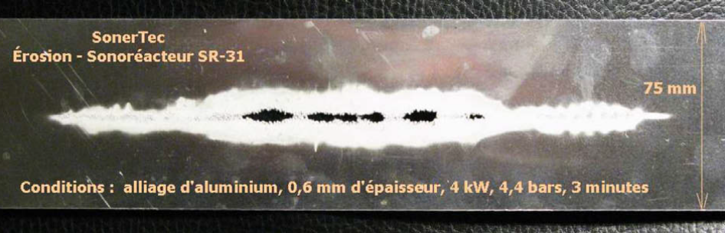
Fig.1 Erosion of a 0.6 mm aluminum alloy plate during a 3 min exposure in model SR-31
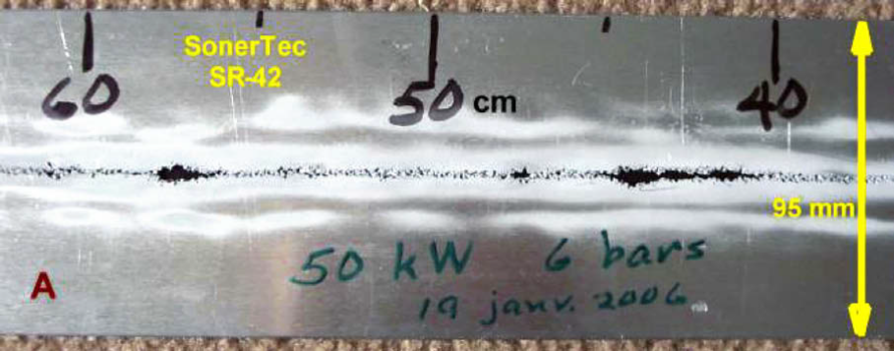
Fig.2 Erosion of a 1.5 mm aluminum alloy plate during a 5 min exposure in model SR-42 (50 kW).
If the cavitation zone is created away from the metallic vibrating surfaces; there will be no contamination of the liquid with erosion products [7, 8]. The operating parameters of the process will be varied like pressure, power and frequency. The power used for producing concentric cavitation zone is 4kW and a frequency of about 45 kHz [2].
Operating pressure:
The operating pressure system of the transducer have the capability of operating above atmospheric pressureand have very high acoustic cavitation efficiency at a constant power given to the electric generator [9].
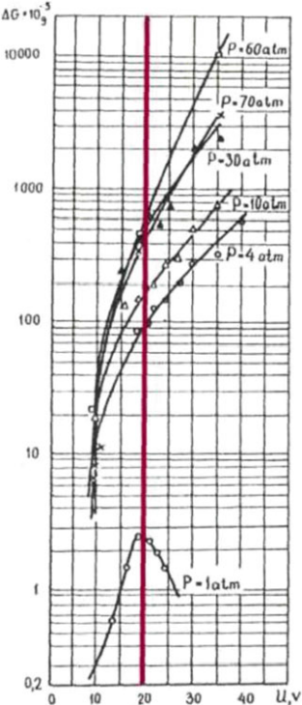
Fig.3For a constant driving voltage 20V, the cavitation efficiency is 40 times higher at 4atm than at 1atm and 80 times greater at 10atm [9]

Frequency:
High frequency ultrasound is generally achieved in the range of 10 and 100 kHz [10]. The frequency depends on the amount of power required for the transducer to produce ultrasonic waves at high frequencies and the power is inversely proportional to the square of the frequency [11]. Frequency depends on the dimensions of the emitter. Povey and Mason 1998 reported that when the emitter length is doubled, the frequency is decreased half [8].
Power intensity:
It is a measure of intensity of the power transmitted from the surface tip of the sonotrode to the medium.It is given by the equation [12]
Pi = P/A [W/m2]........ (1)
(Neis and Blume, 2003) gave the equation for power intensity [13] for a sonotrode of circular area,
Pi = P/πr2 [W/m2]........ (2)
A power of 360W given to the ultrasonic generator of sonotrode 1cm radius produces power intensity of 114.59W/Cm². At the same power, when a sonotrode of smaller radius of 0.5Cm is used, it produces a power intensity of 458.37W/cm².Thus, we can conclude that power intensity is inversely proportional to the sonotrode radius [10].When the sonotrode radius increases, power intensity decreases and the radius decreases, power intensity increases.
Experimental setup:
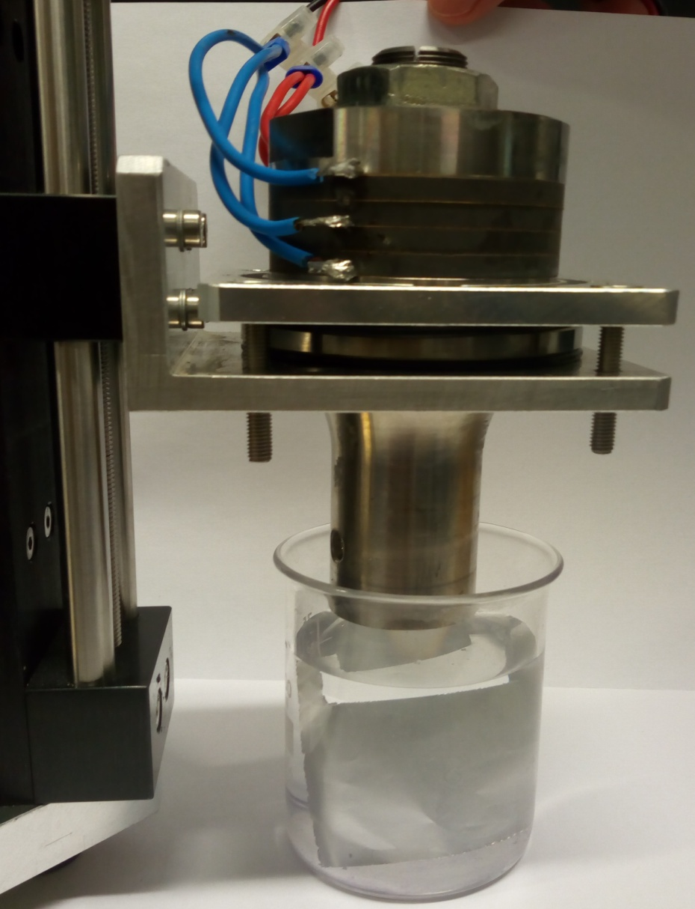
Fig4. Experimental setup of the ultrasonic cavitation
A transducer used is sandwich piezoelectric ultrasonic transducer. It consists of 4 piezoelectric rings made up of piezo ceramic material, cover, nut, horn and Schreiber made up of titanium alloy. The horn of the transducer is 28mm. The signal generator is the IDS Digital phase control 500/100K which is designed and manufactured in Institute of dynamics and Vibration research [14]. Both current and voltage channel is connected to the input of the DPC. The operating paramaters of the DPC are amplifying voltage, current, power, frequency, feedback current and feedback phase. The frequency is set into 22.3 kHz longitudinal mode resonant frequency at λ/2 mode of the transducer.The feedback current and phase is turned on. All the paramaters set in the DPC is saved and loaded into computer control. The output of the Digital phase control 500/100K is connected to the input channel of the Power amplifier QSC 4050 to amplify the signals generated from the DPC [15, 16]. The output of the amplifier is connected to the input of the transducer. The dimensions of the glass vessel are noted using the digital vernier caliper. The glass vessel containing the aluminium foil and water is placed on the moving table under the horn tip of the transducer. Then, the horn tip of the ultrasonic transducer is partly immersed inside the water and the DPC is allowed to run under the specified operating conditions for 30 seconds. During these experiments, the power (feedback current) is also varied to evaluate the cavitation effect on the aluminium foil for each 0.1A

Results and discussions.
Simulation Results:
Before done the experiments, I did the simulation under real conditions. We designed the sandwich piezoelectric transducer in the Solid edge software. Then, I did the simulation in ANSYS Workbench 16.2 version Harmonic response for evaluating the acoustic pressure of the ultrasonic cavitation. I simulated the transducer whose horn tip is partly immersed inside the water containing in the glass vessel and outside the glass vessel there is air (which modeled in the ANSYS design modeler) like what going to do really in lab experimentally.
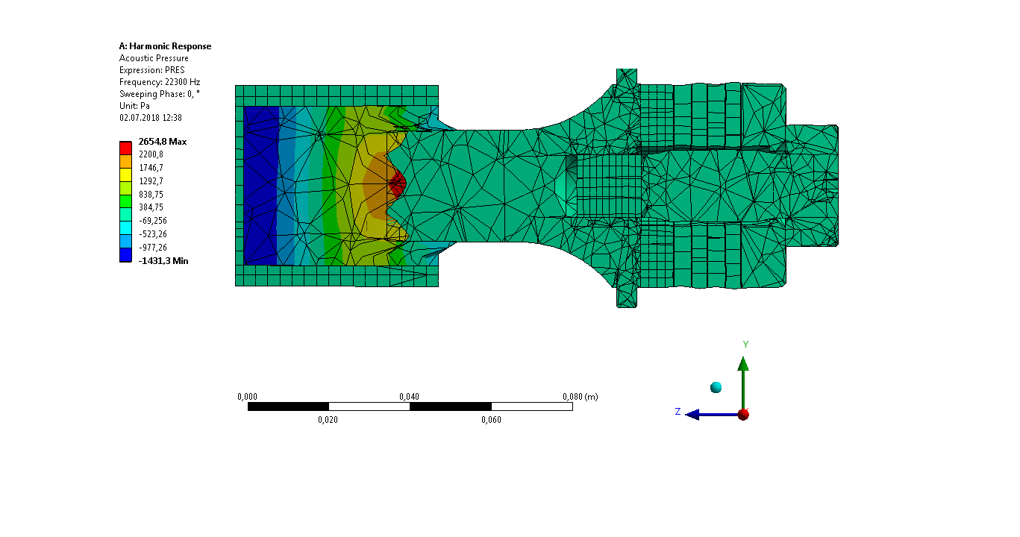
Fig.5 ANSYS simulation results of the acoustic pressure of the ultrasonic cavitation.
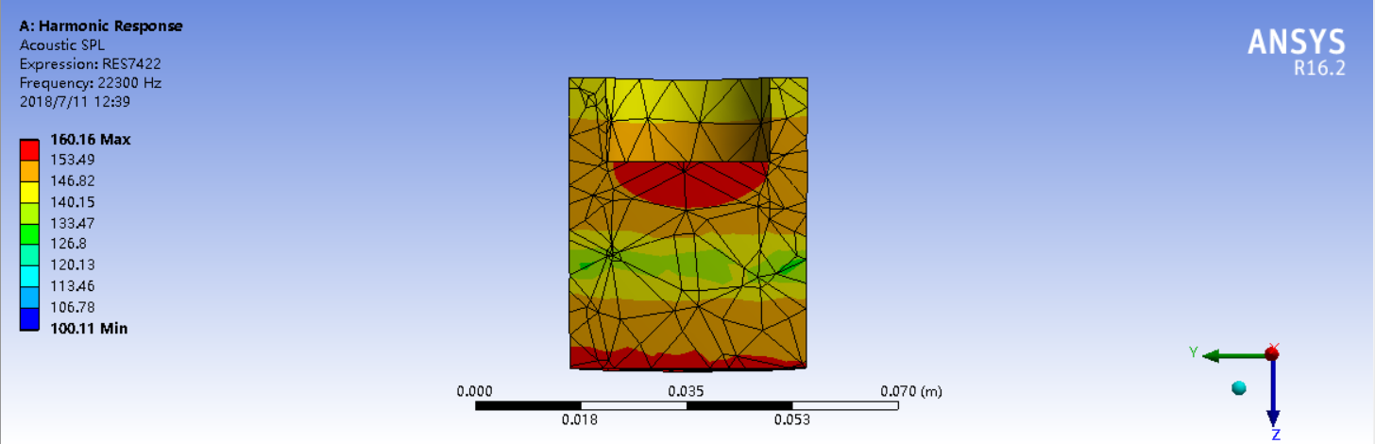
Fig. 6 Simulation results of the acoustic pressure probe of the cavitation.
From the figure 5 &6, I came to find the result that the acoustic pressure is maximum ( Red color region ) at the cavitation zone near the horn tip of the transducer.
Experimental Results:
Then, I did the experiments to evaluate and compare the results of my simulation with the experimental one. During my experiment, I varied the feedback current also to evaluate the cavitation effect with respect to the feedback current from 0.5A to 1.1A.
The following figures will show the effect of acoustic pressure of the ultrasonic cavitation on the aluminium foil at different power values. The dimension of the aluminium foil is 50×60 mm.
Conclusion:
The area of the aluminum foil eroded due to ultrasonic cavitation at 1.1A is more and the area of the eroded region decreases when the power is low. From the results, which I got, I conclude that the Stronger cavitation is near the horn tip of the ultrasonic transducer thereby eroded the aluminium foil more which matches with my simulation results.
References:
[1]Hua I, Thompson JE. Inactivation of Escherichia coli by sonication at discrete ultrasonic frequencies. Water research. 2000 Oct 15; 34(15):3888-93.
[2] Dion JL. Contamination-free high capacity converging waves sonoreactors for the chemical industry. Ultrasonics sonochemistry. 2009 Feb 1; 16(2):212-20
[3] ] Ohrdes H, Ille I, Twiefel J, Wallaschek J, Nogueira R, Rosenwinkel KH. A control system for ultrasound devices utilized for inactivating E. coli in wastewater. Ultrasonics sonochemistry. 2018 Jan 1; 40:158-62.
[4] Pericleous KA, Burnard VB, Djambazov GS, Griffiths WD, Leadbeater T, Parker DJ, Shevchenko D. Cavitation in liquid metal melts using contactless electromagnetic vibration. Skin. 2(2):3.

[5] Komarov S, Kuznetsov D. Erosion resistance and performance characteristics of niobium ultrasonic sonotrodes in molten aluminum. International Journal of Refractory Metals and Hard Materials. 2012 Nov 1; 35:76-83.

[6] Fang Y, Shimizu S, Yamamoto T, Komarov S. Generation of OH Radical by Ultrasonic Irradiation in Batch and Circulatory Reactor. InIOP Conference Series: Earth and Environmental Science 2018 Mar (Vol. 120, No. 1, p. 012019). IOP Publishing.

[7] Freitas S, Hielscher G, Merkle HP, Gander B. Continuous contact-and contamination-free ultrasonic emulsification—a useful tool for pharmaceutical development and production. Ultrasonics sonochemistry. 2006 Jan 1; 13(1):76-85.

[8] Povey MJ. Applications of ultrasonics in food science-novel control of fat crystallization and structuring. Current Opinion in Colloid & Interface Science. 2017 Mar 1; 28:1-6.

[9] Sirotyuk MG. Ultrasonic cavitation processes at increased hydrostatic pressures. Proceedings of the Fifth Congrès International d’Acoustique, Liège. 1965 Sep: 7-14.

[10] Dion JL. Contamination-free sonoreactor for the food industry. InUltrasound Technologies for Food and Bioprocessing 2011 (pp. 175-190). Springer, New York, NY.

[11] Povey MJ, Mason TJ, editors. Ultrasound in food processing. Springer Science & Business Media; 1998.

[12] Mawson R, Tongaonkar J, Bhagwat SS, Pandit AB. Airborne ultrasound for enhanced defoaming applications. In Innovative Food Processing Technologies 2016 (pp. 347-359).

[13] Neis U, Blume T. Ultrasonic disinfection of wastewater effluents for high-quality reuse. Water Science and Technology: Water Supply. 2003 Aug 1; 3(4):261-7.

[14] Bai F, Saalbach KA, Twiefel J, Wallaschek J. Effect of different standoff distance and driving current on transducer during ultrasonic cavitation peening. Sensors and Actuators A: Physical. 2017 Jul 1; 261:274-9

[15] Bai F, Saalbach KA, Long Y, Twiefel J, Wallaschek J. Capability evaluation of ultrasonic cavitation peening at different standoff distances. Ultrasonics. 2018 Mar 1; 84:38-44.

[16] Bai F, Saalbach KA, Wang L, Wang X, Twiefel J. Impact of time on ultrasonic cavitation peening via detection of surface plastic deformation. Ultrasonics. 2018 Mar 31; 84:350-5

Biographies:
Krishnaveni Sivakumar is studying B.E materials Science and Engineering, Department of Mechanical Engineering, College of Engineering Guindy, Anna University, Chennai, Tamilnadu, India. 
Fushi Bai is studying for his PhD degree in the piezo-electrics and ultrasonics workgroup at the Institute of Dynamics and Vibration Research since 2014. His primary areas of research are ultrasonic cavitation and cavitation peening.

Dr. Jens Twiefel received PhD degree in 2010. He is leader of the piezoelectric and ultrasonics workgroup at the Institute of Dynamics and Vibration Research.

Prof. Dr.-Ing. Jörg Wallaschek is leader of the Institute of Dynamics and Vibration Research since 2007. His primary areas of research are dynamics and vibrations of machines, active lighting systems and piezoelectric ultra-sonic motors and actuators.


