Title: Experimental analysis of environmental effects on polymer concrete
Vahab Toufigh, Ph.D., P.E., Pedram Ghasemi, Department of Civil Engineering, Sharif University of Technology, Tehran, Iran

Abstract:
Developing high-performance engineering materials was one of the most important priority of civil engineering. Such materials perform high strength, durability, ductility, toughness and energy absorption. One of these materials is polymer concrete (PC) that has become well-known due to its application in repair and rehabilitation of structures, precast components, as thin overlays and floors. Also, PC used as a repair material for concrete infrastructure like sewer structure applications, drainage channels, swimming pools and other structures that comprise chemically corrosive aggregate. The purpose of this study is to assess the chemical resistance of polymer concrete when exposed to two environments including chemical solutions at two pH contents (2.5 and 12.5) which simulate acidic and alkali environment. In this research, PC samples with two different contents of epoxy resin (10% and 12% of the total weight of composition) have been studied. Five cylindrical and one cubic specimens were prepared For each epoxy resin content. A Uniaxial compression test as destructive test and non-destructive method such as ultrasonic test was applied to determine the change of the features. Results show loss of compression strength in the PC samples which were exposed to chemical solutions. The study showed that the amount of strength loss is related to the pores of PC specimens. Factors as type and content of resin and hardener, type and concentration of chemical solution and interaction between them considerably affected samples strength. This material could be a good candidate for repair and rehabilitation of structures.

Image:
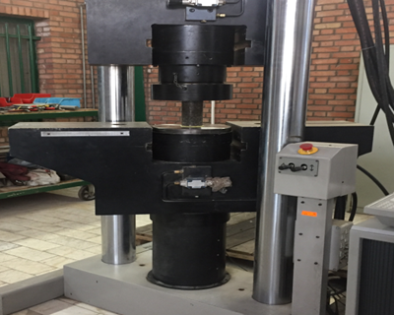
Figure .Uniaxial compression test with universal machine

Recent Publications:
- Yarigarravesh, M., Toufigh, V., & Mofid, M. (2018). Environmental effects on the bond at the interface between FRP and wood. European Journal of Wood and Wood Products, 76(1), 163-174.
- Toufigh, V., Hosseinali, M., & Shirkhorshidi, S. M. (2016). Experimental study and constitutive modeling of polymer concrete’s behavior in compression. Construction and Building Materials, 112, 183-190.
- Bedi, R., Chandra, R., & Singh, S. P. (2013). Mechanical properties of polymer concrete. Journal of Composites, 2013.
- Saadatmanesh, H., Tavakkolizadeh, M., & Mostofinejad, D. (2010). Environmental effects on mechanical properties of wet lay-up fiber-reinforced polymer. ACI materials journal, 107.
- Gorninski, J. P., Dal Molin, D. C., & Kazmierczak, C. S. (2007). Strength degradation of polymer concrete in acidic environments. Cement and Concrete Composites, 29(8), 637-645.

Biography:

Vahab Toufigh is an Associate Professor at the Sharif University of Technology, Tehran, Iran. He received his BS, MS, and PhD in civil engineering from the University of Arizona, Tucson, AZ. His research interests include rehabilitation and repair of structures and constitutive laws with design and fabrication (PC), laboratory testing of structural components, and rehabilitation and strengthening techniques for existing structures.
Email: toufigh@sharif.edu


Pedram Ghasemi is a graduate student in civil engineering and his research interest is sustainable and high-performance materials which have less detrimental effects on environment and rehabilitation and repair of stuctures with proper techniques and materials. His research based on experimental and numerical evaluation to assess mechanical properties and chemical resistance. He has determined this evaluation after three months with making and testing specimens. This study will lead civil engineering to use this type of materials as a repair material or precast component properly and efficiently in each structure, situation and position.
Email: pedram.ghs1993@gmail.com

