Nondestructive and stealth performance evaluations of composites
Jae-Kyeong Jang^{1,a}, Jong-Min Hyun^{1,b}, Dae-Sung Son^{1,c}, Jung-Ryul Lee^{1,d}
¹Department of Aerospace Engineering, Korea Advanced Institute of Science and Technology, Daejeon, Korea
ª84jkjang@kaist.ac.kr, ^{b}jmhyun08@kaist.ac.kr, ^{c}son5963@kaist.ac.kr, ^{d}leejrr@kaist.ac.kr

Abstract
Many studies for composite radar absorbing structures (RAS) and delamination have been performed [1, 2]. The purpose of this study is to understand a correlation between lightning damage and stealth performance of the RAS due to lightning strikes. The RAS in this study has two different layers with two different materials. The material for one layer is glass/epoxy (GFRP) and the other material for the other layer is glass/epoxy-MWCNT. To make the damage on the RAS composite specimens, artificial lightning strike test was performed according to NASA reference [3]. To examine the correlation between the lightning damage and the stealth performance, a non-destructive inspection (NDI) and reflection loss measurement were conducted using pules-echo ultrasonic propagation imager (PE-UPI) system [4] and dual port scanning free space measurement (SFSM) system [5], respectively. The lightning damage is visualized in C-scan results using PE-UPI, and the stealth performance is compared in the X-band (8.2/12.4 GHz). It was verified that the lightning damage affected the radar absorbing performance of the RAS. The performance change of the reflection loss was related to the location and size of the damage.
Image
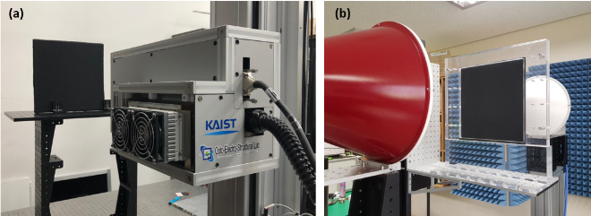
Figure. Evaluation for the correlation between lightning damage and stealth performance of the RAS using (a) PE-UPI system and (b) the dual port SFSM system.

Acknowledgments:
This research was supported by Korean Air funded by the Agency for Defense Development and Technology Innovation Program (10074278) funded By the Ministry of Trade, industry & Energy (MI, Korea).
Recent Publications:
- Iijima S (1991) Helical microtubules of graphitic carbon. Nature 354:56–8.
- Yoshiyasu Hirano, Shingo Katsumata, Yutaka Iwahori, Akira Todoroki (2010) Artificial lightning testing on graphite/epoxy composite laminate. Composites: Part A 41: 1461-1470.
- Fisher FA, Plumer JA, Perala RA (1977) Lightning protection of aircraft. NASA reference publication 1008.
- S C Hong, A D Abetew, J R Lee, and J B Ihn (2017) Three dimensional evaluation of aluminum plates with wall-thinning by Full-Field Pulse-Echo Laser Ultrasonic. Optics and Lasers in Engineering 99: 58-65.
- Jong-Min Hyun, Hasan Ahmed and Jung-Ryul Lee (2017) Development of Dual Port Scanning Free Space Measurement System. Measurement Science and Technology 29.

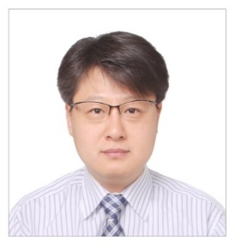
Biography: (150 words limit)
He is associate professor of the Department of Aerospace Engineering in Korea Advanced Institute of Science and Technology, South Korea. His research interest includes Smart Hangar (Inventor), Wireless sensing (wireless strain and ultrasonic sensing devices), pyroshock measurement and propagation imaging (Inventor), Laser ultrasonic propagation imaging (Inventor), Scanning microwave imaging for stealth and radome structures (Inventor), Machine-learning based structural diagnosis, Integrated system health monitoring. His application field encompasses space launchers, unmanned air vehicles, wind turbine, power plants, railway structures, automobile, public safety and radome/stealth structures. He has published over 300 articles and patents in this area, and received several awards, including “Young Scientist Award” in 2016 by sustainable aviation research society, “Grand Prize of the Best Papers” in 2013 by ministry of land, infrastructure, and transport in Korea, “Global Research & Development Center Award” in 2011 by Ministry of Education, Science and Technology.
Email: leejrr@kaist.ac.kr

