Controlled self-assembly of GeSi nanostructures and its perspective in Si mcirocavities
Shuguang Wang, Ningning Zhang, Peizong Chen, Zuimin Jiang and Zhenyang Zhong∗
¹ State Key Laboratory of Surface Physics and Department of Physics, Fudan University, Shanghai 200438, People’s Republic of China
² Collaborative Innovation Center of Advanced Microstructures, Nanjing 210093, People’s Republic of China
*Email:zhenyangz@fudan.edu.cn

Monolithic integration of Si-based microelectronics and optoelectronics is expected to be the viable solution to overcome the performance bottleneck for semiconductor microchips in terms of power consumption, speed and bandwidth [1]. GeSi quantum nanostructures (QNs) have been of great interest for their potential in both microelectronic and optoelectronic device applications, considering their unique properties and the compatibility with the sophisticated Si technology [2]. However, the poor quantum efficiency of the Ge/Si system associated with the indirect band structure hampers their applications in the optoelectronic devices. It is found that the quantum confinement effect and the partial relaxation of the law of momentum conservation can considerably increase the quantum efficiency of the GeSi nanostructures. Further improvement can be realized by embedding GeSi QNs into some microcavities since the light-matter interaction in the cavity can be dramatically enhanced [3]. It is a critical issue to realize the spatial matching, as well as the spectra matching, between the GeSi QNs and the cavity.
In this talk, controlled GeSi QNs in Si microcavities (micropillars and microdisks) are systematically studied. The periodic Si micropillars and microdisks are fabricated by nanosphere lithography [4]. Controlled GeSi coaxial quantum wells (CQWs) on periodic Si(001) micropillars in a large area is realized. By tailoring the growth conditions and the diameters of the pillars (or the microdisks), different configurations of GeSi QNs, including quantum dots (QDs) ‘necklace’, quantum rings (QRs), quantum dot molecules (QDMs), and single QD, are realized on the top edge of the micropillars [5], as shown in Fig. 1. By reducing the Si pillar into small dot, four self-assembled GeSi QDs can be induced at the base edges of the Si dot, resulting in the Ge-Si compound QD molecules [6]. Particularly, the GeSi QNs can be readily modulated by a two-step growth procedure [7]. Such an engineering of GeSi QNs is explained in terms of the surface chemical potential and the anisotropic surface diffusion of adatoms around the patterned Si microstructures during growth, as schematically shown in Fig. 2. Our results disclose the critical effect of the surface curvature on the diffusion and the aggregation of Ge adatoms, which further clarify the unique features and the inherent mechanism of self-assembled QDs on patterned substrates. More interestingly, by designing the diameter and the period of the Si microcavities (pillars or disks), the strong coupling between the spontaneous emission of GeSi QNs and the cavity modes [4], as well as the effect of the photonic crystal bandgap, will remarkably improve the optoelectronic properties of the GeSi QNs. Accordingly, the GeSi QNs embedded in the Si microcavities will have promising futures in the applications of innovative optoelectronic devices.

References
[1] C. Sun, et al. Nature 528, 534 (2015)
[2] K. Wang, et al. Proc. IEEE 95, 1866 (2007)
[3] T. Byrnes, et al., Nat. Phys. 10, 803 (2014).
[4] Z. Wu, et al. Nanotechnology 25, 055204 (2014).
[5] Tong Zhou, et al. Nanoscale 6, 3925 (2014)
[6] H. Lei, et al. Nanotechnology 25, 345301(2014)
[7] S. Wang, et al. Sci. Rep. 6, 28872(2016)

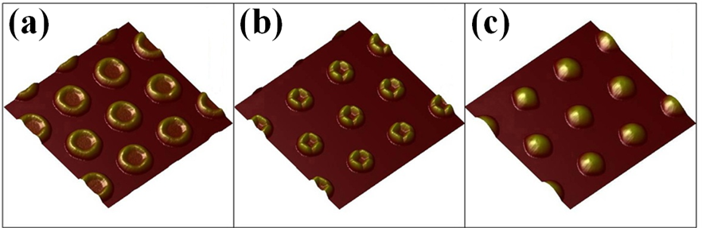
Fig. 1 AFM images of the surface morphologies of GeSi nanostructures, including (a) quantum rings, (b) quantum dot molecules and (c) quantum dots obtained on the top of the pillars with different diameters.

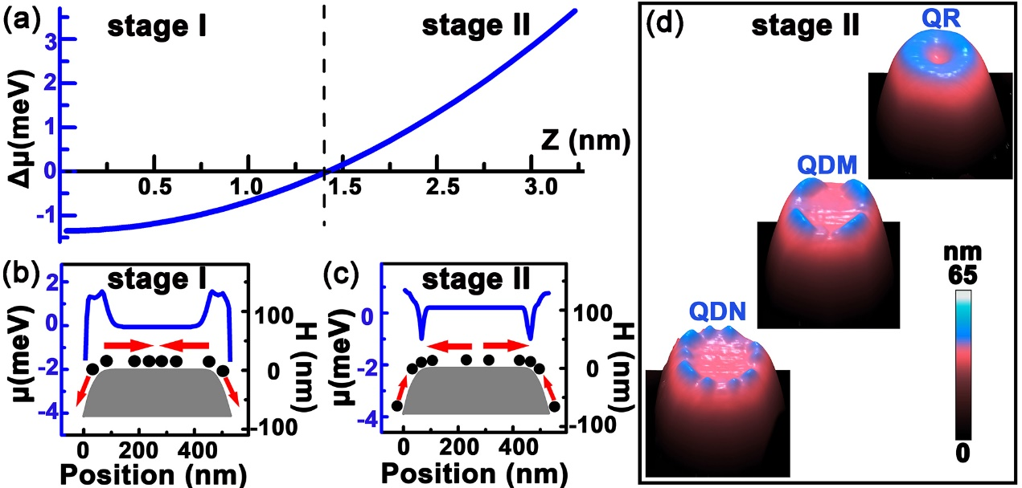
Fig. 2 a) The difference (Δμ=μ_{center}-μ_{edge}) of the SCP at the top center and edge of the pillar as a function of the parameter Z, b) and c) the typical SCP (blue line) and the height profile (gray region) across the center of a pillar in the growth stage I and II, respectively, d) the AFM images of three typical QNs, the QDN, the QDM and the QR, on the pillar. In b) and c), the black solid circles denote the Ge adatoms, the red arrows denote the preferential diffusion of the Ge adatoms. The stage I and II denote the growth processes of Ge on the Si pillar.

