The effect of surface modification of nano magnesium oxide on the thermal properties and mechanical properties of the epoxy composite

M. Wasim Akhtar^{1,2*}, Baloch Muhammad Moazam¹, Muddassir Ali Memon¹, Jong Seok Kim²
¹Department of Metallurgy & Materials Engineering, Mehran University of Engineering & Technology, Jamshoro, Sindh, Pakistan
²School of Semiconductor and Chemical Engineering, Chonbuk National University, Jeonju 54896, Republic of Korea.

Abstract

This work demonstrated the effect of functionalized magnesium oxide (MgO) nanoparticles with 3-(Aminopropyl) triethoxysilane (APTES) as fillers on the thermal and mechanical properties of the epoxy composite. The functionalization of MgO (S-MgO) considerably improved the interfacial bonding between the filler and epoxy matrix. The mechanical properties showed that the addition of functionalized MgO as fillers in composites enhanced the tensile strength, modulus of elasticity and ductility of the composites as compared to neat epoxy. Epoxy composite with S-MgO filler significantly increased the in-plane thermal conductivity by ~10 fold in comparison with neat epoxy. These observations indicated that the silane functionalization on MgO helps to establish the strong interfacial connection and firmly interconnected network between the filler and the epoxy matrix.

Keywords: Thermal properties; Magnesium oxide; Functionalization; Composite materials; Filler

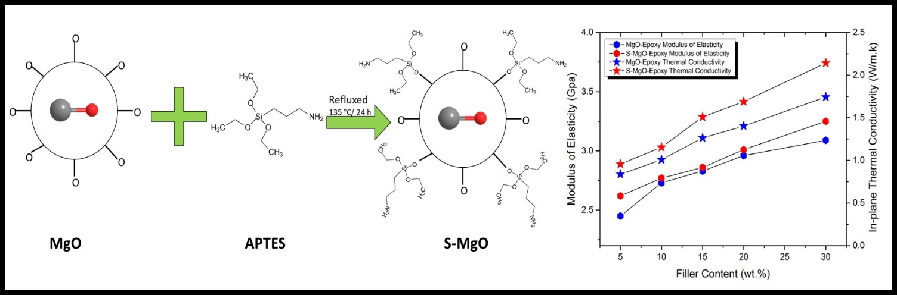
Graphical Abstract

Biography

M. Wasim Akhtar is an assistant professor in Department of Metallurgy & Materials Engineering, Mehran University of Engineering & Technology, Jamshoro, Pakistan. He completed his Ph.D. studies from Chonbuk National University, South Korea in 2017. His area of research is advanced composite materials and the interaction of particulate with the matrix. He presented his work in several conferences and his published his articles in high impact journals related to composite materials.

